Oxford Open Learning

Student Tracking System

*The computerization of an Oxford Open Leaning Tutoring Business*

# Analysis Contents

Introduction 3

Background 3

Problem definition 3

Investigation of old system 5

The current System 5

Context Diagram 7

Data flow diagrams of existing system 8

The Problems with the current system 9

3. Investigation of new system 10

Identification of Prospective Users 10

Process Requirements 10

Data flow diagram of proposed system 11

Data sources, stores and destinations for the proposed system 13

System flow chat diagram of proposed new system 14

Description of operations and entities 14

Entity relationship diagram – Normalized database (3NF) 16

User Data dictionary 17

4. List of S.M.A.R.T. Objectives for the proposed system 19

Process Requirements 19

Inputs, outputs and processes for the proposed system 20

5. Data Volumes 22

6. Overall Break-down of solutions 23

Manual (Pre-Existing solution) 23

Off the shelf software 23

Programmed Solutions 24

7. Justification of the chosen solution 26

# Introduction

## Background

The problem concerns a Tutor from **Oxford Open Learning** (Lesley). The Tutor currently teaches two subjects to approximately 40 students aged between the years of 11 and 16.

The work time is currently a couple of hours a day, where the tutor works on handling the student data and marking incoming student assignments (that are returned via **Oxford Open Learning)**.

## Problem definition

The current system uses a selection of large paper files containing **Log Books** (Fig.1) which contain information unique to each student along with contact details that the tutor has received from **Oxford Open Learning**. There are two parts to the **Log Books,** a **Contact Sheet** and a sheet recording **Tutor Marked Assignment** marks.

An everyday task involves the Tutor receiving an assignment from a student, physically searching for the student in the paper files using A-Z tab file dividers, reading information about the student’s last assignment, marking the students work, then recording the grade, date and providing a comment in the **Log Book** on the **T.M.A. Sheet**. The tutor then contacts the student by telephone or email to give feedback on their work and records this on the **Contact Sheet**. The tutor needs to contact each student every 3 - 4 weeks regardless of whether or not they have submitted any work during that period.

One of the main problems with the current system is knowing when a student needs contacting. At the moment this is done by checking through the paper files and looking at each students **Log book** to see the last date of contact.

The Tutor has recently been assigned 40 more students, which doubles the work load and records the Tutor keeps. The increased amount of information means, records become difficult to maintain, searches decrease because physical searching through large amounts of paper stores is difficult. Overall this leads to data becoming more difficult to access quickly for marking and checking whether it is time to contact an individual student. This means the current system is inefficient and students may ‘slip through the net’.

Please note that **T.M.A.** will be abbreviated from **Tutor Marked Assignment(s)**

My project will be to transfer the working system from paper files to a computer based system.

To maintain records of student activity, facilitate the administrative process that the tutor has to undertake, such as tracking student progress, updating, inserting and deleting student records and producing management reports similar to the student reports the current manual system produces. To make the working processes faster, more efficient and to ensure that the tutor will always be aware of when a student needs contacting.

Fig.1 Log book sample

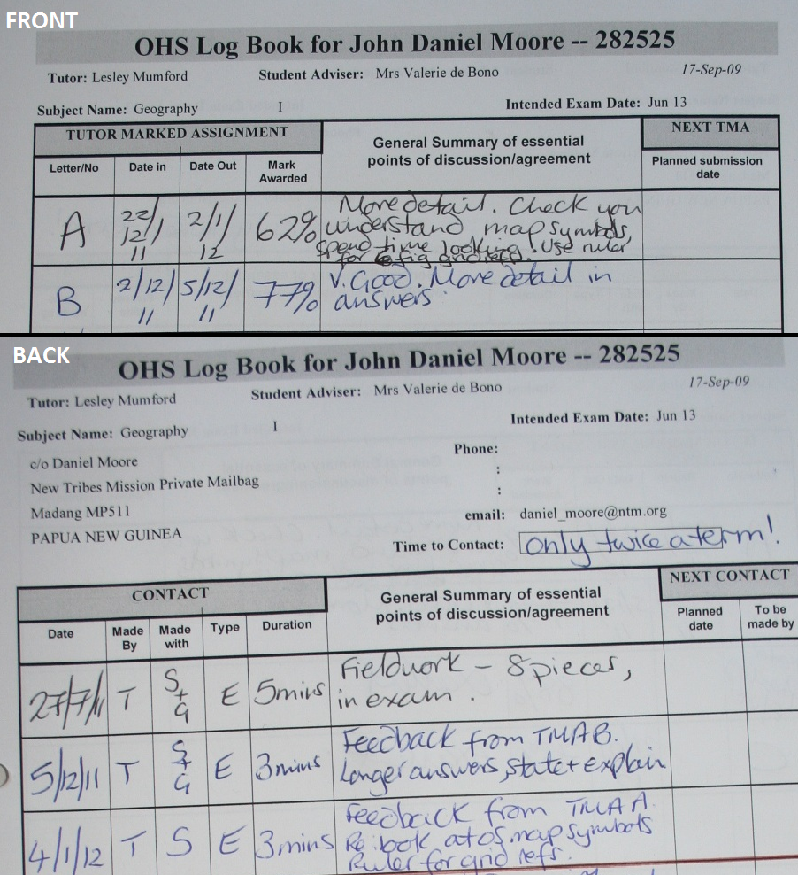

# Investigation of old system

## The current System

My first step was to interview the system user, the tutor. I used a pre-set list of questions (Fig.2) to enable me to find out the inputs, outputs and processes currently used in the paper system by the tutor.

Fig.2 Sample of Questionnaire

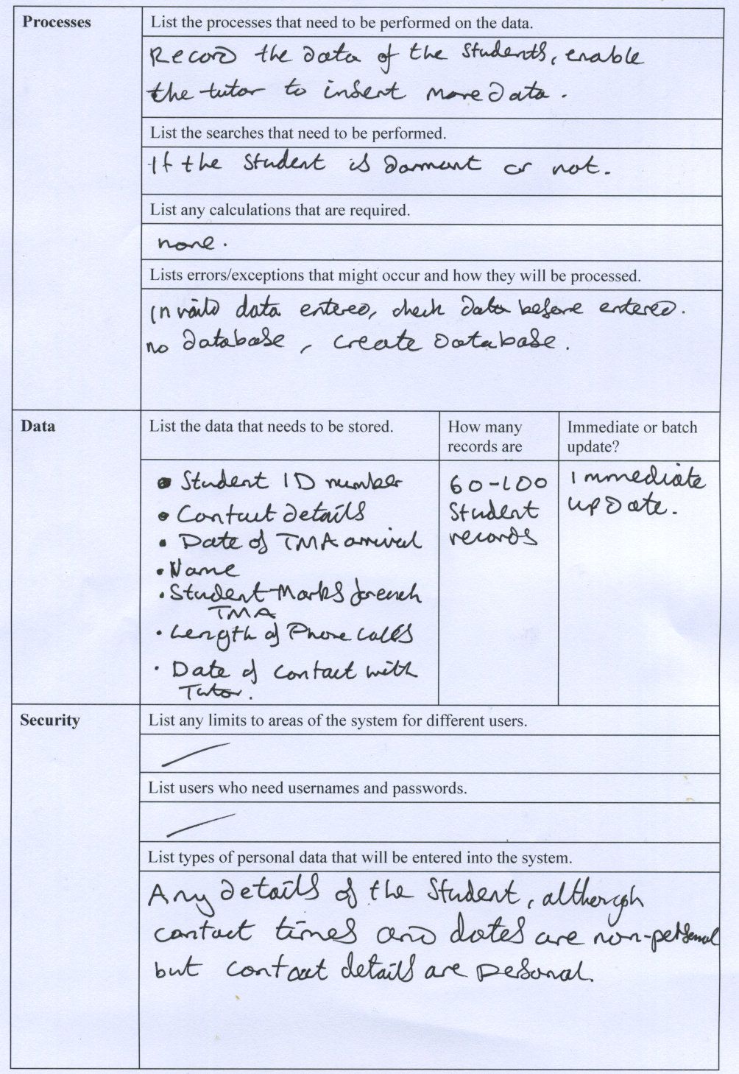

From the interview, questions and my personal observations of the system I found that each student is set work by the tutor to be completed within one month. These are named **Tutor Marked Assignments**, which are sent via email (in Portable Document Format) or post via **Oxford Open Learning**, alongside these are emails from the student with any queries they have related to the course. The tutor processes, marks and records the details of the given **Tutor Marked Assignment** and the contact times with the student, phone calls and emails are all recorded in the respective student **Log Book, Contact Sheet.**

When a student has completed the course the student **Log Books**are sent to**Oxford Open Learning,** so the Tutor can receive payment for the marking of work and teaching of the student through contact with them. So it is important that the type of contact and the time spent on the student is recorded.

This particular tutor teaches two subjects, IGCSE Geography, students can follow this course over one or two years and KS3 Mathematics, which is divided into Year 7, Year 8 and Year 9 – where each course takes one year to complete. The exam date for the above subjects is always June, but if a student joins in 2012 the exam date is 2013, else if they join on a two year course then the exam date falls on 2013 and if the student follows the course over two years the previous student **Log Book** is kept with the new **Log Book,** for clarity**.**

Fig.3 Courses

IGCSE Geography **1st year -2nd year**

KS3 Mathematics starting in **Year 7 - Year 8 - Year 9**

Because the Tutor has to manage a constant supply of students the paper records are only kept for a single year, this enables the current system to have a reduced amount of files and speeds up searching. Students who don’t send work within a 3 month period become **Dormant** and a line is crossed through their name in their corresponding **Log Book**  and whenever they contact or send work to the Tutor (limited to 6 months) they become (re)un-dormant.

## Context Diagram

Below is a context diagram which presents a clearer picture between the **Oxford Open Learning,** Tutor and the student, note that **TMA** stands for **Tutor Marked Assignment**:

Fig.4 Context Diagram of Current System

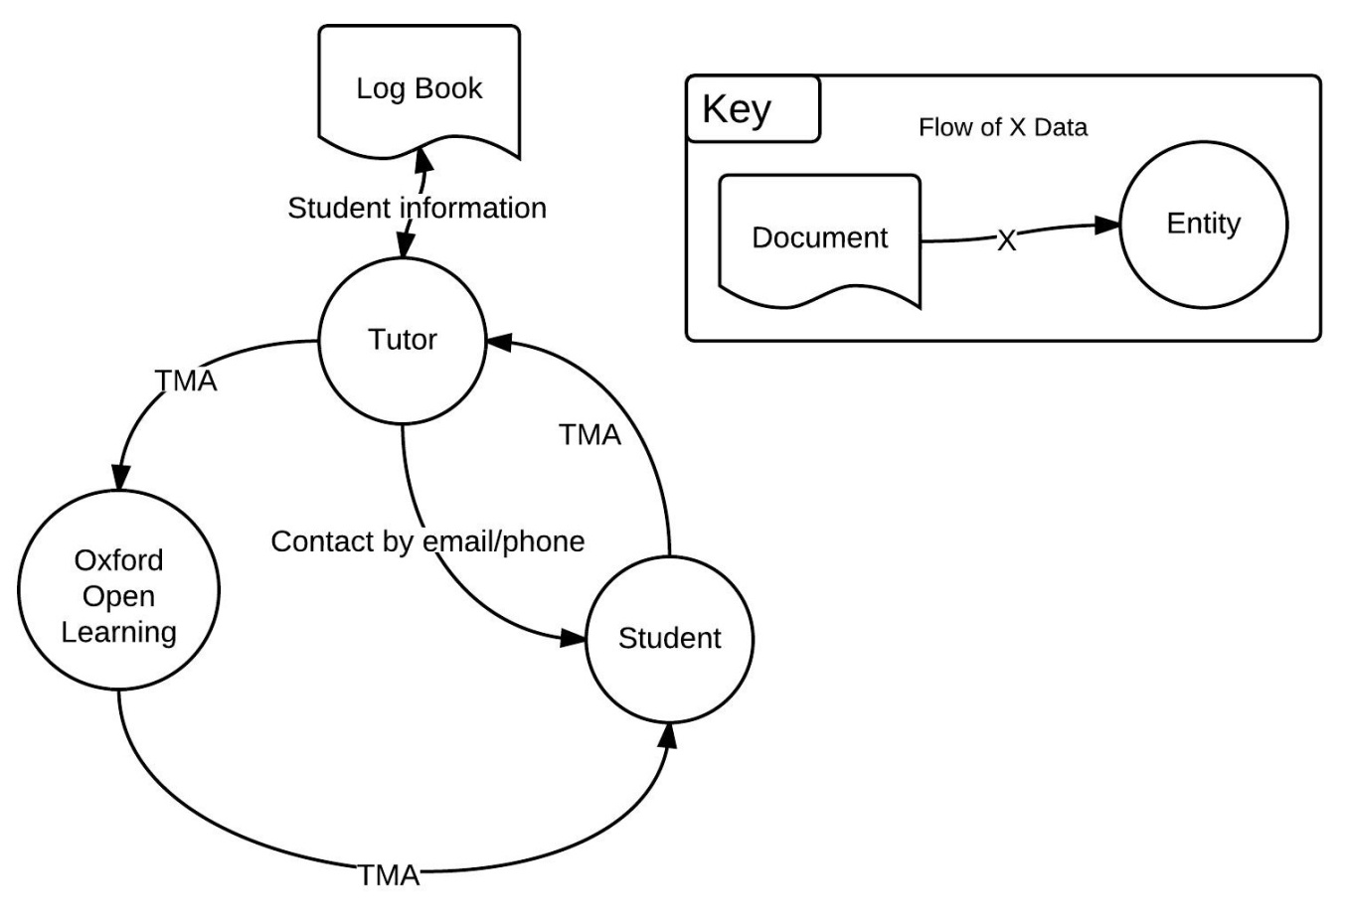

## Data flow diagrams of existing system

These next Data Flow Diagrams explain the flow of data between the Student and the Tutor.

Fig.5 Data flow diagram level 0

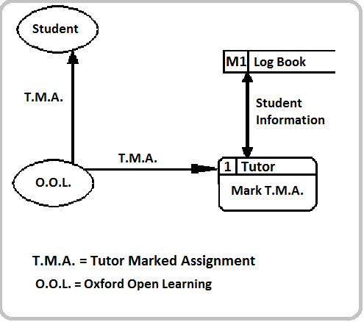

Fig.6 Data flow diagram level 1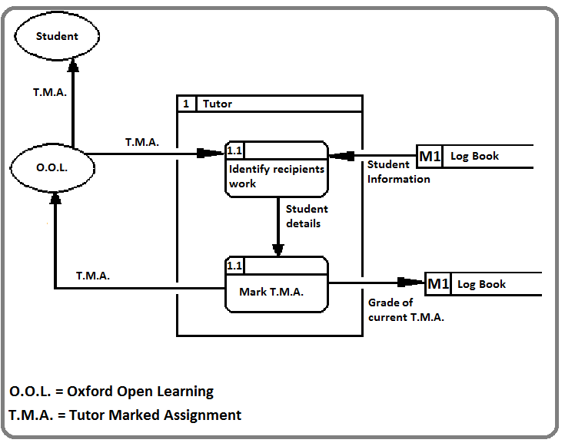

## The Problems with the current system

Findings from interview with user, based on the set of questions:

* A large amount of paper work is involved, which can become very labour intensive at times and leads to slow searches throughout the records.
* **Log Books** of old student records are being removed because they take up physical space which is limited. Plus they are useful for maintenance when using data tracking or for a history of past students.
* No sort of alert system to notify the tutor when to next check a student record, this slows down system management and students deadlines are sometimes missed.
* Repeated data is used where the Tutor is writing a comment about the students work in the **Log Book** and for the student about their work.

# 3. Investigation of new system

## Identification of Prospective Users

The system is to be used for an Oxford Open Learning tutor in my case the user is Lesley Mumford, this can be summarised below:

**Oxford Open Learning: GCSE/KS3 Tutor**

**End User: Mrs L. Mumford (Subject Tutor)**

## Process Requirements

After the interview with the user and based upon my interpretation of the current system and the disadvantages with it, I have produced a list of requirements the system must uphold.

The system must be able to:

1. Display student details and their corresponding TMA and Contact details.
2. Create a new student and add TMA and contact details to the record.
3. Have support for **Dormant**  students and reactivating them
4. Print a **Log Book T.M.A.** sheet with all the **T.M.A.** details relating to a particular student, make the report similar to the current system  **T.M.A. Log Book**
5. Print a **Log Book** Contact sheet with all of the details of a particular student, again have a similar report to the current system
6. Have support for the storage of old students who have completed their course, but these must not normally be displayed when viewing students.
7. Have unlimited space to store student records (to a extent)

## Data flow diagram of proposed system

These next Data Flow Diagrams explain the flow of data for the proposed system between **Oxford Open Learning**, the Student and the Tutor.

Fig.7 Data flow diagram level 0

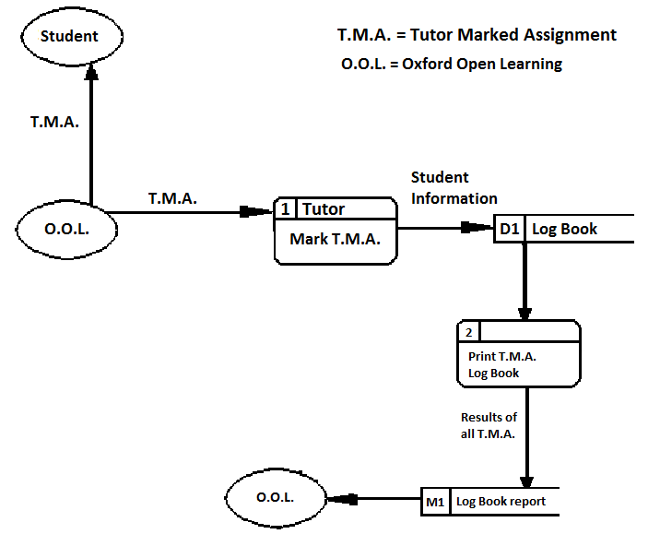

Fig.8 Data flow diagram level 1

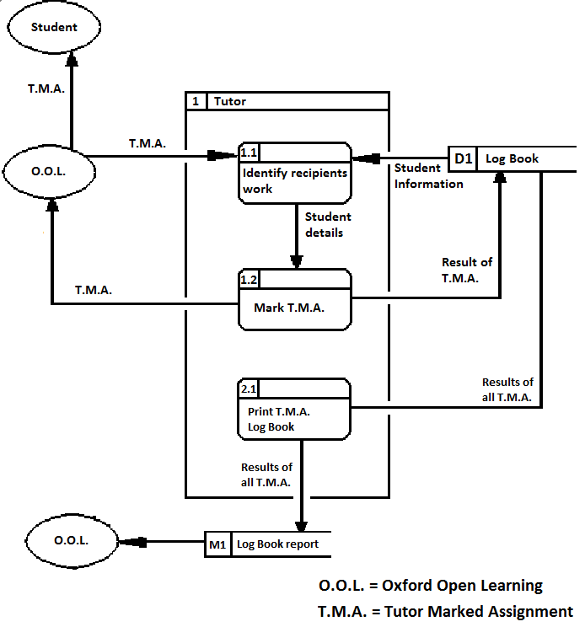

## Data sources, stores and destinations for the proposed system

#### Documents

* **Tutor Marked Assignments (TMA’s)** – These are assignments sent to the tutor by post from the student via **O.O.L.**, which the tutor has set for the student which have to be completed within a certain date. A mark is gathered from these and inputted into the system.
* **Printed T.M.A. report** – These are based, and contain all the information from the current systems Log Book TMA. The tutor selects a student then clicks the print report button which displays a report about that selected student.
* **Printed Contact report -** These are very similar to the TMA report, again based on the current system and a report is generated in Microsoft word when a button is pressed.

#### Stores

* **Student’s data, from a Log Book** – This will come from Oxford Open Learning and provide all the data about a student that a tutor will receive. The tutor will enter this data into the system and it will be used for searching and keeping track of the student.

#### Sources

* **Oxford Open Learning Tutor** –They will be able to edit any information about any student in an easy to use environment with search boxes that displays a list of all the students with the desired searched category. They will give example questions and answers for the student by email or phone call.
* **OOLCourse** – This contains example questions and answers that will be used when answering student’s queries.

#### Destination

* **Tutor** – Once the data is entered into the system the tutor will be able to receive these outputs of the system:
* **Student** – Once the marked TMA has been returned to them they will have an analysis of their work reviewed with the result.
* **Oxford Open Learning -**  They receive the printed reports and calculate pay for the tutor based on the contact times.

## System flow chat diagram of proposed new system

Fig.9 system flow chart of proposed system

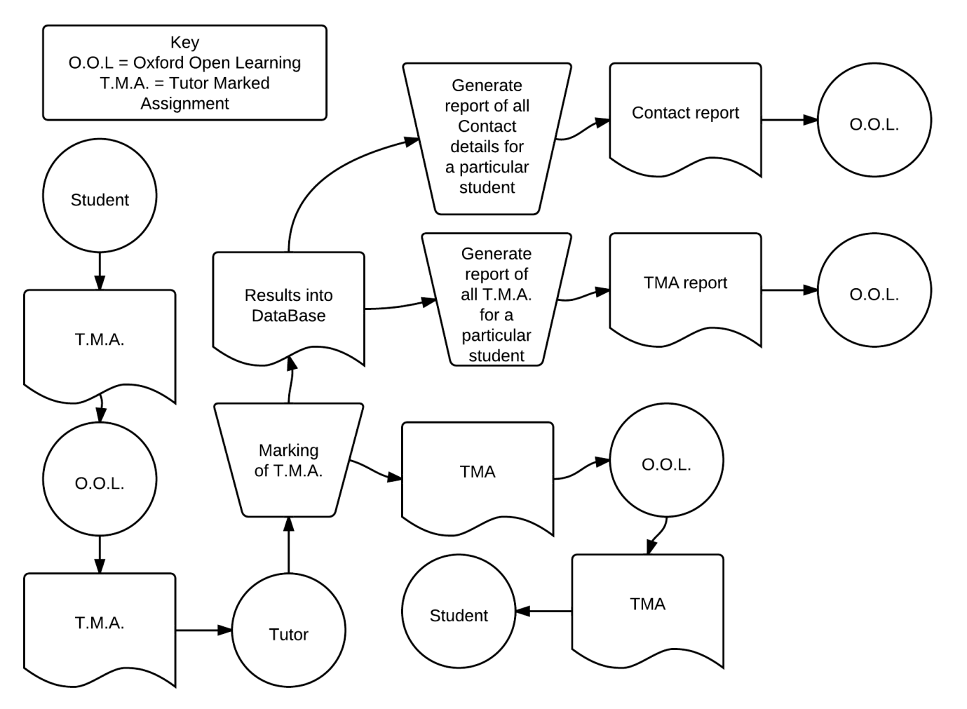

## Description of operations and entities

The different symbols in the dataflow chart are divided into sections below:

#### Operation

* **Marking of a T.M.A.** – This is a process done by the tutor where the Tutor Marked Assignment is received, the grade, comment and date of marking are recorded into the Database and the marked T.M.A. is sent to the student via **Oxford Open Learning**.
* **Generate reports of T.M.A./Contact** – These are generated using the results of TMA from a particular student, which have been stored on a database where the tutor has once entered in that information based upon TMA the student has submitted.

#### Entities

* **Student** – Produces work relating to pre-set assignments the tutor sets. Each T.M.A. relates to a letter in which the student methodically goes through until they finish the course. Will produce these once a month and be contacted by the Tutor weekly or otherwise based on their performance.
* **Tutor** - Marks T.M.A., records the grade and contacts the student with a comment on their performance. Contact times are recorded in the students **Log Book** on the database.
* **Oxford Open Learning (O.O.L.)** – Issues new students and the corresponding **Log Book** to the Tutor, as well as posting T.M.A. to and from students and their tutors.

#### Documents

* **T.M.A.** – Work that particular students have done, will contain a grade on the current work when the process of marking the work has been completed by the Tutor.
* **Results into Database** – These are the resulting grades and comments for the students work, stored into tables on a database for each student.
* **Printed T.M.A. Report –** This contains information about the TMA of a particular student that the tutor has defined before printing
* **Printed Contact Report** – This contains information about the contact details of a particular student,

## Entity relationship diagram – Normalized database (3NF)

This shows the proposed system entity relationships between each table in the database, note the use of a compound primary key between ‘tblStudentCourse’ – ‘tblContact’ and –‘tblStudentTMA’. This is a combination of the 2 foreign keys in ‘tblStudentCourse’ from ‘tblStudent’ and ‘tblCourse’ creating a unique set of numbers and creating a compound primary key. From the ERD below you can see that the database is fully normalized with no non-key dependencies and no redundant data.

Fig.10 entity relationship diagram

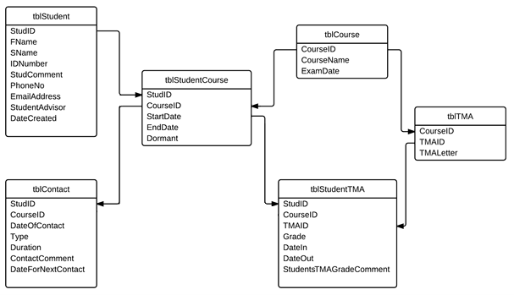

## User Data dictionary

This features information based upon the research and analysis of the system.

|  |  |  |  |
| --- | --- | --- | --- |
| Name | Comment | Range | Validation |
| Log Book, T.M.A. | Contains information about the T.M.A. the student has completed | Paper file | N/A |
| Log Book, Contact | Contains information about the contact with the student, (listed below) | Paper file | N/A |
| Laptop | The use of which the tutor sends and receives email from. | 1200x800 screen resolution | N/A |
| Student first name | The first name of the student. | All alphabetic characters including “-“ | Used when searching for a student. |
| Student second name | The second name of the student. | Same as First Name | “ “ |
| Student ID Number | Will be in a numerical form, not to be confused with Student ID | Number of max 10 characters | “ “ |
| Student Comment | A description about the overall performance or notes on or about the student | Will be text of large length | N/A |
| Phone Number | The phone number used to contact the student. | This will be numerical character of length 11 | N/A |
| Email Address | The email address used to contact the student. | Will contain an ‘@’ symbol | N/A |
| Student Advisor | The advisor assigned to the particular student. | A name of the Student advisor | N/A |
|  |  |  |  |
| Course Name | The name of the course the student is on. | Must be one of the courses from the list. | For searches to see what student belongs to certain courses. |
| Exam Date | Relates to Course | Will be the date of the exam on the course the student is on | N/A |
| Start Date | The start date of the course the students on | A date when the student enrolled on the course | N/A |
| End Date | The end date of the course the student is on | The end date the student is due to leave the course | N/A |
| Name | Comment | Range | Validation |
| Dormant | After 3 months of no contact with the student, then dormant becomes true | True or false | Searching won’t cover dormant students but the option to search for dormant students will be available |
| TMA Letter | Letter corresponding to the current module of work assignment that the student has currently sent to the tutor | A Letter from A – J for Geography and  A – O for mathematics years 7,8,9 | Must be a letter |
| Grade | Will be in percentage format for GCSE grades.  80% >= A*  70% = A  60% = B  50% = C  40% <= D | Between 0 to 100 | Will be in percentage format |
| Date In | The date the Tutor receives the T.M.A. | A date | N/A |
| Date Out | The date the T.M.A. leaves the Tutor | “ “ | N/A |
| Students TMA Grade Comment | The Tutors description on a particular T.M.A. and their thoughts on the grade of that T.M.A. | A paragraph of text | N/A |
| Date of Contact | What date and time did the student either phone/email or interact with the tutor. | A date | N/A |
| Type | Telephone –T  Email – E  What contact did the tutor use. | A Letter T or E | N/A |
| Duration | A length where the tutor spent time with the student | A integer, relating to time in minutes | N/A |
| Contact Comment | Comment on how the contact with the student went. | A small paragraph of text | N/A |

# 4. List of S.M.A.R.T. Objectives for the proposed system

After taking into account for my user requirements, with the current and proposed system analysis, I produced a set of objectives which I thought feasible and able to achieve within the user needs. They are summarised below:

## Process Requirements

The System must be able to:

1. Display a list of student details into a grid. These include the date each student record was created, the first, second name of each student and the corresponding course name for each student,
2. Enable the user to select a student from the grid and more in depth details about the selected student are displayed, such as a comment about the student and the student ID of the selected student,
3. Display in a similar grid the **Tutor Marked Assignments** details corresponding to the selected student when a button is pressed. These are the **T.M.A.** grade, the **T.M.A.** letter number that relates to the grade and the date in and out dates for each **T.M.A.,**
4. Calculate the average grade of student results for each **T.M.A.** and display a percentage and grade for each students **T.M.A.**
5. Create a new **T.M.A.** record for the selected student based on the input values by the tutor,
6. Display in another grid the **Contact** details relating to the selected student. These are the times the tutor has interacted with the student, the type of the contact, the length of the contact, the date and the next expected date for another contact,
7. Create a new Contact record for the selected student, specific to the inputted values by the tutor,
8. Enable the user to create a new student record based on values entered by the tutor,
9. Make a student record **Dormant** when they haven’t produced work or responded with the tutor in a 3 month period,
   * Reactivate **Dormant** student records when they contact the tutor again via email or post within a year
10. Print a **Log Book T.M.A.** sheet with all the **T.M.A.** details relating to a particular student, make the report similar to the current system  **T.M.A. Log Book**
11. Print a **Log Book** Contact sheet with all of the details of a particular student, again have a similar report to the current system
12. Have support for the storage of old students who have completed their course, but these must not normally be displayed when viewing students.

#### Acceptable Limitations

* Email will not be embedded into the program because the addition of the feature will be more of a hassle from the users perspective than outlook expresses would,
* The electronic data transfer between **Oxford Open Learning** and the Tutor will not be dealt with, although please note that physical incoming **Log Books** from **Oxford Open Leaning** will be used.
* The system will only retain assignment outcomes, not the actual assignments in paper form.
* The printed report will contain all of the information about any particular student and will be as near the current system **Log Book**, but the exact style may not match

## Inputs, outputs and processes for the proposed system

#### System inputs

* **Log books** detailsfrom **Oxford Open Learning** containing details of a student including information listed above in the data dictionary, entered by the tutor.
* New **T.M.A.** and **Contact** details for a particular student, entered by the tutor.
* Database of stored student information.

#### System Processes

* Store the inputted information into a database
* Display selected students **T.M.A.** and Contact details
* Generate a report for a selected students **T.M.A.** or **Contact** details

#### System Outputs

* Display a list of student information including contact details and that particular students**T.M.A.**
* **T.M.A.**  reports of a particular student
* **Contact** reports of a particular student
* Database, storing the records of the above

#### Tutor Processes

* Marking **T.M.A.**

#### Tutor Outputs

* Marked **T.M.A.**delivered to the corresponding student via **Oxford Open Learning**
* Result of marked work including TMA letter and grade
* Email and phone calls to the students assisting them with their queries
* Result of the above, meaning the type of contact, length and a comment about the contact.

#### Performance requirements

The technical equipment used by the tutor is minimal, with a standard laptop with a 1280x600 screen monitor resolution. However the tutor uses approximately 6 large A4 files to store the current 80 student **Log Books** which are filling the only available work space the Tutor has. Based on this research the performance requirements are as follows:

1. Application to not exceed a 1280x600 monitor resolution
2. Computer is running on Microsoft Windows XP Professional
3. Database must store the necessary student records described below
4. Speed is quite important as any ‘hiccups’ will result in the decrease of work speed, so the application must be efficient in time.
5. Physical files should not exceed 6 because there is minimal space for storage.

# 5. Data Volumes

The proposed system first creates a record in the students table on a database for each student inputted by the tutor. Because the requirements wanted past tracking of student data, the maximum number of records is greater than the current students of 80. The tutor receives new students every year, which hence implies 80+ records per year.

On average a record takes up around 16b so for 100 years that gives

8,000+ records = 128,000 b

128,000b/1024 = 1101.56 kb

1102kb / 1024 = 1.099 mb

A Microsoft Jet Engine database can fit up to 2GB of space, therefore the maximum amount of space above can easily fit onto a Microsoft Jet Engine database, which is why I have chosen this preferred method for data storage.

The program could be stored on a flash drive where the capacity (2GB) would be large enough to fit the application and database files onto. But because the user has a laptop, the practicality of a flash drive always ‘sticking out the side’ has made me choose the laptops hard disk drive.

#### Hardware Specification

* Keyboard – used to input student data into the system
* Mouse – used to interact with forms
* Visual Display Unit – displays the student details from the application and the report
* Hard Disk Drive (HDD) – to store the database and the application
* Printer – to print out the TMA and contact reports

# 6. Overall Break-down of solutions

## Manual (Pre-Existing solution)

The current system: as documented above, involves the tutor sorting out details and **T.M.A.** grades of the assigned students into **Log Books** which contain **Tutor Marked Assignments** and contact times.

The advantages of this current system are:

* Minimal IT knowledge required, compared with the solutions below
* Only have one state of data (paper)

Disadvantages:

* User has to check through the entire data of students sheets to find whether the student needs to be contacted again or whether their **Tutor Marked Assignments** need checking, this is quite labour intensive and gets more difficult when the amount of records increase.
* Tutor has no record store of the past students because they send their only data copy to Oxford Open Learning
* Potential chance of data loss, because the data is only in a paper format.
* Minimal data storage, because when the record amounts increase, so does the physical paper storage, where from the process requirements there is limited space

This is currently quite efficient, although with the increase in student records it will become difficult to maintain the amount paperwork required for each student. This is the main reason the analysis points to a programmed solution.

## Off the shelf software

This software is easily immediately available to the Tutor, but with that missing degree of familiarity and individuality a bespoke application has to offer. Some of the latest available software that can be used to solve this problem are listed below:

#### **Microsoft Access**

Advantages:

* Useful tools or reports can be built in short spaces of time.
* Can create a fully functional database to solve the proposed problem

Disadvantages:

* Is a little susceptible to quirky operations, such as an odd mouse click
* Very different to the current system in place, i.e. lots of buttons which are irrelevant from the users point of view, which is annoying and makes the program difficult to use.

Fig. 11 Microsoft Access

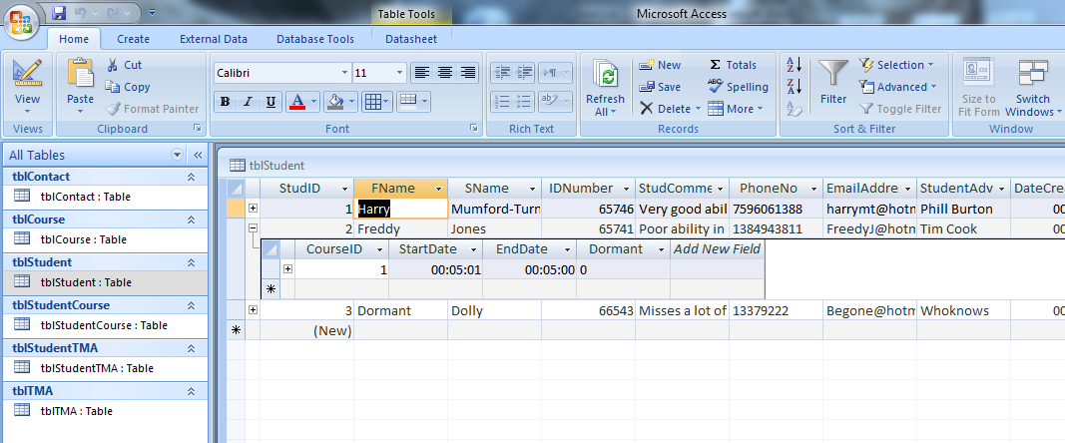

Although Access can be classed as a valid solution, as I said before, it just doesn’t have the individuality that a bespoke application has on offer.

## Programmed Solutions

There are several bespoke programmed solutions for this problem, the advantages and disadvantages of a few important ones are listed below:

#### **Delphi**

Advantages

* Is able to support a good user interfaceex. able to drag and drop objects and attach functions to various buttons and other on-screen elements.
* Is able to manipulate with databases well so could provide an adequate route for this particular avenue

Disadvantages

* Based on my personal knowledge of Delphi, I feel that I do not have sufficient skills to program using this language
* Lack of integration with the Microsoft Office environment

#### **Visual Basic**

Advantages

* Supports similar features as Delphi i.e. is able to manipulate with databases well
* Widely support language, so support for the technical solution after the current project is available
* Will tailor to the end-user’s requirements closer than the previous solutions based on my current skill level of the language
* High integration with Microsoft Office, with programmatic access to the MS Office environment

Disadvantages

* The Applications which are developed in visual basic are limited to Windows Operating Systems, but based on the current user requirements this is not an issue

#### **Web based** solution, using software hosted on an external server

Advantages

* The tutor could access the students anywhere (where there was internet access)
* No data on disk, ‘Cloud’ environment, easy to access

Disadvantages

* Lack of features based on more technical coding ability
* Cost of hosting a server with the software running on
* Security issue with sensitive students data would be a disadvantage but because the program deals with one user this isn’t necessary
* As a counter option to the first advantage; the Tutor would not be able to view the details without the internet.

# 7. Justification of the chosen solution

After carrying out my observation of the users processes, analysing the current/proposed system and discussing with my end-user, I have chosen a solution. This solution will be coded in the language Visual Basic.

I shall be storing the student’s data using DDL, and DML for the generation of the database through the Microsoft Jet engine. Although the application should be able to support other databases for wider use of the program, so the implementation should meet this necessary requirement.

The reports will be transferred to the program ‘Microsoft Word’ where the user can then print the generated report.

I have rejected the non-bespoke solutions because they lack that missing degree of familiarity and individuality a bespoke application has to offer. The language was chosen, based on my experience in programming with it before and I feel it will easily tailor to the end users needs based on this particular problem. It also is an easy language to understand in English, which makes it very maintainable for other programmers to use the source code for after the project.

Design Contents

1. Overall System Design 28

2. Modular Structure of system 29

Brief System Flow Chart 29

Full System Flow Chart 30

Hierarchy chart 32

3. Identification of suitable algorithms 33

Pseudo-code 34

Revised Entity relationship model 43

Database dictionary 43

Design Data dictionary 47

5. User interface design 52

HCI 52

Relationship between each form 59

User Interface Design Rationale 60

6. System Security 61

7. Test Strategy 61

# 1. Overall System Design

#### Overview

The application to be designed is one which stores information about the student and information on their current and existing work into a database using the Microsoft Access Jet Engine version 12.0. Although supporting other databases must be implemented for the possibility of using the program for different users with other databases, this will be established by only changing a small part of the application, so it must be programmed to fit this requirement.

The reports will be generated and displayed using Microsoft Word, Visual Basic (VB.NET) will be used to code the application and a single user, the tutor will use this application to input and extract data about the students and their assignments.

The program should enable (the one single) user to; view displayed records for all students or a particular student’s current Tutor Marked Assignment, create new records for new students, and update records for existing students. The user can then choose to print a detailed sheet about a particular student, which contains all of the selected students Tutor Marked Assignments or the contact details.

# 2. Modular Structure of system

Below are various diagrams displaying the structure of the proposed system.

## Brief System Flow Chart

Below is a brief display of the system flow chart. This contains no inputs and outputs to create a cleaner presentation.

Fig. 12 the brief system flow chart

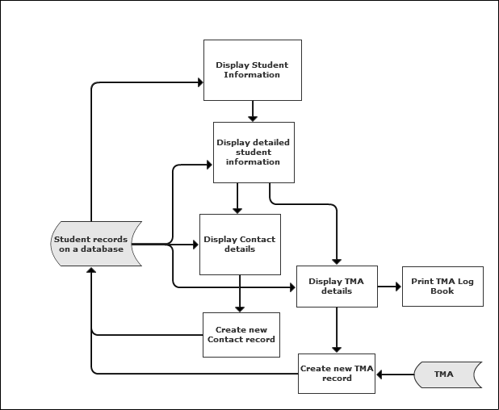

## Full System Flow Chart

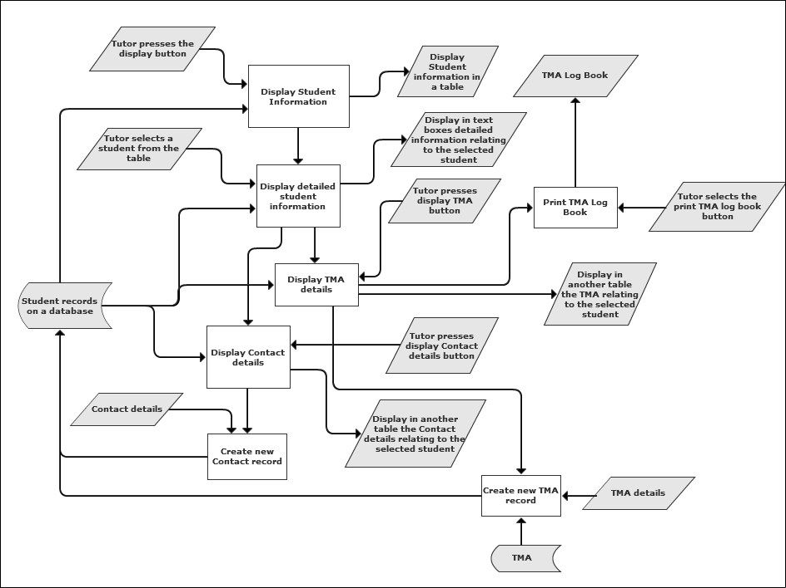Fig.13 the full system flow chart

#### Processes

* **Display Student information** – Uses the information previously entered in by the user, from the Database
* **Display detailed student information**– Using the information from the displayed grid, more detailed student details are presented in text boxes, such as the StudentComment
* **Display contact details**– Using information from the database the contact details for the selected student are displayed in another tab
* **Display T.M.A. details**– similar to the contact details, these are displayed using information from the database based on the selected student
* **Print T.M.A. log Book**– The user prints a **T.M.A.** Log book which contains information from the data base regarding the selected student
* **Create new T.M.A. record/ Create new contact record**– A new record in the database is created based upon values the user enters in,

## Hierarchy chart

#### First Tier

Fig.14 Hiarachy chart

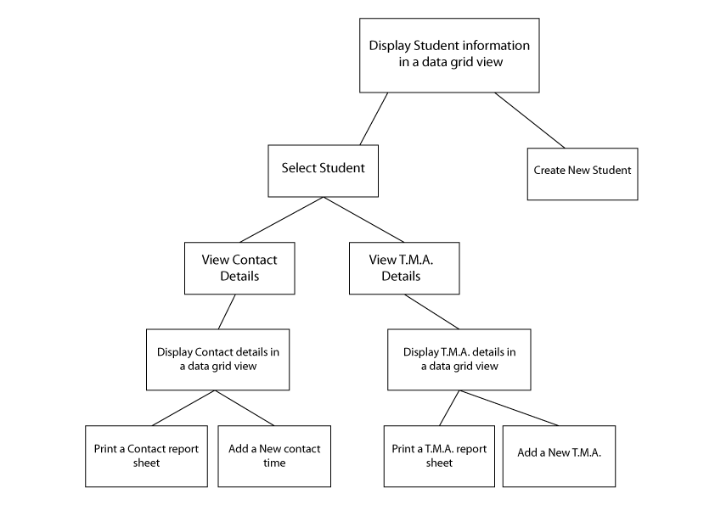

# 3. Identification of suitable algorithms

Looking at the previous system flowcharts and structure chars, the projects requires the production and use of a few algorithms.

Here is the list of algorithms required:

1. **CheckDatabaseExists** – Runs a check on the directory and what button has been pressed to see if the database exists
2. **PopulateDataSetandDataTables**- Populates the dataset and tables with the corresponding table in the database
3. **DisplayStudentsInfo**– Displays the course name, comment, ID number, date the record was created, FName and SName relating to each student in the database
4. **DisplayTMAInfo** – Displays the relating TMA information about the selected student
5. **SetExamDate** – Displays the correct exam date using their start date and coursename
6. **SetCorrectTMALetters** – enables the user to only enter in the correct TMA letters based on the course that students on
7. **AddNewTMA** – Adds a new TMA to the selected student using relationships with the database
8. **DisplayContactInfo** – Displays the relating Contact information about the selected student
9. **AddNewContact** – Adds a new Contact record to the selected student using relationships with the database
10. **CreateNewStudent** – Creates a new student record in the database with the given values
11. **PrintTMALogBook** – Gets the data of the selected students Tutor Marked Assignments and transfers it to a Microsoft word document ready to be printed by the user
12. **PrintContactLogBook** -Gets the contact data of the selected student and transfers it to a Microsoft word document ready to be printed by the user

## Pseudo-code

#### CheckDataBaseExists

**When** Button Create Database is pressed

**Let** CreateDB = true

CheckDatabaseExists(CreateDB)

**When** Button Display Students is pressed

**Let** CreateDB = false

CheckDatabaseExists(CreateDB)

**CheckDatabaseExists**

**Let** DBPathName = DatabaseName textbox

**If** DBPathName exists **And** CreateDB = true **then**

Let “Database already exists” be displayed

DatabaseName textbox &“ new”

**Else If** DBPathName exists **And** CreateDB = false **then**

Return

**Else** CreateDatabase

**End if**

If the directory exists and the user has clicked the create DB button then a message box is displayed informing the user and 'new' is added to the filename

If the database does exist and the user clicked on the Display Students button then simply return or if the database really does not exist then create it using the Create Database subroutine.

#### PopulateDataSetandDataTables

**Let** DA = Data adapter

**Let** DS =Data Set

**Let** Com = DatabaseCommand

**Let** Con = Data base Connection

Con = open

**For i = 0 To**TablesInDatabase.max – 1

DA.Com = “SELECT ALL RECORDS FORM TABLE (i)”

Fill Table(i) in DS with DA.Com

Add to DA Mappings for each table name

**Next i**

Con = close

Add to DS relations

Student and StudentCourse

Student and Contact

Course and StudentCourse

Course and TMA

TMA and StudTMA

**Let** array(0,1) = Table(StudID, CourseID)

**Let** array(1,0) = Table(CourseID, StudID)

Add to DS relations array(0,0) and array(1,1) for

StudentCourse and StudentTMA

Form a connection string to use when opening the database connection. A dataset is filled with multiple data tables and mappings are relations are added for each table name. Indexes are added in the form of keys, an array of data columns is created where the 2 primary keys are held.

#### DisplayStudInfo

**Let** DTAllStud = DataTable

DTAllStud = FillDTWithSpecificColumns()

**Let** StudCourseRow = DataRow

**Let** CourseRow = DataRow

**Let** StudRow = DataRow

**For Each** StudRow In table Students Rows

**For each** SCrow in Table StudentCourses where StudID = StudRow

**For each** SCrow in Table Courses where CourseID = SCrow CourseID

**Let** NewRow = DataRow

NewRow = StudID, CoureID, FName, SName, StudentNumber, DateCreated, CourseName, StudentNumber,StudComment,

NewRow = DTAllStud add NewRow

DataGrid = DTAllStud

DataGridColumns.Hide = StudComment,StudID,CourseID,StudentNumber

Define a temporary data table where information from each table will be held, this is filled with the appropriate column. The CourseID is located for each student, each row in the datatable students is checked to see if the StudID and CourseID match in datatable StudentCourses.

If they do then add a new row to the 'AllStud' datatable based on the other records in the matching course row. Finally a “View” on the data is used to access the temporary datatable and is displayed in the datagrid view.

#### DisplayTMAInfo

**Let** DTofTMA = DataTable

DTofTMA = FillDTWithSpecificColumns()

**Let**StudTMArow = DataRow

**Let** TMArow = DataRow

**For Each** StudTMArow In Table Student TMA where StudID = StudentID.Selected Student

And CourseID = CouseID.selected Student

**For Each** TMArow In Table TMA

Where TMAID = StudTMArow TMAID

And CourseID = CourseID.Selected Student

**Let** NewRow = DataRow

NewRow = TMAID, StudID, CourseID, TMALetter, Grade

NewRow = DTofTMA add NewRow

DataGridTMA = DTofTMA

DataGridTMA.hide Column: StudID, CourseID, TMAID

Cycles through each student’s TMA and extracts the information from it.

#### SetExamDate

**Let** CourseName = User input text

**Let** SelectedStudent == SS

**If** CourseName = Mathematics Year 7, 8, 9 **Then**

**If** SS.StartDate = June to Dec **Then**

SS.ExamDate = + 1 calender year

**Else If** SS.StartDate = Jan to May **Then**

SS.ExamDate = + 2 Calender years

**And if** CourseName = Geography **Then**

**Let** DateDifference: TodaysDate - SS.StartDate

**If** DateDifference < 1 calender year **Then**

SS.ExamDate = + 2 Calender year

**Else If** DateDifference < 2 calender years **Then**

SS.ExamDate = + 1 Calender year

SS.ExamDate.Display

Sets the exam date by finding the difference in date and based on today’s date sets the exam date for that student.

#### SetCorrectTMALetters

**Let** CourseNameRow = DataRow

**For Each** CourseNameRow In Table Courses **where** CourseID = SS.CourseID

**Select Case** CourseNameRow.CourseName

**Case** "Mathematics Year 7" To "Mathematics Year 8"

**For Each** c In "ABCDEF".ToCharacterArray()

**If**  c = TMALetter **Then**

Let AddTMALetters = True

**ElseIf** TMALetter = “Null” **Then**

TMA Letter Item array.add c

**Else**

**If** AddTMALetters = true **Then**

Add c to the combo box

**Next** c

**Case** "Geography 1" Or "Geography 2"

**For Each** c In "ABCDEFGHIJ".To Character Array()

TMA Letter Item array add c

**Next** c

Fills the combo box with the correct TMA Letter Names depending on what course that student is on.

#### AddNewTMA

**Let** largestTMAID = 0

Table TMA Sort By the TMAID in DESCENDING order

largestTMAID = DTTMAS Top TMAID

**Using DA** INSERT INTO tblTMA (CourseID, TMAID, TMALetter)

VALUES (DTofSS.CourseID, largestTMAID + 1)

DA.Update(DTTMAS)

**Using DA** INSERT INTO tblStudentTMA (StudID, CourseID, TMAID, Grade, StudentsTMAGradeComment)

VALUES (StudentID, CourseID, largestTMAID,Grade TMAComment)

DA.Update(DTStudentTMAS)

Finds the highest TMAID value and inserts a new record into the database based on the user entered values

#### DisplayContactInfo

**Let** DTofContact = DataTable

DTofContact = FillDTWithSpecificColumns()

**Let** Contactrow = DataRow

**For Each** Contactrow In Table Contact where StudID = StudentID.Selected Student

**Let** NewRow = DataRow

NewRow = StudID, DateOfContact, Type, Duration, ContactComment, DateforNext

NewRow = DTofContact add NewRow

DataGridContact = DTofContact

DataGridContact.hide Column StudID, ContactComment

ContactComment = TextBoxComment

Finds the highest ContactID value and inserts a new record into the database based on the user entered values

#### AddNewContact

**Let** largestStudID = 0

Table Student **Sort**By the StudID in DESCENDING order

largestStudID = Table Student Top StudID

**Using DA** INSERT INTO tblStudentTMA (StudID, DateOfContact, Type, Duration, ContactComment, DateforNext)

VALUES (largestStudID + 1, DateOfContact, Type, Duration, ContactComment, DateforNext)

DA.Update(DTContact)

Finds the largests StudID and creates a new Contact record based on values entered in by the user.

#### CreateNewStudent

**Let** largestStudID = 0

Table Student **Sort**By the StudID in DESCENDING order

largestStudID = Table Student Top StudID

**Using DA** INSERT INTO tblStudent (StudID, FName, SName, StudentNumber, DateCreated, StudentNumber,StudComment)

VALUES (largestStudID + 1, FName.textbox, SName.textbox, StudentNumber.textbox, Date.Today, Type.textbox, Duration.textbox, ContactComment.textbox, DateforNext.datetimepicker)

DA.Update(DTStudents)

Finds the largests StudID and creates a new student record based on values entered in by the user.

#### PrintTMALogBook

**Let** oWord = Word application create

**Let** oPara1 = document add paragraph

oPara1 text = "T.M.A. Details for Student: " & StudentName & " -- " & Student ID number

oPara1 = bold

**Let** MaxRows = DatagridTMA rows count

**Let** oTable = add to document with rows of MaxRows and 4 columns

oTable enable borders

oTable.Cell(1, 1).Text = "TMA Letter"

oTable.Cell(1, 2).Range.Text = "TMA Grade"

oTable.Cell(1, 3).Range.Text = "Date In"

oTable.Cell(1, 4).Range.Text = "Date Out"

**For** r = 2 To MaxRows + 1

**For** c = 1 To 4

oTable.Cell(r, c).Text = DatagridTMA.Rows(r - 2).Cells.Item(c - 1).Value

**Let** oPara2 = Document add another paragraph

oPara2 text = "Subject: " & Course

**Let** oPara3 = Document add another paragraph

oPara2 text = "Tutor: Lesley Mumford"

**Let** oPara4 = Document add another paragraph

oPara2 text = "Intended Exam Date: " & ExamDate

Creates a word application and inserts a header in bold. Get the maximum row count in the datagrid and create a table based on the row count. Insert sub text at the end of the document.

#### PrintContactLogBook

**Let** oWord = Word application create

**Let** oPara1 = document add paragraph

oPara1 text = "Contact Details for Student: " & StudentName & " -- " & Student ID number

oPara1 = bold

**Let** MaxRows = DatagridContact rows count

**Let** oTable = add to document with rows of MaxRows and 4 columns

oTable enable borders

oTable.Cell(1, 1).Text = "Date Of Contact"

oTable.Cell(1, 2).Text = "Type"

oTable.Cell(1, 3).Text = "Duration"

oTable.Cell(1, 4).Text = "Date for Next Contact"

**For** r = 2 To MaxRows + 1

**For** c = 1 To 4

oTable.Cell(r, c).Text = DatagridContact.Rows(r - 2).Cells.Item(c - 1).Value

**Let** oPara2 = Document add another paragraph

oPara2 text = "Subject: " & Course

**Let** oPara3 = Document add another paragraph

oPara2 text = "Tutor: Lesley Mumford"

**Let** oPara4 = Document add another paragraph

oPara2 text = "Intended Exam Date: " & ExamDate

Creates a word application and inserts a header in bold. Get the maximum row count in the datagrid and create a table based on the row count. Insert sub text at the end of the document.

## Revised Entity relationship model

Based upon information in the analysis, the ERD model needed to be revised. The columns, ‘ExamDate’ from tblCourse and ‘StudentAdvisor’ were removed from the database. This was decided from the information about how each column was to be used in the program.

The Exam date is calculated using a algorithm which uses the date the student record was created and adds years to the date depending on what course the students on (CourseName). The exam date was originally stated for the printed **T.M.A. Log Book report** and the tutor to view at their own reference. But because the **Log Book report** was sent to **Oxford Open Learning** and the tutor didn’t need to know the exact month only the year, the month wasn’t needed. Because each course has a separate exam date year, this can be calculated using the above algorithm. This meant that the ‘ExamDate’ was redundant data in the database, so it was removed.

The Student Advisor is the personal student’s teacher assigned to them to advise them on what courses they should take next, etc. This wasn’t needed by the tutor and so was only used for the **Log Book reports** similar to the Exam date, **O.O.L.** didn’t need this information so the ‘StudentAdvisor’ was removed from the database.

The compound primary key between tblContact wasn’t needed because the contact details didn’t depend on what course the student was on, so it only needed information from the student table.

Fig.15 The revised Simple ERD

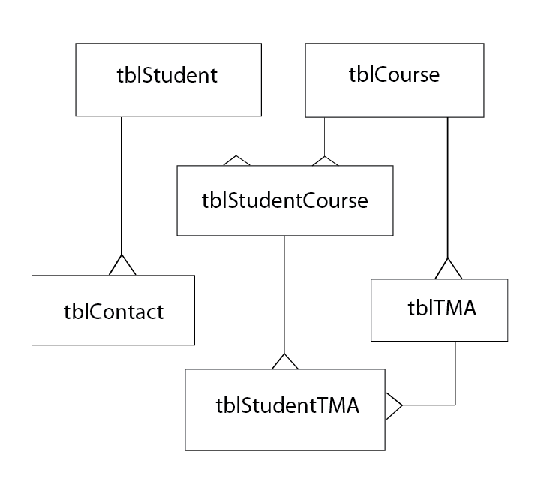

Fig.16 The revised ERD model

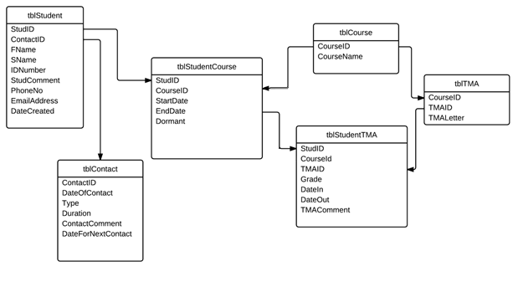

## Database dictionary

|  |  |  |  |  |  |
| --- | --- | --- | --- | --- | --- |
| Table | Name | Data Type | Char Length | Validation Required | Description |
| Student | StudID | Long | Max | Primary Key | Used to get the contact details about a particular student |
| “ | FName | String | 60 | None | The first name of the student |
| “ | SName | String | 60 | None | The second name of the student |
| “ | IDNumber | Integer | 6 | None | The Students ID number not to be confused with StudID |
| “ | StudComment | String | 200 | None | A comment about a particular student |
| “ | PhoneNo | Integer | 15 | None | The contact phone number of the student |
| “ | EmailAddress | String | 40 | None | The contact email address of the student |
| “ | DateCreated | Date | DD/MM/YYYY | Checked in ‘ExamDate Algorithm’ | Will be set to the day that the record was created |
| Course | CourseID | Long | Max | Primary Key | Used to identify what course a particular student is on |
| “ | CourseName | String | 20 | None | The name that the course is on |
| Student Course | StudID | Long | Max | Foreign key to tblStudent – used as a compound primary key to tblStudentTMA | Used as a compound primary key to tblStudentTMA to find the grade that a particular student has for a particular TMA on a particular course. |
| “ | CourseID | Long | Max | Foreign key to tblStudent | Used as a compound primary key to tblStudentTMA |
| “ | StartDate | Date | DD/MM/YYYY | Checked in ‘ExamDate Algorithm’ | The Start date of the student on the course |
| “ | EndDate | Date | DD/MM/YYYY | Checked in ‘ExamDate Algorithm’ | The end date of the student on the course this will be 1 year from start date or 2 years if they are on geography 2 |
| “ | Dormant | String | 5 | Checked in ‘Display  Students Algorithm’ | Used by the above ‘Display students algorithm’ represents a Boolean value, but as a string, so if it is true the record isn’t displayed unless specified. |
| TMA | CourseID | Long | Max | Foreign key to tblCourse | Used to find what course the TMA is on |
| “ | TMAID | Long | Max | Primary Key | To find what grade a particular TMA is worth |
| “ | TMALetter | String | 1 | A single Letter | The Letter of a Tutor Marked Assignment |
| Student  TMA | StudID | Long | Max | Foreign key to tblStudentCourse | Used as a compound primary key to find the grade that a particular student has for a particular TMA |
| Table | Name | Data Type | Char Length | Validation Required | Description |
| “ | CourseID | Long | Max | Foreign key to tblStudentCourse | “ |
| “ | TMAID | Long | Max | Foreign key to tblTMA | “ |
| “ | Grade | Integer | 3 | Used in ‘Calculate average grade algorithm’ | The grade of the TMA letter |
| “ | DateIn | Date | DD/MM/YYYY | Date today | The date the TMA was received by the tutor |
| “ | DateOut | Date | DD/MM/YYYY | 1 week from datein default | The date the TMA leaves the tutor ( defaults to 1 week from date in) |
| “ | StudentsTMA  Grade  Comment | String | 200 | none | The comment about a TMA |
| Contact | StudID | Long | Max | Foreign key to tblStudent | Used to find contact details with the student |
| “ | DateOf  Contact | Date | DD/MM/YYYY | Date when record is created | The date the Tutor contacted the student |
| “ | Type | String | 1 | None | The type of contact with the student telephone or email |
| “ | Duration | Integer | 3 | None | The length of the contact |
| “ | Contact  Comment | String | 200 | None | A comment on how the contact went |
| “ | DateForNext  Contact | Date | DD/MM/YYYY | Default to 1 week in advance | The date for a next contact time |

## Design Data dictionary

|  |  |  |  |
| --- | --- | --- | --- |
| **Variable Name** | **Datatype** | **Planned to go In subroutine:** | **Description** |
| SSStudentID | Integer | None Global | The selected students Student ID |
| SSCourseID | Integer | None Global | The selected students CourseID |
| SSTMAID | Integer | None Global | The selected students TMA ID |
| DTStudents | DataTable | CreateDatabase | The table which represents the table in the database |
| DTCourses | DataTable | CreateDatabase | The table which represents the table in the database |
| DTStudentCourses | DataTable | CreateDatabase | The table which represents the table in the database |
| DTContacts | DataTable | CreateDatabase | The table which represents the table in the database |
| DTTMAS | DataTable | CreateDatabase | The table which represents the table in the database |
| DA | OleDbDataAdapter | CreateDatabase | The main data adapter which communicates with the database |
| DS | DataSet | CreateDatabase | The dataset which contains the above tables |
| oleCom | OleDbCommand | CreateDatabase | The command to execute the communication with the database |
| oleCon | OleDbConnection | CreateDatabase | The connection “gateway” to the database |
| adoxDB | ADOX.Catalog | CreateDatabase | The creation of the database |
| adodbCon | ADODB.Connection | CreateDatabase | The connection to define where to create the database |
| adodbCom | ADODB.Command | CreateDatabase | The command to decide how to create the database |
| DatabasePathName | String | CreateDatabase | The path to where the database will be created |
| SQL | String | CreateDatabase | The sql querry string |
| StudentIDColumn | DataColumn | DisplayStudents | The corresponding column used in the view |
| FirstNameColumn | DataColumn | DisplayStudents | The corresponding column used in the view |
| SurNameColumn | DataColumn | DisplayStudents | The corresponding column used in the view |
| DateCreatedColumn | DataColumn | DisplayStudents | The corresponding column used in the view |
| StudCommentColumn | DataColumn | DisplayStudents | The corresponding column used in the view |
| CourseIDColumn | DataColumn | DisplayStudents | The corresponding column used in the view |
| **Variable Name** | **Datatype** | **Planned to go In subroutine:** | **Description** |
| CourseNameColumn | DataColumn | DisplayStudents | The corresponding column used in the view |
| StudentNumber  Column | DataColumn | DisplayStudents | The corresponding column used in the view |
| StartDate | DateTime | DisplayTMA | The start date of the TMA |
| TMALetterColumn | DataColumn | DisplayTMA | The corresponding column used in the view |
| TAMGradeColumn | DataColumn | DisplayTMA | The corresponding column used in the view |
| DateInColumn | DataColumn | DisplayTMA | The corresponding column used in the view |
| DateOutColumn | DataColumn | DisplayTMA | The corresponding column used in the view |
| TMAIDColumn | DataColumn | DisplayTMA | The corresponding column used in the view |
| StudIDColumn | DataColumn | DisplayTMA | The corresponding column used in the view |
| CourseIDColumn | DataColumn | DisplayTMA | The corresponding column used in the view |
| TMACommentColumn | DataColumn | DisplayTMA | The corresponding column used in the view |
| View | DataView | DisplayTMA | The view which is used to display the students information in a datagrid |
| StudTMArow | DataRow | DisplayTMA | The row which contains the correct index |
| TMArow | DataRow | DisplayTMA | The row which contains the correct index |
| Addingrow | DataRow | DisplayTMA | The row which is going to be added into the database |
| RowOfTMALetter | DataRow | SetCorrectTMA  Letters | The row which contains the letter of the last TMA |
| TMALetter | String | SetCorrectTMA  Letters | The last TMA letter |
| CourseNameRow | DataRow | SetCorrectTMA  Letters | The row in which to decide upon the course name |
| AddTMALetters | Boolean | SetCorrectTMA  Letters | Whether or not to add TMA letters |
| MaxTMAID | Integer | AddNewTMA | The maximum TMAID |
| oleComScalar | OleDb  Command | AddNewTMA | The command to execute to the database |
| **Variable Name** | **Datatype** | **Planned to go In subroutine:** | **Description** |
| MaxRows | Integer | PrintTMA | The maximum number of rows in the table to be printed |
| tempStartDate | DateTime | DisplayContacts | The start date of the Contact |
| DateOfContactColumn | DataColumn | DisplayContacts | The corresponding column used in the view |
| TypeColumn | DataColumn | DisplayContacts | The corresponding column used in the view |
| DurationColumn | DataColumn | DisplayContacts | The corresponding column used in the view |
| DateForNextContact  Column | DataColumn | DisplayContacts | The corresponding column used in the view |
| StudIDColumn | DataColumn | DisplayContacts | The corresponding column used in the view |
| ContactIDColumn | DataColumn | DisplayContacts | The corresponding column used in the view |
| ContactComment  Column | DataColumn | DisplayContacts | The corresponding column used in the view |
| MaxContact | Integer | AddNewContact | The maximum contact ID value |
| Contacttblrow | DataRow | AddNewContact | The Datarow on that table |
| Type | String | AddNewContact | The type of contact |
| MaxRows | Integer | PrintContact | The maximum number of rows in the table |
| AddStudComment | String | SaveStudent  comment | The comment to be added |

# 4. Planned SQL Querries

Beacsue there are many wasy to manipulate data to and from the database, I need to establish and state which pathway to choose.

Fig.17 Diagram of the selected way to manipulate the data

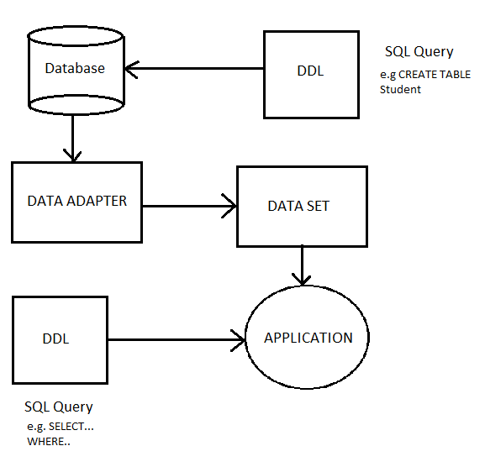

Below are some examples of the SQL Querries that will take place.

This SQL command creates the student table.

CREATE TABLE tblStudent (StudID LONG, CONSTRAINT pk_StudID PRIMARY KEY (StudID), FName TEXT(60), SName TEXT(60), IDNumber TEXT(6), StudComment TEXT(200), PhoneNo TEXT(15), EmailAddress TEXT(40), DateCreated DATE)

This SQL command creates the Student Course table.

CREATE TABLE tblStudentCourse (StudID LONG, CourseID LONG, CONSTRAINT fk_Coursetbl FOREIGN KEY (CourseID) REFERENCES tblCourse(CourseID), CONSTRAINT fk_Studenttbl FOREIGN KEY (StudID) REFERENCES tblStudent(StudID), PRIMARY KEY (StudID, CourseID), StartDate DATE, EndDate DATE, Dormant TEXT(6))

During prototyping VB.NET code was established which will be used for final program, below are the relationships between each datatable in the dataset.

DA.TableMappings.Add("Table", "tblStudent")

DA.TableMappings.Add("Table1", "tblCourse")

DA.TableMappings.Add("Table2", "tblStudentCourse")

DTStudents = DS.Tables(0)

DTCourses = DS.Tables(1)

DTStudentCourses = DS.Tables(2)

This is an example of the datarelations between Course and Student Course, in VB.NET. The compound primary key for Student TMA table is used below.

DS.Relations.Add(New DataRelation("CourStudCorRelation", DTCourses.Columns("CourseID"), DTStudentCourses.Columns("CourseID"), True))

'Compound Primary Key For

' StudentCourse - StudentTMA

'Create an array of datacolumns where the 2 primary keys are held

Dim SCcpk(1), SCSTcpk(1) As DataColumn

SCcpk(0) = DTStudentCourses.Columns("StudID")

SCcpk(1) = DTStudentCourses.Columns("CourseID")

SCSTcpk(0) = DTStudentTMAS.Columns("StudID")

SCSTcpk(1) = DTStudentTMAS.Columns("CourseID")

'Enforces the relations between these 2 keys

DS.Relations.Add(New DataRelation("CPKStudentTMA", SCcpk, SCSTcpk, True))

DS.EnforceConstraints = True

Below is the connection string for VB.NET which connects with the Microsoft Jet engine database.

Provider=Microsoft.ACE.OLEDB.12.0;Data Source=C:/DatabaseName.accdb;

# 5. User interface design

Below are designs which should reflect the finished project. They are not made by prototyping, but with a piece of software: Adobe Illustrator CS5.

## HCI

The design is targeted at home use, which means the presentation doesn’t need to reflect a predefined business style or logo. I have decided to use a colour scheme which is easy on the eye and using a larger font size makes the text easier to read on a small net book, which is one of the product requirements and results in a better usability. The dialog boxes are large enough for the user to easily click them and to exit the program the user clicks the cross at the top left of the form. When the user goes to another tab page, there are back buttons which direct the user back to the main tab, or the user can click the corresponding tab page to return to the main tab. So there are multiple pathways for the user to return to the main tab page, which creates a easier way to return ‘home’.

#### All Students tab

This displays all the students from tblStudent, with each of their own Course Name, extracted from tblCourse by the indexes. When the user first installs the program they will have to create the database, this is done by entering in a new database name and pressing the ‘Create DataBase’ button, which creates a database by the given namelocated in the program directory. This enables the user to then press the ‘create new student’ button and start entering data (shown below). Otherwise if this is a normal run the user enters in the database name, then they can optionally select the ‘Show dormant Students’ radio box to also show any students that have become **Dormant** or simply press the display students button for all their records to be displayed**.**

I decided to have the selected students details be displayed on the same screen as the data grid, because the presentation was more practical and because of the length of ‘Student comment’

To create a more secure feel to the program I added a bar across the top, which describes the screen the user is currently on. This creates a related environment across the application which is similar to the existing system and thus gives a better bespoke solution to the user.

To update the comment on the student, the user can edit the textbox at this screen and after edits the comment is committed to the database.

Fig. 17 All Students tab

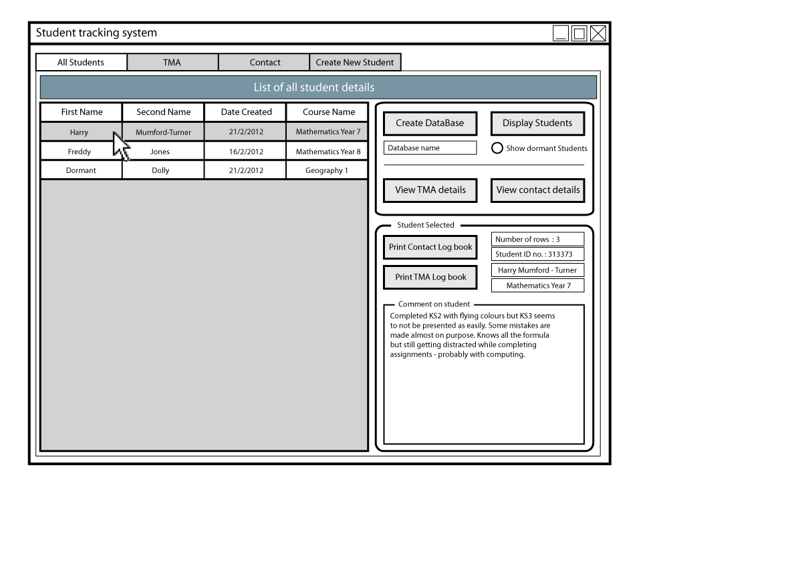

#### T.M.A. details tab

To access this screen the user clicks on the ‘View T.M.A.’ button from the ‘All Students‘ tab, or optionally the user can click on the ‘TMA’ tab above, but information will only be displayed when they have selected a student in the ‘All Students’ tab, because the user hasn’t specified what a particular student to find the T.M.A. details of.

This tab displays all the T.M.A. and their corresponding grade, which is again found through indexes on ‘tblStudentCourse’ and ‘tblTMA’, the user can create new T.M.A., edit the comment and ‘Date out’ for the selected T.M.A.

When the user selects a T.M.A. letter from the data grid the corresponding letter and grade are displayed in a pleasant font, to create a easy presentation for the user to easily note down the letter and grade.

For the creation of a new T.M.A. record the user enters in the grade and letter, the T.M.A. letter will relate to the course the T.M.A. is on, which means restrictions are in place to stop the user from entering a wrong T.M.A. letter.

Date in will default to now if the user doesn’t enter in a date and date out can be changed at a later date, but will default one week from today if the user hasn’t entered in a date.

Fig. 18 T.M.A. tab

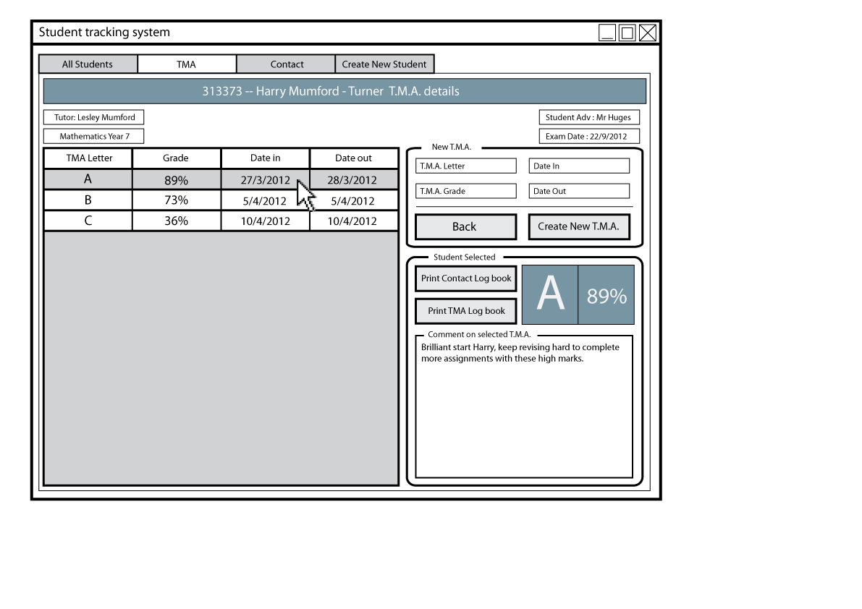

#### Contact details

Similar to the TMA tab the user access this either from the button located on the all students tab, or changing tabs when they have previously clicked the Contact details button.

The information on this tab page relates to tblContact and tblStudent and their indexes.

Comparing the pages, I used a very similar design to create solid integrity throughout the design and instead of the TMA letter, the Type of contact is used with the duration.

To create a new contact the user enters in the duration, easily selects the type from the radio button, enters in the date of next contact and clicks the create new contact button. This adds the contact time to the data grid view and database.

Very similar to the TMA tab the comment on the contact can be changed at different intervals when selected a contact.

When viewing the data grid the information must be presented in such a way, so that it can be easily extracted or read. So the duration is shortened to 25m instead of minutes and based on the analysis research the tutor was already using a shorthand so the design should reflect this as much as possible.

Fix. 19 Contact tab

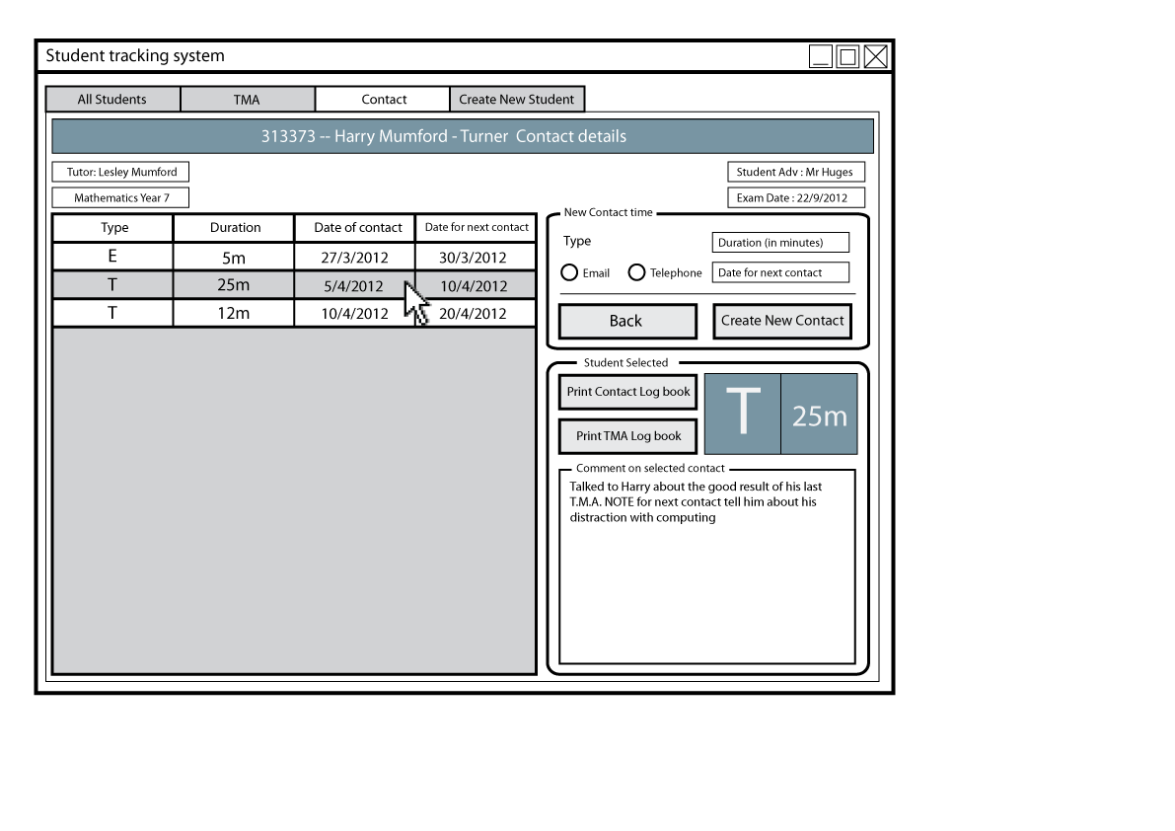

#### Create new student

From the ‘All Students’ tab the user can either click the ‘Create new students’ button or they can select the ‘Create New Student’ tab from the top. This tab is where the user can enter in details for the creation of a new student.

The user enters in the details corresponding to each textbox, including the ‘course name’, which is a dropdown menu including of each course name for easy selection.

The back button, like on each tab page, returns the user to the ‘All Students’ tab, which is considered as the ‘Home’ tab.

When the ‘create new student button’ is clicked, a message box is displayed notifying the user of the values they entered. Then all the boxes are wiped so the student can enter another student, if they wish.

Fig. 20 Create New Student tab

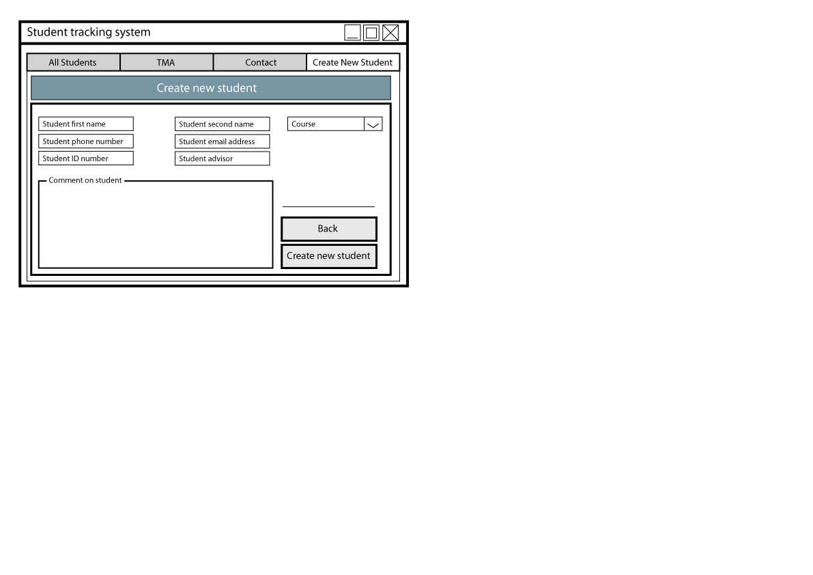

#### Printing a TMA Log Book

Below is the output of ‘Joe Bloggs’ **T.M.A. Log Book** (to an extent) which is derived when the user presses the ‘Print TMA Log Book’ button from either the ‘All Students’ tab or the ‘TMA’ tab. The design of the **Log Book**, gathered from the analysis, was reflected in this design, because the user will be printing this and sending the printed page to **Oxford Open Learning** so the layout should reflect the current design as much as possible. This document will be created using Microsoft Word, which will open and be displayed when the ‘Print TMA log book’ button is pressed.

Fig. 21Printed T.M.A.Log Book

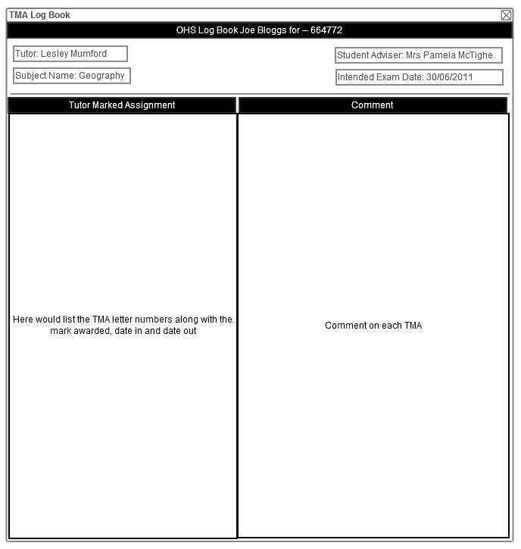

#### Printing a Contact Log Book

Below is the output of ‘Joe Bloggs’ **ContactLog Book**(to an extent) which is similar to the ‘TMA log book’ and derived when the user presses the ‘Print Contact Log Book’ button from either the ‘All Students’ tab or the ‘Contact’ tab. The design is very similar to the ‘TMA Log book’ and reflects the analysis, current system **Log Book**.

Fig. 22 Contact Log Book report

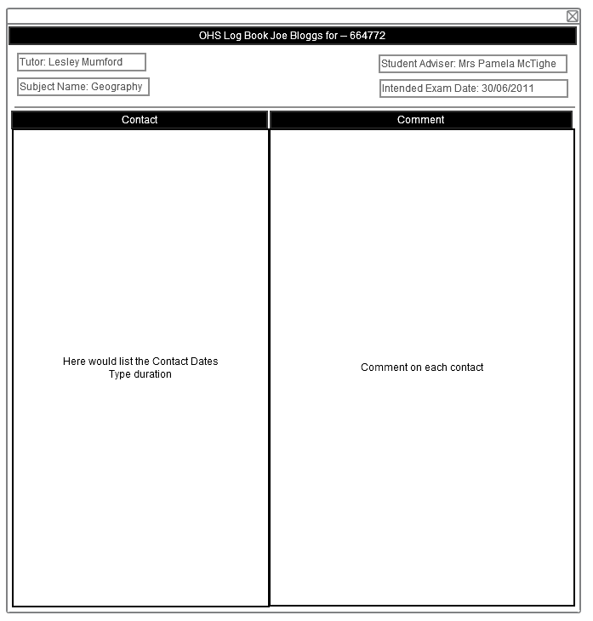

## C:\Users\Harry\Desktop\relationshipbetween-each-form.pngRelationship between each form

Fig.23 Diagram showing the relationship between each form

## User Interface Design Rationale

I chose to use a graphical user interface (GUI) rather than a command line (CLI) application because the user requirements stated that the students needed to be displayed in a table. Although this can be done in a CLI application, the data the user has to enter in must be minimal for good usability, so a GUI application where the user can simply click buttons rather than typing is more user-friendly.

# 6. System Security

The only user for my project will be the single tutor, meaning the application won’t be available to all **Oxford Open Learning** tutors. Because the project is dealing with data about a particular student, it is classed as sensitive data, which must be protected under the data protection act of 1998. But because I only have one user, who currently has access to all student details, it is not needed to protect this information from the user so security requirements are quite nonexistent.

# 7. Test Strategy

It is extremely import that I test the application to reveal the errors that could occur and to show that the complete application is working. Some errors, such as if the database exists will definitely occur when changing machines. This is another main reason why I shall do a system test with typical to extreme data.

I shall be conducting white-box testing where the full code will be available, so I can test complete scenarios the user will face upon using this application.

Testing Contents

Detailed test plan 62

Typical 62

Extreme 65

Erroneous data 67

Samples 68

Samples of actual test runs 68

Typical 68

Extreme Data 78

Erroneous data 81

Test evaluation 82

# Detailed test plan

Below is a detailed plan on the tests that I shall conduct to prove that the application is sufficient to be given to the user.

## Typical

|  |  |  |  |  |  |  |
| --- | --- | --- | --- | --- | --- | --- |
| Test No. | Tab | Purpose | Test Data | Expected Result | Type | Result |
| 1 | All Students | To create a new data base with 6 tables by the given name. | A string entered into the database name text box, then the create database button pressed | Message box showing: “Database with 6 tables has been created” | Typical | Success |
| 2 | All Students | To display student information on the datagrid | Pressing the Display students button when the database name exists | Student information displayed in the grid | Typical | Success |
| 3 | All Students | To display student information in a datagrid | Create database button pressed then display students button pressed | Student information displayed in the grid | Typical | Success |
| 4 | All Students | To produce the comment, FName, SName and course the student is on in textboxes | User selects a row on the data grid by clicking it | Comment, Course, First and Second Name are displayed in the corresponding textboxes | Typical | Success |
| 5 | All Students | To display only the dormant students | User ticks the “Show dormant Students” button | List of dormant students are displayed | Typical | Success |
| 6 | All Students | Change the student comment | User changes the comment for the selected student and presses save comment | MsgBox showing “Comment Changed” | Typical | Success |
| 7 | All Students / TMA | View the TMA details about a selected student | User selects a student and presses the view TMA details button | Tab control moved to the TMA tab and TMAs relating to the selected student are displayed | Typical | Success |
| 8 | All Students /Contact | View the contact details about a selected student | User selects a student and presses the view Contact details button | Tab control moved to the Contact tab and Contacts relating to the selected student are displayed | Typical | Success |
| 9 | All Students | Display a T.M.A. print report about the selected student | User presses the Print TMA report button | Microsoft word opens with a table listing the students report | Typical | Success |
| 10 | All Students | Display a Contact print report about the selected student | User presses the Print Contact report button | Microsoft word opens with a table listing the students report | Typical | Success |
| 11 | All Students | Create new students | Click the create new student tab after clicking the display students button | Moves to the All Student Tab | Typical | Success |
| 12 | TMA | Create new TMAs | Enter in the TMA letter, the TMA grade and the indate and out date (In date is defaulted to today) | Adds a new TMA with the entered information to the datagrid | Typical | Success |
| 13 | TMA | Edit the comment regarding each TMA | User edits the comment about the selected TMA and presses save comment | MsgBox showing “Comment saved” | Typical | Success |
| 14 | TMA | Display a T.M.A. print report about the selected student | Press Print TMA log book | Same as test 11 | Typical | Success |
| 15 | TMA | Display a Contact print report about the selected student | Press Print contact log book | Same as test 12 | Typical | Success |
| 16 | TMA | Return to the home All students tab | Press the back button | Tab control is moved over to the All students tab | Typical | Success |
| 17 | Contact | Add a contact time | Button Add contact time is pressed when the duration and type have been picked | New contact time is displayed in a grid | Typical | Success |
| 18 | Create New Student | To create a new student | Enter in correct information and press create new student button | Msgbox showing “Added (and the entered student name)” | Typical | Success |

## Extreme

|  |  |  |  |  |  |  |
| --- | --- | --- | --- | --- | --- | --- |
| Test No. | Tab | Purpose | Test Data | Expected Result | Type | Result |
| 19 | All Students | Check the validation for the creation of the database | Enter in an already used name | Messagebox showing:  “Database already exists” and add a “new” to the TBox_Database  Name text | Extreme | Success |
| 20 | All Students | Check the validation for the display of students | Pressing the Display students button before the database has been created | Same as test 1 | Extreme | Success |
| 21 | All Students | Check validation for the creation of students without specifying what database they are being created into | Click the create new student tab before clicking the display students button | Stops the user from moving to the all students tab | Extreme | Success |
| 22 | TMA | Check validation of creating a new T.M.A. | Enter a grade that is > 100 in this case 101 | Msgbox showing “Grade too high” | Extreme | Success |
| 23 | Contact | Check the validation of the creation of a contact time | Enters in duration but not type | Msgbox showing “Please enter in a type” | Extreme | Success |
| 24 | Contact | Check the validation of the creation time for the duration | Enter in a number higher than 1000 e.x. 1001 | Msgbox showing “Please enter a valid duration” | Extreme | Success |
| 25 | Create New Student | To check the validation for the creation of a new student | Leave a field Blank | Msgbox showing “Error please enter in correct information.” | Extreme | Success |
| 26 | Create New Student | To check the validation for the creation of a new student | Make a field too long ie Phone number 50 characters too big | Msgbox showing “Error please enter in correct information | Extreme | Success |
| 27 | Create New Student | To check the validation for the creation of a new student | Leave a field unentered | Msgbox showing “Please Fill all fields” | Extreme | Success |

## Erroneous data

|  |  |  |  |  |  |  |
| --- | --- | --- | --- | --- | --- | --- |
| Test No. | Tab | Purpose | Test Data | Expected Result | Type | Result |
| 28 | TMA | Check validation of creating a new T.M.A. | Enter a grade that is > 100 in this case 1000000 | Msgbox showing “Grade too high” | Erroneous | Success |
| 29 | Contact | Check the validation of the creation time for the duration | Enter in 900000 | Msgbox showing “Please enter a valid duration” | Erroneous | Success |
| 30 | Create New Student | Check the validation | Enter in a very large field eg phone number | Msg box showing” The field is too small to accept the amount of data you attempted to add” | Erroneous | Success |

# Samples

Below are some samples of the test runs, with cross reference to the test number and more importantly the test plan.

## Samples of actual test runs

#### Typical

|  |  |
| --- | --- |
| Test No. | Test result |
| 1 | C:\Users\Harry\Desktop\Testing\Typical\1new.png  Message box appears with a dialog box presenting the user with the result. |
| 2 | C:\Users\Harry\Desktop\Testing\Typical\2new.png  Details are displayed to the user on each student, note for this test data I have only used a single student record. |
| 3 | C:\Users\Harry\Desktop\Testing\Typical\3new.png  When the Display Students button is pressed a database is created and the column headers are shown but the user needs to enter in any records of the students before they are displayed. |
| 4 | C:\Users\Harry\Desktop\Testing\Typical\4new.png  Upon selecting a student from the list , more indepth details about that student are displayed such as the comment on the student. |
| 5 | C:\Users\Harry\Desktop\Testing\Typical\5new.png  For this example I have entered in a dormant student. |
| 6 | C:\Users\Harry\Desktop\Testing\Typical\6new.png  The comment was edited and the save comment button pressed which saves the comment to the database and the student. |
| 7 | C:\Users\Harry\Desktop\Testing\Typical\7new.png  The T.M.A. row is selected and the information is displayed. |
| 12 | C:\Users\Harry\Desktop\Testing\Typical\12new.png  Details are entered into the TMALetter combo box and the TMA Grade textbox, which are stored in the database upon pressing the Create New T.M.A. button. |
| 13 | C:\Users\Harry\Desktop\Testing\Typical\13new.png  Same as the student comment, when the Save Comment button is pressed the edited comment is saved to the database. |
| 18 | C:\Users\Harry\Desktop\Testing\Typical\18new.png  A message box is displayed notifying the user of the changes to their records. |

#### Extreme Data

|  |  |
| --- | --- |
| Test No. | Test result |
| 19 | C:\Users\Harry\Desktop\Testing\Errounous\19new.png  When entering a database name that already exists a notification is displayed informing the user of this error. Then “new” is added to the existing database name. |
| 22 | C:\Users\Harry\Desktop\Testing\Errounous\22new.png  If the grade is accidentally entered in too high (over 100) then a messagebox is displayed and the record isn’t saved to the database |
| 27 | C:\Users\Harry\Desktop\Testing\Errounous\27.png  If a field has been accidentally untouched, i.e. First Name, a message box is displayed informing the user that they need to fill all the fields. |

#### Erroneous data

|  |  |
| --- | --- |
| Test No. | Test Result |
| 28 | C:\Users\Harry\Desktop\Testing\Extreme\28.png  Upon entering a ludicrously high T.M.A. grade the messagebox from Test no. 22 is still displayed. |
| 30 | C:\Users\Harry\Desktop\Testing\Extreme\30.png  When entering in data which is over the limit of the maximum amount of characters e.g. phone number, then a messagebox is displayed informing the user of their accidental mistake. |

# Test evaluation

After conducting the tests, I felt the application passed the user requirement needs and is working enough for the user to use this program at full.

Maintenance Contents

1. System overview 84

Acknowledgement of non-candidate coding 84

2. Detailed algorithm design 84

CheckDatabaseExists 85

PopulateDataSetandDataTables 86

DisplayStudInfo 87

DisplayTMAInfo 89

SetExamDate 90

SetCorrectTMALetters 91

AddNewTMA 92

DisplayContactInfo 94

AddNewContact 95

CreateNewStudent 96

PrintTMALogBook 98

PrintContactLogBook 100

Variable list 102

4. Annotated CODE LISTING 108

List of forms 108

# 1. System overview

The application creates a database via the Microsoft Jet Engine, with 6 tables. Upon a user entering student information, it stores this in the tables corresponding to their columns. The user then can extract this information for it to be displayed in datagridviews for the user to update and edit some parts of the data such as the comments on the student, TMA and contact meeting. The user can also print a report about a selected student from the datagridview, this interacts with Microsoft 2007 word and creates a file displaying the selected students information in a table.

## Acknowledgement of non-candidate coding

For the printing of the TMA and Contact details report, non-candidate code was modified and used. This was because the code was easy to use and fitted my user requirements, so I felt it necessary to use in my project.

The code was used from the Microsoft Developer Network.

*http://msdn.microsoft.com/en-us/ms348103*

# 2. Detailed algorithm design

Below is the complete list of algorithm designs, on the left is the psudo code for the algorithm and the right is the actual necessary code.

1. **CheckDatabaseExists**
2. **PopulateDataSetandDataTables**
3. **DisplayStudInfo**
4. **DisplayTMAInfo**
5. **SetExamDate**
6. **SetCorrectTMALetters AddNewTMA**
7. **DisplayContactInfo**
8. **AddNewContact**
9. **CreateNewStudent**
10. **PrintTMALogBook**
11. **PrintContactLogBook**

## CheckDatabaseExists

Runs a check on the directory and what button has been pressed to see if the database exists

PrivateSub Btn_CreateDB_Click

Dim CreateDB AsBoolean = True

CheckDatabaseExists(CreateDB)

EndSub

Sub Btn_DisplayStudents_Click

Dim CreateDB AsBoolean = False

PopulateDSandDT(CheckDatabaseExists(CreateDB))

DisplayStudents(ShowDormantOnly)

EndSub

FunctionCheckDatabaseExists(ByRef CreateDB AsBoolean)

Dim DatabasePathName AsString = TBox_DriveLetter.Text &":\"& TBox_DatabaseName.Text &".accdb"

Dim ConnectionString AsString = "Provider=Microsoft.ACE.OLEDB.12.0;Data Source="& DatabasePathName &";"

IfDir(DatabasePathName) <>""And CreateDB = TrueThen

MsgBox("Database allready exists.")

TBox_DatabaseName.Text = TBox_DatabaseName.Text &"new"

ElseIfDir(DatabasePathName) <>""And CreateDB = FalseThen

Else

CreateDatabase(ConnectionString)

EndIf

CheckDatabaseExists = ConnectionString

EndFunction

**When** Button Create Database is pressed

**Let** CreateDB = true

CheckDatabaseExists(CreateDB)

**When** Button Display Students is pressed

**Let** CreateDB = false

CheckDatabaseExists(CreateDB)

**CheckDatabaseExists**

**Let** DBPathName = DatabaseName textbox

**If** DBPathName exists **And** CreateDB = true **then**

Let “Database already exists” be displayed

DatabaseName textbox &“ new”

**Else If** DBPathName exists **And** CreateDB = false **then**

Return

**Else** CreateDatabase

**End if**

## PopulateDataSetandDataTables

Populates the dataset and tables with the corresponding table in the database

**Let** DA = Data adapter

**Let** DS =Data Set

**Let** Com = DatabaseCommand

**Let** Con = Data base Connection

Con = open

**For i = 0 To**TablesInDatabase.max – 1

DA.Com = “SELECT ALL RECORDS FORM TABLE (i)”

Fill Table(i) in DS with DA.Com

Add to DA Mappings for each table name

**Next i**

Con = close

Add to DS relations

Student and StudentCourse

Student and Contact

Course and StudentCourse

Course and TMA

TMA and StudTMA

**Let** array(0,1) = Table(StudID, CourseID)

**Let** array(1,0) = Table(CourseID, StudID)

Add to DS relations array(0,0) and array(1,1) for StudentCourse and StudentTMA

PrivateSubPopulateDSandDT(ByVal ConStr)

oleCon = NewOleDbConnection(ConStr)

oleCon.Open()

DA = NewOleDbDataAdapter

DS = NewDataSet

oleCom = NewOleDbCommand

oleCom.Connection = oleCon

Tables(0) = "tblStudent"

Tables(1) = "tblCourse"

Tables(2) = "tblStudentCourse"

Tables(3) = "tblTMA"

Tables(4) = "tblStudentTMA"

Tables(5) = "tblContact"

DA.SelectCommand = oleCom

For i = 0 ToTables.GetUpperBound(0) - 1

DA.SelectCommand.CommandText = "SELECT * FROM "&Tables(i)

DA.Fill(DS, Tables(i))

Next

oleCon.Close()

DA.TableMappings.Add("Table", "tblStudent")

DA.TableMappings.Add("Table1", "tblCourse")

DA.TableMappings.Add("Table2", "tblStudentCourse")

DA.TableMappings.Add("Table3", "tblTMA")

DA.TableMappings.Add("Table4", "tblStudentTMA")

DA.TableMappings.Add("Table5", "tblContact")

DTStudents = DS.Tables(0)

DTCourses = DS.Tables(1)

DTStudentCourses = DS.Tables(2)

DTTMAS = DS.Tables(3)

DTStudentTMAS = DS.Tables(4)

DTContacts = DS.Tables(5)

DS.Relations.Add(NewDataRelation("StudStudCorRelation", DTStudents.Columns("StudID"), DTStudentCourses.Columns("StudID"), True))

Note the other relations are in effect but not displayed here for space.

DimSCcpk(1), SCSTcpk(1) AsDataColumn

SCcpk(0) = DTStudentCourses.Columns("StudID")

SCcpk(1) = DTStudentCourses.Columns("CourseID")

SCSTcpk(0) = DTStudentTMAS.Columns("StudID")

SCSTcpk(1) = DTStudentTMAS.Columns("CourseID")

DS.Relations.Add(NewDataRelation("CPKStudentTMA", StudCourseCompPK, StudCourseStudTMACompPK, True))

DS.EnforceConstraints = True

EndSub

## DisplayStudInfo

Displays the course name, comment, ID number, date the record was created, FName and SName relating to each student in the database

**Let** DTAllStud = DataTable

DTAllStud = FillDTWithSpecificColumns()

**Let** StudCourseRow = DataRow

**Let** CourseRow = DataRow

**Let** StudRow = DataRow

**For Each** StudRow In table Students Rows

**For each** SCrow in Table StudentCourses where StudID = StudRow

**For each** SCrow in Table Courses where CourseID = SCrow CourseID

**Let** NewRow = DataRow

NewRow = StudID, CoureID, FName, SName, StudentNumber, DateCreated, CourseName, StudentNumber,StudComment,

NewRow = DTAllStud add NewRow

DataGrid = DTAllStud

DataGridColumns.Hide = StudComment,

StudID,

CourseID,

StudentNumber

SubDisplayStudents(ShowDormantOnly AsBoolean)

DTAllStud = CreateTempDTStudents()

Dim StudCourseRow AsDataRow

Dim CourseRow AsDataRow

Dim StudRow AsDataRow

'Algorithm to locate the courseID of each student

'Goes through each row in DTStudents to see if the StudID matches in DTStudentCourses

If ShowDormantOnly = TrueThen

ForEach StudRow InDTStudents.Rows()

ForEach StudCourseRow InDTStudentCourses.Select("StudID = "& StudRow.Item("StudID") &" AND Dormant = 'True'")

'Goes through each row in DTCourses to see if the courseID of DTStudentCourses match

ForEach CourseRow InDTCourses.Select("CourseID = "& StudCourseRow.Item("CourseID"))

'If they do then add a new row to the 'AllStud' datatable based on the other records in the matching course row

Dim Addingrow AsDataRow = DTAllStud.NewRow()

Dim tempDateCreated AsDate = StudRow.Item("DateCreated")

With Addingrow

.Item(0) = StudRow.Item("StudID")

.Item(1) = StudRow.Item("FName")

.Item(2) = StudRow.Item("SName")

.Item(3) = tempDateCreated.ToString("d")

.Item(4) = StudRow.Item("StudComment")

.Item(5) = CourseRow.Item("CourseID")

.Item(6) = CourseRow.Item("CourseName")

.Item(7) = StudRow.Item("IDNumber")

EndWithDTAllStud.Rows.Add(Addingrow)

Next

Next

Next

Else

ForEach StudRow InDTStudents.Rows()

ForEach StudCourseRow InDTStudentCourses.Select("StudID = "& StudRow.Item("StudID") &" AND Dormant = 'False'")

'Goes through each row in DTCourses to see if the courseID of DTStudentCourses match

ForEach CourseRow InDTCourses.Select("CourseID = "& StudCourseRow.Item("CourseID"))

'If they do then add a new row to the 'AllStud' datatable based on the other records in the matching course row

StudRow.Item("StudComment")

Dim Addingrow AsDataRow = DTAllStud.NewRow()

Dim tempDateCreated AsDate = StudRow.Item("DateCreated")

With Addingrow

.Item(0) = StudRow.Item("StudID")

.Item(1) = StudRow.Item("FName")

.Item(2) = StudRow.Item("SName")

.Item(3) = tempDateCreated.ToString("d")

.Item(4) = StudRow.Item("StudComment")

.Item(5) = CourseRow.Item("CourseID")

.Item(6) = CourseRow.Item("CourseName")

.Item(7) = StudRow.Item("IDNumber")

EndWith

DTAllStud.Rows.Add(Addingrow)

Next

Next

Next

EndIf

'Creates a new view on the data which uses the temporary data table to be displayed in the Data grid view

Dim view AsDataView = NewDataView

view.Table = DTAllStud

DGrid_Students.DataSource = view

'Renames the headers - making them look more pleaseable to the user

With DGrid_Students

.Columns.Item("FName").HeaderText() = "First Name"

.Columns.Item("SName").HeaderText() = "Second Name"

.Columns.Item("DateCreated").HeaderText() = "Date Created"

.Columns.Item("StudComment").Visible = False

.Columns.Item("StudID").Visible = False

.Columns.Item("CourseID").Visible = False

.Columns.Item("StudentNumber").Visible = False

EndWith

EndSub

## DisplayTMAInfo

Displays the relating TMA information about the selected student

**Let** DTofTMA = DataTable

DTofTMA = FillDTWithSpecificColumns()

**Let**StudTMArow = DataRow

**Let** TMArow = DataRow

**For Each** StudTMArow In Table Student TMA where StudID = StudentID.Selected Student And CourseID = CouseID.selected Student

**For Each** TMArow In Table TMA Where TMAID = StudTMArow TMAID And CourseID = CourseID.Selected Student

**Let** NewRow = DataRow

NewRow = TMAID, StudID, CourseID, TMALetter, Grade

NewRow = DTofTMA add NewRow

DataGridTMA = DTofTMA

DataGridTMA.hide Column:

StudID, CourseID, TMAID

SubPopulateTMADGrid()

DTofTMA = CreateTempDTTMAS()

Dim view AsDataView = NewDataView

Dim StudTMArow AsDataRow

Dim TMArow AsDataRow

ForEach StudTMArow InDTStudentTMAS.Select("StudID = "& SSStudentID &" AND CourseID = "& SSCourseID)

ForEach TMArow InDTTMAS.Select("TMAID = "& StudTMArow.Item("TMAID") &" AND CourseID = "& SSCourseID)

Dim addingrow AsDataRow = DTofTMA.NewRow()

Dim tempDateIn AsDate = StudTMArow.Item("DateIn")

Dim tempDateOut AsDate = StudTMArow.Item("DateOut")

With addingrow

.Item(0) = TMArow.Item("TMALetter")

.Item(1) = StudTMArow.Item("Grade")

.Item(2) = tempDateIn.ToString("d")

.Item(3) = tempDateOut.ToString("d")

.Item(4) = StudTMArow.Item("StudID")

.Item(5) = StudTMArow.Item("CourseID")

.Item(6) = StudTMArow.Item("TMAComment")

.Item(7) = TMArow.Item("TMAID")

EndWith

DTofTMA.Rows.Add(addingrow)

Next

Next

'Point the newly created datatable to the view which points to the datagrid

view.Table = DTofTMA

DGrid_TMA.DataSource = view

'Hide the index columns and others that won’t be visible to the user

With DGrid_TMA

.Columns.Item("StudID").Visible = False

.Columns.Item("CourseID").Visible = False

.Columns.Item("TMAID").Visible = False

.Columns.Item("TMAComment").Visible = False

EndWith

## SetExamDate

Displays the correct exam date using their start date and coursename

**Let** CourseName = User input text

**Let** SelectedStudent == SS

**If** CourseName = Mathematics Year 7, 8, 9 **Then**

**If** SS.StartDate = June to Dec **Then**

SS.ExamDate = + 1 calender year

**Else If** SS.StartDate = Jan to May **Then**

SS.ExamDate = + 2 Calender years

**And if** CourseName = Geography **Then**

**Let** DateDifference: TodaysDate - SS.StartDate

**If** DateDifference < 1 calender year **Then**

SS.ExamDate = + 2 Calender year

**Else If** DateDifference < 2 calender years **Then**

SS.ExamDate = + 1 Calender year

SS.ExamDate.Display

Sub SetExamDate()

'CourseName

TBox_tmaCourse.Text = TBox_allstudCourse.Text

'Find Exam Date

Dim tempStartDate AsDateTime

ForEach row InDTStudentCourses.Select("StudID = "& SSStudentID &" AND CourseID = "& SSCourseID)

tempStartDate = row.Item("StartDate")

If TBox_tmaCourse.Text = "Geography 2"Then

TBox_tmaExamDate.Text = tempStartDate.AddYears(2).Year.ToString("d")

Else

TBox_tmaExamDate.Text = tempStartDate.AddYears(1).Year.ToString("d")

EndIf

Next

## SetCorrectTMALetters

Enables the user to only enter in the correct TMA letters based on the course that student is on

**Let** CourseNameRow = DataRow

**For Each** CourseNameRow In Table Courses **where** CourseID = SS.CourseID

**Select Case** CourseNameRow.CourseName

**Case** "Mathematics Year 7" To "Mathematics Year 8"

**For Each** c In "ABCDEF".ToCharacterArray()

**If**  c = TMALetter **Then**

**Let** AddTMALetters = True

E**lseIf** TMALetter = “Null” **Then**

TMA Letter Item array.add c

**Else**

**If** AddTMALetters = true **Then**

Add c to the combo box

**Next** c

**Case** "Geography 1" Or "Geography 2"

**For Each** c In "ABCDEFGHIJ".To Character Array()

TMA Letter Item array add c

**Next** c

Sub SetCorrectTMALetters()

'Get the maximum TMA Letter

Dim RowOfTMALetter AsInteger = DGrid_TMA.Rows.Count - 1

Dim TMALetter AsString

Try

TMALetter = DGrid_TMA.Rows(RowOfTMALetter).Cells("TMALetter").Value

Catch ex AsException

TMALetter = "Null"

EndTry

'Clears the Old TMA Letters that were previously in the Combo Box

CBox_TMALetterAdd.Items.Clear()

'For the adding of new student

'Fills the combo box with the correct TMALetter Names

Dim CourseNameRow AsDataRow

Dim AddTMALetters AsBoolean

ForEach CourseNameRow InDTCourses.Select("CourseID = "& SSCourseID)

SelectCaseCourseNameRow.Item("CourseName")

Case"Mathematics Year 7"To"Mathematics Year 8"

ForEach c In"ABCDEF".ToCharArray()

If c = TMALetter Then

AddTMALetters = True

ElseIf TMALetter = "Null"Then

CBox_TMALetterAdd.Items.Add(c)

Else

If AddTMALetters = TrueThen

CBox_TMALetterAdd.Items.Add(c)

EndIf

EndIf

Next c

Case"Geography 1"To"Geography 2"

ForEach c In"ABCDEFGHIJ".ToCharArray()

If c = TMALetter Then

AddTMALetters = True

ElseIf TMALetter = "Null"Then CBox_TMALetterAdd.Items.Add(c)

Else

If AddTMALetters = TrueThen

CBox_TMALetterAdd.Items.Add(c)

EndIf

EndIf

Next c

EndSelect

Next

## AddNewTMA

Adds a new TMA to the selected student using relationships with the database

**Let** largestTMAID = 0

Table TMA Sort By the TMAID in DESCENDING order

largestTMAID = DTTMAS Top TMAID

**Using DA** INSERT INTO tblTMA (CourseID, TMAID, TMALetter)

VALUES (DTofSS.CourseID, largestTMAID + 1)

DA.Update(DTTMAS)

**Using DA** INSERT INTO tblStudentTMA (StudID, CourseID, TMAID, Grade, StudentsTMAGradeComment)

VALUES (StudentID, CourseID, largestTMAID,Grade TMAComment)

DA.Update(DTStudentTMAS)

Sub AddNewTMA

'Get the max TMAID

Dim SQL AsString = "SELECT MAX(TMAID) FROM tblStudentTMA"

Dim MaxTMAID AsInteger

Dim oleComScalar AsNewOleDbCommand(SQL, oleCon)

oleComScalar.Connection.Open()

Try

MaxTMAID = oleComScalar.ExecuteScalar()

Catch ex AsException

'If there isnt any values let tmaID = 1

MaxTMAID = 0

EndTry

MaxTMAID += 1

oleCom.Connection = oleCon

'Add to Dataset

Dim TMAtblrow AsDataRow

TMAtblrow = DS.Tables("tblTMA").NewRow()

TMAtblrow.Item("CourseID") = SSCourseID

TMAtblrow.Item("TMAID") = MaxTMAID

TMAtblrow.Item("TMALetter") = CBox_TMALetterAdd.Text

DTTMAS.Rows.Add(TMAtblrow)

Dim StudTMAtblrow AsDataRow

StudTMAtblrow = DS.Tables("tblStudentTMA").NewRow()

StudTMAtblrow.Item("StudID") = SSStudentID

StudTMAtblrow.Item("CourseID") = SSCourseID

StudTMAtblrow.Item("TMAID") = MaxTMAID

StudTMAtblrow.Item("Grade") = CInt(TBox_GradeAdd.Text)

StudTMAtblrow.Item("DateIn") = DTP_DateIn.Value.ToString("d")

StudTMAtblrow.Item("DateOut") = DTP_DateOut.Value.ToString("d")

StudTMAtblrow.Item("TMAComment") = TBox_TMAComment.Text

DTStudentTMAS.Rows.Add(StudTMAtblrow)

'Add to Database

DA.InsertCommand = NewOleDbCommand("INSERT INTO tblTMA (CourseID, TMAID, TMALetter) " _

&"VALUES ("& SSCourseID &", "& MaxTMAID &", '"& CBox_TMALetterAdd.Text &"')", oleCon)

DA.Update(DTTMAS)

DA.InsertCommand = NewOleDbCommand("INSERT INTO tblStudentTMA (StudID, CourseID, TMAID, Grade, DateIn, DateOut, TMAComment) " _

&"VALUES ("& SSStudentID &", "& SSCourseID &", "& MaxTMAID &", '"&CInt(TBox_GradeAdd.Text) &"', #"& DTP_DateIn.Value.ToString("d") &"#, #"& DTP_DateOut.Value.ToString("d") &"#, '"& TBox_TMAComment.Text &"')", oleCon)

DA.Update(DTStudentTMAS)

DS.AcceptChanges()

oleCon.Close()

'Repopulates the datagrid with the new information

PopulateTMADGrid()

EndSub

## DisplayContactInfo

Displays the relating Contact information about the selected student

**Let** DTofContact = DataTable

DTofContact = FillDTWithSpecificColumns()

**Let** Contactrow = DataRow

**For Each** Contactrow In Table Contact where StudID = StudentID.Selected Student

**Let** NewRow = DataRow

NewRow = StudID, DateOfContact, Type, Duration, ContactComment, DateforNext

NewRow = DTofContact add NewRow

DataGridContact = DTofContact

DataGridContact.hide Column StudID, ContactComment

ContactComment = TextBoxComment

SubPopulateContactDGrid()

'Creates a new view and fill the above columns with data from the pure data tables

Dim view AsDataView = NewDataView

Dim ContactRow AsDataRow

ForEach ContactRow In DTContacts.Rows

Dim addingrow AsDataRow

addingrow = DTofContact.NewRow()

Dim tempDateForNextContact AsDateTime = ContactRow.Item("DateForNextContact")

Dim tempDateOfContact AsDateTime = ContactRow.Item("DateOfContact")

With addingrow

.Item("DateOfContact") = tempDateOfContact.ToString("d")

.Item("Type") = ContactRow.Item("Type")

.Item("Duration") = ContactRow.Item("Duration")

Item("DateForNextContact") = tempDateForNextContact.ToString("d")

.Item("ContactComment") = ContactRow.Item("ContactComment")

.Item("StudID") = ContactRow.Item("StudID")

.Item("ContactID") = ContactRow.Item("ContactID")

EndWith

DTofContact.Rows.Add(addingrow)

Next

'Point the newly created datatable to the view which points to the datagrid

view.Table = DTofContact

DGrid_Contact.DataSource = view

'Hide the index columns to the user

With DGrid_Contact

.Columns.Item("StudID").Visible = False

.Columns.Item("ContactID").Visible = False

.Columns.Item("ContactComment").Visible = False

EndWith

EndSub

## AddNewContact

Adds a new Contact record to the selected student using relationships with the database

**Let** largestStudID = 0

Table Student **Sort**By the StudID in DESCENDING order

largestStudID = Table Student Top StudID

**Using DA** INSERT INTO tblStudentTMA (StudID, DateOfContact, Type, Duration, ContactComment, DateforNext)

VALUES (largestStudID + 1, DateOfContact, Type, Duration, ContactComment, DateforNext)

DA.Update(DTContact)

Sub AddNewContact

'Get the maximum contactID from the contact table

Dim MaxContactID AsInteger

Dim SQL AsString = "SELECT MAX(ContactID) FROM tblContact"

Dim oleComScalar AsNewOleDbCommand(SQL, oleCon)

oleComScalar.Connection.Open()

Try

MaxContactID = oleComScalar.ExecuteScalar()

Catch ex AsException

MaxContactID = 0

EndTry

MaxContactID += 1

oleCom.Connection = oleCon

'Add to Dataset

Dim Contacttblrow AsDataRow

Contacttblrow = DTContacts.NewRow()

Dim Type AsString

'See what type is selected

If Rbtn_contEmailAdd.Checked Then

Type = "E"

Else

Type = "T"

EndIf

Contacttblrow.Item("StudID") = SSStudentID

Contacttblrow.Item("ContactID") = MaxContactID

Contacttblrow.Item("DateOfContact") = Date.Today.ToString("d")

Contacttblrow.Item("Type") = Type

Contacttblrow.Item("Duration") = CInt(TBox_Duration.Text)

Contacttblrow.Item("ContactComment") = "Enter Comment here"

Contacttblrow.Item("DateForNextContact") = DTP_FutureContTime.Value.ToString("d")

DTContacts.Rows.Add(Contacttblrow)

'Add to Database

DA.InsertCommand = NewOleDbCommand("INSERT INTO tblContact (StudID, ContactID, DateOfContact, Type, Duration, ContactComment, DateForNextContact) " _

&"VALUES ("& SSStudentID &","& MaxContactID &", #"&Date.Today.ToString("d") &"#, '"& Type &"', "&CInt(TBox_Duration.Text) &", 'Enter Comment here', #"& DTP_FutureContTime.Value.ToString("d") &"#)", oleCon)

DA.Update(DTContacts)

DS.AcceptChanges()

oleCon.Close()

PopulateContactDGrid()

EndSub

## CreateNewStudent

Creates a new student record in the database with the given values

SubCreateNewStudent()

Dim addFName AsString = TBox_NewFN.Text

Dim addSName AsString = TBox_NewSN.Text

Dim addCourse AsString = CBox_NewCourse.Text

Dim addPhoneNum AsString = TBox_NewPhoneNo.Text

Dim addStudComment AsString = "Enter a Comment here"

Dim addEmailAddress AsString = TBox_NewEmail.Text

Dim addStudIDno AsString = TBox_NewIDNO.Text

'If the textboxes = what they originally = then error message

If addFName = "First Name"Or addSName = "Second Name"Or addCourse = "Course"Or addPhoneNum = "Phone Number"Or addEmailAddress = "Email Address"Or addStudIDno = "Student ID number"Then

MsgBox("Please Fill all fields")

Return

EndIf

Dim DatabasePathName AsString = TBox_DriveLetter.Text &":\"& TBox_DatabaseName.Text &".accdb"

Dim ConStr AsString = "Provider=Microsoft.ACE.OLEDB.12.0;Data Source="& DatabasePathName &";"

'Get the maximum stud ID

Dim SQL AsString = "SELECT MAX(StudID) FROM tblStudent"

oleCon = NewOleDbConnection(ConStr)

Dim oleComScalar AsNewOleDbCommand(SQL, oleCon)

oleComScalar.Connection.Open()

Dim NewStudID AsInteger

Try

NewStudID = oleComScalar.ExecuteScalar()

Catch ex AsException

NewStudID = 0

EndTry

NewStudID += 1

'Get the maximum CourseID

SQL = "SELECT MAX(CourseID) FROM tblCourse"

oleComScalar = NewOleDbCommand(SQL, oleCon)

Dim NewCourseID AsInteger

Try

NewCourseID = oleComScalar.ExecuteScalar()

Catch ex AsException

NewCourseID = 0

EndTry

NewCourseID += 1

'Form connection string and open the database connection

oleCom = NewOleDbCommand

oleCom.Connection = oleCon

DA = NewOleDbDataAdapter

**Let** largestStudID = 0

Table Student **Sort**By the StudID in DESCENDING order

largestStudID = Table Student Top StudID

**Using DA** INSERT INTO tblStudent (StudID, FName, SName, StudentNumber, DateCreated, StudentNumber,StudComment)

VALUES (largestStudID + 1, FName.textbox, SName.textbox, StudentNumber.textbox, Date.Today, Type.textbox, Duration.textbox, ContactComment.textbox, DateforNext.datetimepicker)

DA.Update(DTStudents)

'tblStudent

DA.InsertCommand = NewOleDbCommand("INSERT INTO tblStudent (StudID, FName, SName, IDNumber, StudComment, PhoneNo, EmailAddress, DateCreated) "VALUES ("& NewStudID &", '"& addFName &"', '"& addSName &"', '"& addStudIDno &"', "& _

"'"& addStudComment &"', '"& addPhoneNum &"', '"& addEmailAddress &"', #"&Date.Today.ToString("d") &"#)", oleCon)

Dim StudRow1 AsDataRow = DTStudents.NewRow()

StudRow1("StudID") = NewStudID

StudRow1("FName") = addFName

StudRow1("SName") = addSName

StudRow1("IDNumber") = addStudIDno

StudRow1("StudComment") = addStudComment

StudRow1("PhoneNo") = addPhoneNum

StudRow1("EmailAddress") = addEmailAddress

StudRow1("DateCreated") = Date.Today.ToString("d")

DTStudents.Rows.Add(StudRow1)

Try

DA.Update(DTStudents)

Catch ex AsException

MsgBox(ex.Message)

NewStudID = 0

NewCourseID = 0

Return

EndTry

DS.AcceptChanges()

'tblCourse

DA.InsertCommand = NewOleDbCommand("INSERT INTO tblCourse (CourseID, CourseName) VALUES ("& NewCourseID &", '"& CBox_NewCourse.Text &"')", oleCon)

Dim CourseRow1 AsDataRow = DS.Tables(1).NewRow()

CourseRow1("CourseID") = NewCourseID

CourseRow1("CourseName") = CBox_NewCourse.Text

DTCourses.Rows.Add(CourseRow1)

DA.Update(DTCourses)

DS.AcceptChanges()

'tblStudentCourse

Dim EndDate AsString

If CBox_NewCourse.Text = "Geography 2"Then

EndDate = Date.Today.AddYears(2).ToString("d")

Else

EndDate = Date.Today.AddYears(1).ToString("d")

EndIf

DA.InsertCommand = NewOleDbCommand("INSERT INTO tblStudentCourse (StudID, CourseID, StartDate, EndDate, Dormant)VALUES ("& NewStudID &", "& NewCourseID &", #"&Date.Today.ToString("d") &"#, #"& EndDate &"#, 'False')", oleCon)

Dim SCRow1 AsDataRow = DS.Tables(2).NewRow()

SCRow1("StudID") = NewStudID

SCRow1("CourseID") = NewCourseID

SCRow1("StartDate") = Date.Today.ToString("d")

SCRow1("EndDate") = EndDate

SCRow1("Dormant") = "False"

DTStudentCourses.Rows.Add(SCRow1)

DA.Update(DTStudentCourses)

DS.AcceptChanges()

oleCon.Close()

MsgBox("Added "& addFName &" "& addSName)

EndSub

## PrintTMALogBook

Gets the data of the selected students Tutor Marked Assignments and transfers it to a Microsoft word document ready to be printed by the user

**Let** oWord = Word application create

**Let** oPara1 = document add paragraph

oPara1 text = "T.M.A. Details for Student: " & StudentName & " -- " & Student ID number

oPara1 = bold

**Let** MaxRows = DatagridTMA rows count

**Let** oTable = add to document with rows of MaxRows and 4 columns

oTable enable borders

oTable.Cell(1, 1).Text = "TMA Letter"

oTable.Cell(1, 2).Range.Text = "TMA Grade"

oTable.Cell(1, 3).Range.Text = "Date In"

oTable.Cell(1, 4).Range.Text = "Date Out"

**For** r = 2 To MaxRows + 1

**For** c = 1 To 4

oTable.Cell(r, c).Text = DatagridTMA.Rows(r - 2).Cells.Item(c - 1).Value

**Let** oPara2 = Document add another paragraph

oPara2 text = "Subject: " & Course

**Let** oPara3 = Document add another paragraph

oPara2 text = "Tutor: Lesley Mumford"

**Let** oPara4 = Document add another paragraph

oPara2 text = "Intended Exam Date: " & ExamDate

Sub Btn_tmaPrintTMA_Click(sender As System.Object, e As System.EventArgs) Handles Btn_tmaPrintTMA.Click

Dim oWord As Word.Application

Dim oDoc As Word.Document

Dim oTable As Word.Table

Dim oPara1, oPara2, oPara3, oPara4 As Word.Paragraph

Dim missing AsObject = System.Reflection.Missing.Value

'Start Word and open the document template.

oWord = CreateObject("Word.Application")

oWord.Visible = True

oDoc = oWord.Documents.Add

'Insert a paragraph at the beginning of the document.

oPara1 = oDoc.Content.Paragraphs.Add

oPara1.Range.Text = "T.M.A. Details for Student: "& TBox_allstudStudName.Text &" -- "& TBox_allstudSIDNO.Text

oPara1.Range.Font.Bold = True

oPara1.Format.SpaceAfter = 12 '12 pt spacing after paragraph.

oPara1.Range.InsertParagraphAfter()

oPara1.Range.Font.Bold = False

oPara1.Range.InsertFile(TBox_DriveLetter.Text &":\StudContactReport.docx", missing, False, False, False)

Dim MaxRows AsInteger

MaxRows = DGrid_TMA.Rows.Count

'Insert a MaxRows x 4 table, fill it with data

Dim r AsInteger, c AsInteger

oTable = oDoc.Tables.Add(oDoc.Bookmarks.Item("\endofdoc").Range, MaxRows + 1, 4)

oTable.Range.ParagraphFormat.SpaceAfter = 6

oTable.Borders.Enable = True

oTable.Cell(1, 1).Range.Text = "TMA Letter"

oTable.Cell(1, 2).Range.Text = "TMA Grade"

oTable.Cell(1, 3).Range.Text = "Date In"

oTable.Cell(1, 4).Range.Text = "Date Out"

For r = 2 To MaxRows + 1

For c = 1 To 4

oTable.Cell(r, c).Range.Text = DGrid_TMA.Rows(r - 2).Cells.Item(c - 1).Value.ToString

Next

Next

oTable.Rows.Item(1).Range.Font.Bold = True

'Add some text after the table.

oPara2 = oDoc.Content.Paragraphs.Add(oDoc.Bookmarks.Item("\endofdoc").Range)

oPara2.Range.Text = "Subject: "& TBox_tmaCourse.Text

oPara2.Format.SpaceAfter = 1

oPara2.Range.InsertParagraphAfter()

oPara2.Range.InsertFile(TBox_DriveLetter.Text &":\StudContactReport.docx", missing, False, False, False)

oPara3 = oDoc.Content.Paragraphs.Add(oDoc.Bookmarks.Item("\endofdoc").Range)

oPara3.Range.Text = "Tutor: Lesley Mumford"

oPara3.Format.SpaceAfter = 1

oPara3.Range.InsertParagraphAfter()

oPara3.Range.InsertFile(TBox_DriveLetter.Text &":\StudContactReport.docx", missing, False, False, False)

oPara4 = oDoc.Content.Paragraphs.Add(oDoc.Bookmarks.Item("\endofdoc").Range)

oPara4.Range.Text = "Intended Exam Date: "& TBox_tmaExamDate.Text

oPara4.Format.SpaceAfter = 1

oPara4.Range.InsertParagraphAfter()

oPara4.Range.InsertFile(TBox_DriveLetter.Text &":\StudContactReport.docx", missing, False, False, False)

EndSub

## PrintContactLogBook

Gets the contact data of the selected student and transfers it to a Microsoft word document ready to be printed by the user

**Let** oWord = Word application create

**Let** oPara1 = document add paragraph

oPara1 text = "Contact Details for Student: " & StudentName & " -- " & Student ID number

oPara1 = bold

**Let** MaxRows = DatagridContact rows count

**Let** oTable = add to document with rows of MaxRows and 4 columns

oTable enable borders

oTable.Cell(1, 1).Text = "Date Of Contact"

oTable.Cell(1, 2).Text = "Type"

oTable.Cell(1, 3).Text = "Duration"

oTable.Cell(1, 4).Text = "Date for Next Contact"

**For** r = 2 To MaxRows + 1

**For** c = 1 To 4

oTable.Cell(r, c).Text = DatagridContact.Rows(r - 2).Cells.Item(c - 1).Value

**Let** oPara2 = Document add another paragraph

oPara2 text = "Subject: " & Course

**Let** oPara3 = Document add another paragraph

oPara2 text = "Tutor: Lesley Mumford"

**Let** oPara4 = Document add another paragraph

oPara2 text = "Intended Exam Date: " & ExamDate

PrivateSub Btn_contPrintContact_Click(sender As System.Object, e As System.EventArgs) Handles Btn_contPrintContact.Click

Dim oWord As Word.Application

Dim oDoc As Word.Document

Dim oTable As Word.Table

Dim oPara1, oPara2, oPara3, oPara4, oPara5, oPara6 As Word.Paragraph

Dim missing AsObject = System.Reflection.Missing.Value

'Start Word and open the document template.

oWord = CreateObject("Word.Application")

oWord.Visible = True

oDoc = oWord.Documents.Add

'Insert a paragraph at the beginning of the document.

oPara1 = oDoc.Content.Paragraphs.Add

oPara1.Range.Text = "Contact Details for Student: "& TBox_allstudStudName.Text &" -- "& TBox_allstudSIDNO.Text

oPara1.Range.Font.Bold = True

oPara1.Format.SpaceAfter = 12 '12 pt spacing after paragraph.

oPara1.Range.InsertParagraphAfter()

oPara1.Range.Font.Bold = FalseoPara1.Range.InsertFile(TBox_DriveLetter.Text &":\StudContactReport.docx", missing, False, False, False)

Dim MaxRows AsInteger

ForEach row InDTContacts.Select("StudID = "& SSStudentID)

MaxRows += 1

Next

'Insert a MaxRows x 4 table, fill it with data

Dim r AsInteger, c AsInteger

oTable = oDoc.Tables.Add(oDoc.Bookmarks.Item("\endofdoc").Range, MaxRows + 1, 4)

oTable.Range.ParagraphFormat.SpaceAfter = 6

oTable.Borders.Enable = True

oTable.Cell(1, 1).Range.Text = "Date Of Contact"

oTable.Cell(1, 2).Range.Text = "Type"

oTable.Cell(1, 3).Range.Text = "Duration"

oTable.Cell(1, 4).Range.Text = "Date for Next Contact"

For r = 2 To MaxRows + 1

For c = 1 To 4

oTable.Cell(r, c).Range.Text = DGrid_Contact.Rows(r - 2).Cells.Item(c - 1).Value.ToString

Next

Next

oTable.Rows.Item(1).Range.Font.Bold = True

'Add some text after the table.

oPara2 = oDoc.Content.Paragraphs.Add(oDoc.Bookmarks.Item("\endofdoc").Range)

oPara2.Range.InsertParagraphBefore()

oPara2.Range.Text = "Subject: "& TBox_contCourse.Text

oPara2.Format.SpaceAfter = 24

oPara2.Range.InsertParagraphAfter()

oPara2.Range.InsertFile(TBox_DriveLetter.Text &":\StudContactReport.docx", missing, False, False, False)

oPara3 = oDoc.Content.Paragraphs.Add(oDoc.Bookmarks.Item("\endofdoc").Range)

oPara3.Range.InsertParagraphBefore()

oPara3.Range.Text = "Tutor: Lesley Mumford"

oPara3.Format.SpaceAfter = 30

oPara3.Range.InsertParagraphAfter() oPara3.Range.InsertFile(TBox_DriveLetter.Text &":\StudContactReport.docx", missing, False, False, False)

oPara4 = oDoc.Content.Paragraphs.Add(oDoc.Bookmarks.Item("\endofdoc").Range)

oPara4.Range.InsertParagraphBefore()

oPara4.Range.Text = "Intended Exam Date: "& TBox_contExamDate.Text

oPara4.Format.SpaceAfter = 30

oPara4.Range.InsertParagraphAfter()

oPara4.Range.InsertFile(TBox_DriveLetter.Text &":\StudContactReport.docx", missing, False, False, False)

oPara5 = oDoc.Content.Paragraphs.Add(oDoc.Bookmarks.Item("\endofdoc").Range)

oPara5.Range.InsertParagraphBefore()

oPara5.Range.Text = "Phone Number : "& TBox_EmailAddress.Text

oPara5.Format.SpaceAfter = 30

oPara5.Range.InsertParagraphAfter() oPara5.Range.InsertFile(TBox_DriveLetter.Text &":\StudContactReport.docx", missing, False, False, False)

oPara6 = oDoc.Content.Paragraphs.Add(oDoc.Bookmarks.Item("\endofdoc").Range)

oPara6.Range.InsertParagraphBefore()

oPara6.Range.Text = "Email Address : "& TBox_PhoneNo.Text

oPara6.Format.SpaceAfter = 30

oPara6.Range.InsertParagraphAfter() oPara6.Range.InsertFile(TBox_DriveLetter.Text &":\StudContactReport.docx", missing, False, False, False)

EndSub

## Variable list

|  |  |  |  |
| --- | --- | --- | --- |
| **Variable Name** | **Datatype** | **In subroutine:** | **Description** |
| SSStudentID | Integer | None Global | The selected students Student ID |
| SSCourseID | Integer | None Global | The selected students CourseID |
| SSTMAID | Integer | None Global | The selected students TMA ID |
| DTStudents | DataTable | None Global | The table which represents the table in the database |
| DTCourses | DataTable | None Global | The table which represents the table in the database |
| DTStudentCourses | DataTable | None Global | The table which represents the table in the database |
| DTContacts | DataTable | None Global | The table which represents the table in the database |
| DTTMAS | DataTable | None Global | The table which represents the table in the database |
| DTStudentTMAS | DataTable | None Global | The table which represents the table in the database |
| DTofTMA | DataTable | None Global | A temporary table which the TMAgrade corresponding to the letter are stored along with the indexes |
| DTofContact | DataTable | None Global | A temporary table which the Contact times corresponding to the student are stored along with the indexes |
| DA | OleDbData  Adapter | None Global | The main data adapter which communicates with the database |
| DS | DataSet | None Global | The dataset which contains the above tables |
| oleCom | OleDb  Command | None Global | The command to execute the communication with the database |
| oleCon | OleDb  Connection | None Global | The connection “gateway” to the database |
| **Variable Name** | **Datatype** | **In subroutine:** | **Description** |
| Tables(6) | String | None Global | For help with filling the database |
| adoxDB | ADOX.Catalog | CreateDatabase | The creation of the database |
| adodbCon | ADODB.  Connection | CreateDatabase | The connection to define where to create the database |
| adodbCom | ADODB.  Command | CreateDatabase | The command to decide how to create the database |
| NoTables | Integer | CreateDatabase | A counter to count the number of tables in the database |
| SQLString | String | CreateDatabase | The sql query to the MS Jet Engine |
| CreateDB | Boolean | CreateDatabase | Decide whether or not to create the database |
| CreateDB | Boolean | CheckDatabase  Exists | Decide whether or not to create the database |
| DatabasePathName | String | CheckDatabase  Exists | The path to where the database will be created |
| ConnectionString | String | CheckDatabase  Exists | The connection string which defines the correct parameters to the creation of the database |
| StudCourseRow | DataRow | DisplayStudents | The row which contains the correct index |
| CourseRow | DataRow | DisplayStudents | The row which contains the correct index |
| StudRow | DataRow | DisplayStudents | The row which contains the correct index |
| AddingRow | DataRow | DisplayStudents | The row which is going to be added into the database |
| view | DataView | DisplayStudents | The view which is used to display the students information in a datagrid |
| StudentIDColumn | DataColumn | DisplayStudents | The corresponding column used in the view |
| FirstNameColumn | DataColumn | DisplayStudents | The corresponding column used in the view |
| SurNameColumn | DataColumn | DisplayStudents | The corresponding column used in the view |
| **Variable Name** | **Datatype** | **In subroutine:** | **Description** |
| DateCreatedColumn | DataColumn | DisplayStudents | The corresponding column used in the view |
| StudCommentColumn | DataColumn | DisplayStudents | The corresponding column used in the view |
| CourseIDColumn | DataColumn | DisplayStudents | The corresponding column used in the view |
| CourseNameColumn | DataColumn | DisplayStudents | The corresponding column used in the view |
| StudentNumberColumn | DataColumn | DisplayStudents | The corresponding column used in the view |
| CreateDB | Boolean | DisplayStudents | Decide whether or not to create the database |
| ShowDormantOnly | Boolean | DisplayStudents | Decide whether or not to display the dormant students |
| SCcpk(1) | DataColumn | DisplayStudents | Student Course compound Primary key values |
| SCSTcpk(1) | DataColumn | DisplayStudents | Student Course Student TMA compound primary key values |
| tempStartDate | DateTime | DisplayTMA | The start date of the TMA |
| TMALetterColumn | DataColumn | DisplayTMA | The corresponding column used in the view |
| TAMGradeColumn | DataColumn | DisplayTMA | The corresponding column used in the view |
| DateInColumn | DataColumn | DisplayTMA | The corresponding column used in the view |
| DateOutColumn | DataColumn | DisplayTMA | The corresponding column used in the view |
| TMAIDColumn | DataColumn | DisplayTMA | The corresponding column used in the view |
| StudIDColumn | DataColumn | DisplayTMA | The corresponding column used in the view |
| CourseIDColumn | DataColumn | DisplayTMA | The corresponding column used in the view |
| TMACommentColumn | DataColumn | DisplayTMA | The corresponding column used in the view |
| **Variable Name** | **Datatype** | **In subroutine:** | **Description** |
| View | DataView | DisplayTMA | The view which is used to display the students information in a datagrid |
| StudTMArow | DataRow | DisplayTMA | The row which contains the correct index |
| TMArow | DataRow | DisplayTMA | The row which contains the correct index |
| Addingrow | DataRow | DisplayTMA | The row which is going to be added into the database |
| RowOfTMALetter | DataRow | SetCorrectTMA  Letters | The row which contains the letter of the last TMA |
| TMALetter | String | SetCorrectTMA  Letters | The last TMA letter |
| CourseNameRow | DataRow | SetCorrectTMA  Letters | The row in which to decide upon the course name |
| AddTMALetters | Boolean | SetCorrectTMA  Letters | Whether or not to add TMA letters |
| SQL | String | AddNewTMA | The sql querry string |
| MaxTMAID | Integer | AddNewTMA | The maximum TMAID |
| oleComScalar | OleDbCommand | AddNewTMA | The command to execute to the database |
| TMAtblrow | DataRow | AddNewTMA | The Datarow on that table |
| StudTMAtblrow | Datarow | AddNewTMA | The child Datarow for that table |
| oWord | Word  .Application | PrintTMA | The application use the features of word |
| oDoc | Word.  Document | PrintTMA | To create and display a word document |
| oTable | Word.  Table | PrintTMA | To create a table on that document |
| oPara1 | Word.  Paragraph | PrintTMA | To create a paragraph on the document |
| oPara2 | Word.  Paragraph | PrintTMA | To create a paragraph on the document |
| oPara3 | Word.  Paragraph | PrintTMA | To create a paragraph on the document |
| **Variable Name** | **Datatype** | **In subroutine:** | **Description** |
| oPara4 | Word.  Paragraph | PrintTMA | To create a paragraph on the document |
| Missing | System.  reflection.  missing.value | PrintTMA | Define whether or not the document is missing |
| MaxRows | Integer | PrintTMA | The maximum number of rows in the table |
| r | Integer | PrintTMA | Rows on the table |
| c | integer | PrintTMA | Columns on the table |
| tempStartDate | DateTime | DisplayContacts | The start date of the Contact |
| DateOfContactColumn | DataColumn | DisplayContacts | The corresponding column used in the view |
| TypeColumn | DataColumn | DisplayContacts | The corresponding column used in the view |
| DurationColumn | DataColumn | DisplayContacts | The corresponding column used in the view |
| DateForNextContactColumn | DataColumn | DisplayContacts | The corresponding column used in the view |
| StudIDColumn | DataColumn | DisplayContacts | The corresponding column used in the view |
| ContactIDColumn | DataColumn | DisplayContacts | The corresponding column used in the view |
| ContactCommentColumn | DataColumn | DisplayContacts | The corresponding column used in the view |
| View | Dataview | DisplayContacts | The view which is used to display the students information in a datagrid |
| ContactRow | Datarow | DisplayContacts | The row which contains the correct index |
| AddingRow | Datarow | DisplayContacts | The row which is going to be added into the database |
| SQL | String | AddNewContact | The sql querry string |
| MaxContact | Integer | AddNewContact | The maximum contact ID value |
| oleComScalar | OleDb  Command | AddNewContact | The command to execute to the database |
| Contacttblrow | DataRow | AddNewContact | The Datarow on that table |
| **Variable Name** | **Datatype** | **In subroutine:** | **Description** |
| Type | String | AddNewContact | The type of contact |
| oWord | Word.  Application | PrintContact | The application use the features of word |
| oDoc | Word.  Document | PrintContact | To create and display a word document |
| oTable | Word.  Table | PrintContact | To create a table on that document |
| oPara1 | Word.  Paragraph | PrintContact | To create a paragraph on the document |
| oPara2 | Word.  Paragraph | PrintContact | To create a paragraph on the document |
| oPara3 | Word.  Paragraph | PrintContact | To create a paragraph on the document |
| oPara4 | Word.  Paragraph | PrintContact | To create a paragraph on the document |
| oPara5 | Word.  Paragraph | PrintContact | To create a paragraph on the document |
| oPara6 | Word.  Paragraph | PrintContact | To create a paragraph on the document |
| Missing | System.  reflection.  missing.value | PrintContact | Define whether or not the document is missing |
| MaxRows | Integer | PrintContact | The maximum number of rows in the table |
| r | Integer | PrintContact | Rows on the table |
| c | integer | PrintContact | Columns on the table |
| AddStudComment | String | Btn_SaveStud  Comment_ Click | The comment to be added |
| DatabasePathName | String | Btn_SaveStud  Comment_ Click | The database path name |
| ConStr | String | Btn_SaveStud  Comment_ Click | The connection string to the database |
| oleStr | String | Btn_SaveStud  Comment_ Click | The OleDbConnection string |
| AddStudComment | String | Btn_SaveCont  Comment_ Click | The comment to be added |
| **Variable Name** | **Datatype** | **In subroutine:** | **Description** |
| DatabasePathName | String | Btn_SaveCont  Comment_ Click | The database path name |
| ConStr | String | Btn_SaveCont  Comment_ Click | The connection string to the database |
| oleStr | String | Btn_SaveCont  Comment_ Click | The OleDbConnection string |
| AddStudComment | String | Btn_SaveTMA  Comment_ Click | The comment to be added |
| DatabasePathName | String | Btn_SaveTMA  Comment_ Click | The database path name |
| ConStr | String | Btn_SaveTMA  Comment_ Click | The connection string to the database |
| oleStr | String | Btn_SaveTMA  Comment_ Click | The OleDbConnection string |

# 4. Annotated CODE LISTING

See appendix 2

## List of forms

* Main Form
  + All Students Tab
  + TMA Tab
  + Contact Tab
  + Create New Student Tab

|  |
| --- |
| User Manual |
| Student Tracking system |
| Harry Mumford - Turner |

**Convention**

**T.M.A. = Tutor Marked Assignment**

**O.O.L. = Oxford Open Learning**

Contents

1. Introduction 112

2. Installation 112

System Requirements 112

Installation 113

3. The different Tabs 114

All Students Part 1 114

4. Creating a new student 115

Create New Student Tab 115

5. Displaying all students 117

All Students Part 2 117

Dormant 118

6. Creating a new Contact time for a particular student 118

Contact Tab 118

7. Creating a new T.M.A. for a particular student 119

TMA 119

# 1. Introduction

The system is designed to store and display details about students belonging to the user of the application. It is used by the tutor who is assigned the given students.

The main feature of the program is the ability to display a list of all the students assigned to the tutor along with their Tutor Marked Assignments and times they contacted the tutor. To display this information the program must also be able to store this information based on entered details from the tutor. In addition to this the program is able to print a report of the students T.M.A. and contact details, in which the report could be sent to **Oxford Open Learning** for which would enable the tutor to receive payment.

# 2. Installation

## System Requirements

To run the system as intended, you must have:

* Windows XP or above
* 1 gig of RAM
* 2 GB of free hard disk space
* Monitor capable of at least 1200x800
* Microsoft Word 2007 and later

## Installation

1. Insert the CD-ROM
2. Open the CD folder using Windows Explorer -- Press start then open “My Computer” and open the disk called “Student-Tracking-SYS”
3. Copy the "Student Tracking System" folder inside the disk to your "Program Files" folder
4. 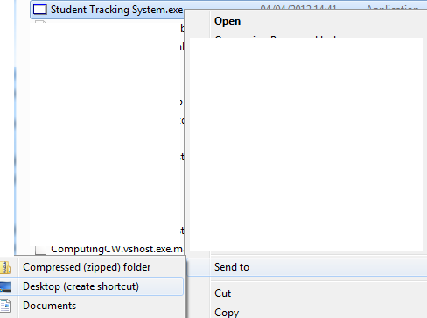Create a new shortcut on the desktop -- Browse into the newly copied folder and right click on the Student Tracking System.exe and select “Send to -> Desktop” as show in Fig.1

Fig.1Creating a new shortcut

1. To then run the software, double click on new icon from the desktop.

# 3. The different Tabs

## All Students Part 1

This is the first screen you will be presented with. Each number below details the indicated section.

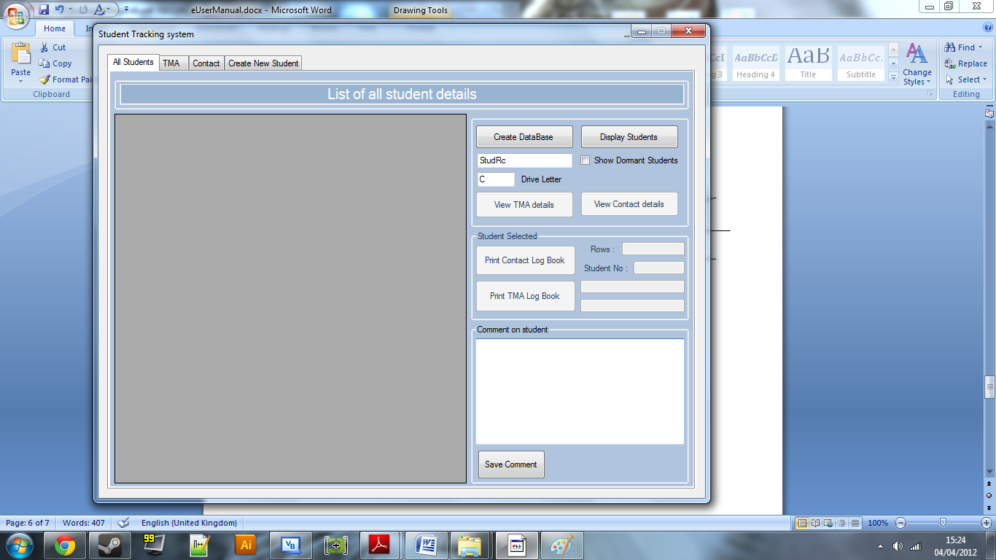

Fig. 2 All Students Tab

1

3

2

1a

1b

1. The create database button – When pressed creates the storage for the new student records.

NOT ADVISED YOU CHANGE THESE

* 1. The name of the database
  2. The drive where the database will be stored

1. Display students button – This finds the information from the database and displays it in the grey grid above, but on the first start up no information will be displayed.
2. Create Students TAB – This will need to be selected in order to create new students

# 4. Creating a new student

## Create New Student Tab

After selecting this tab on the first run, you will need to enter in new students details

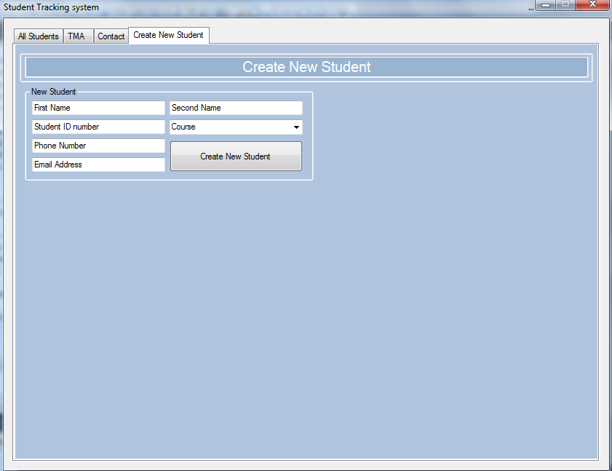

1a

3

2

1

Fig. 3 Create New Student Tab

1. Boxes to enter in new student information – From the **Log Book** sent by **Oxford Open Learning** you can find the details above, e.g. the name and student ID can be found from this T.M.A. **Log Book** but the contact details like phone number and email must be found on the Contact **Log Book**, note that some students don’t have a contact phone number, if this is the case type “N/A” in the Phone Number field.

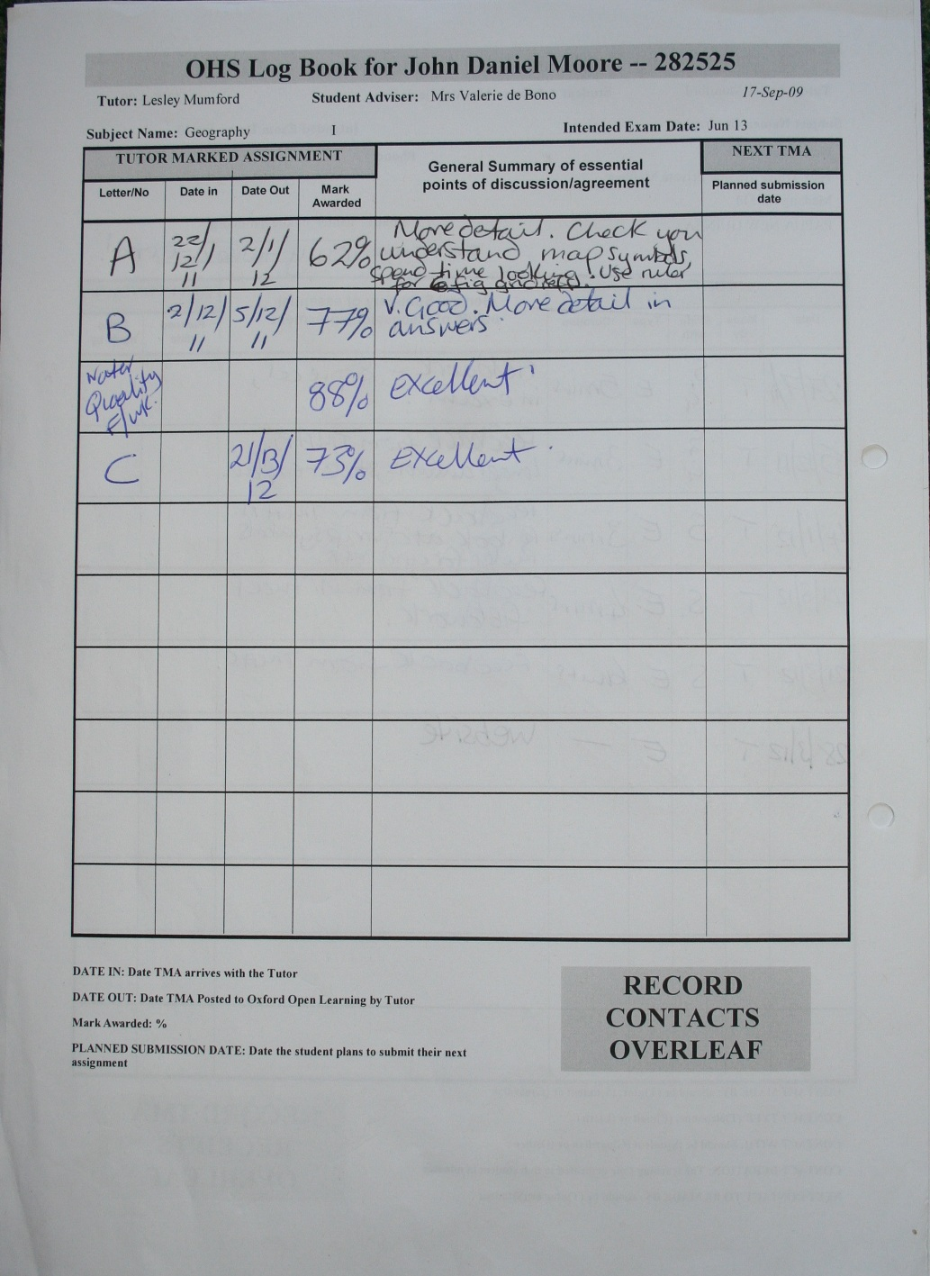

Fig. 4 - O.O.L. T.M.A. Log Book

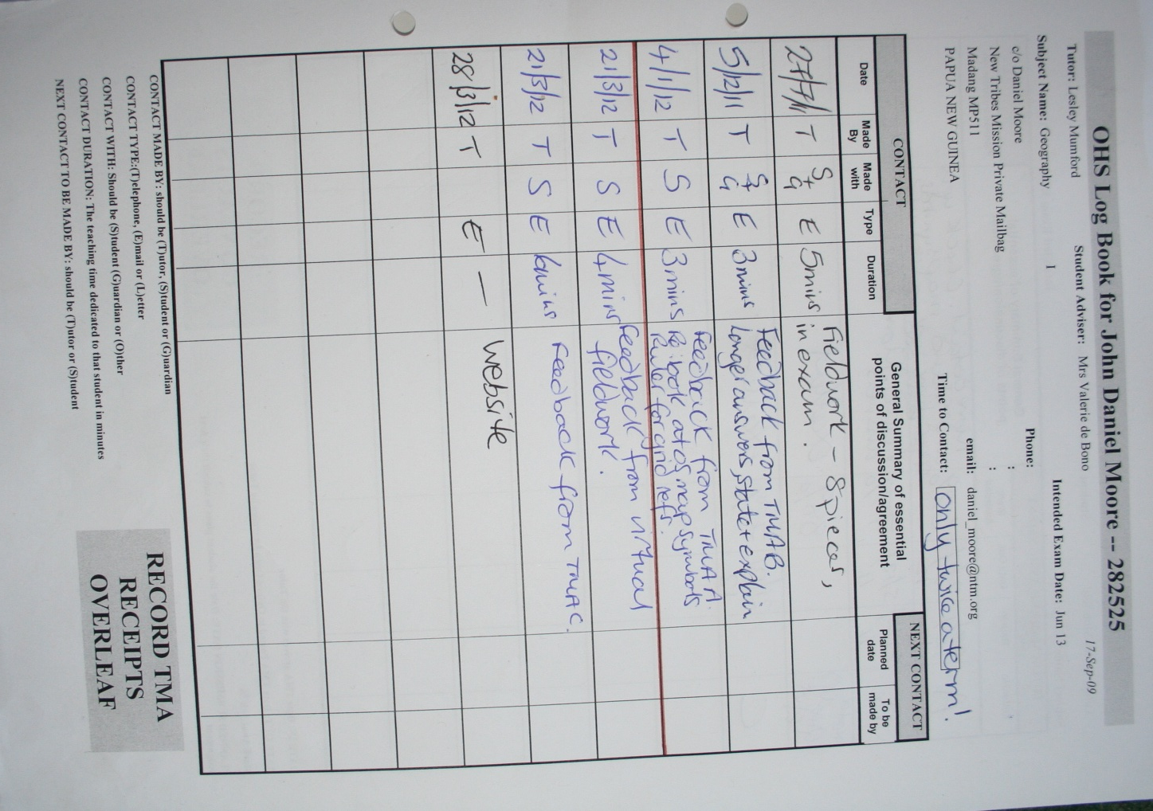

Fig. 5 O.O.L. Contact Log Book

1. a. Select the course the students on from the dropdown list of courses.
2. Create new student button – This will present a dialog box notifying you of the students name you have entered into the database. You can re-enter another set of student details and press this button again as many times as necessary.
3. 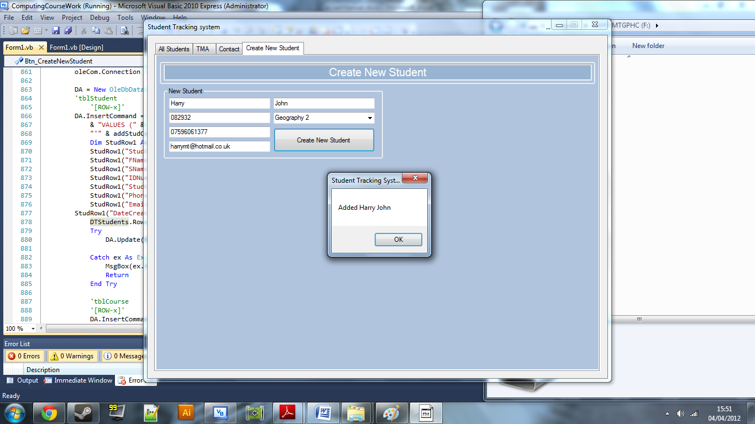Return back to the All Students Tab – When you have finished entering students details press this tab to return to the main screen.

Dialog box Fig. 6

# 5. Displaying all students

## All Students Part 2

After entering students details you are presented with the “All students” Tab in a different state.

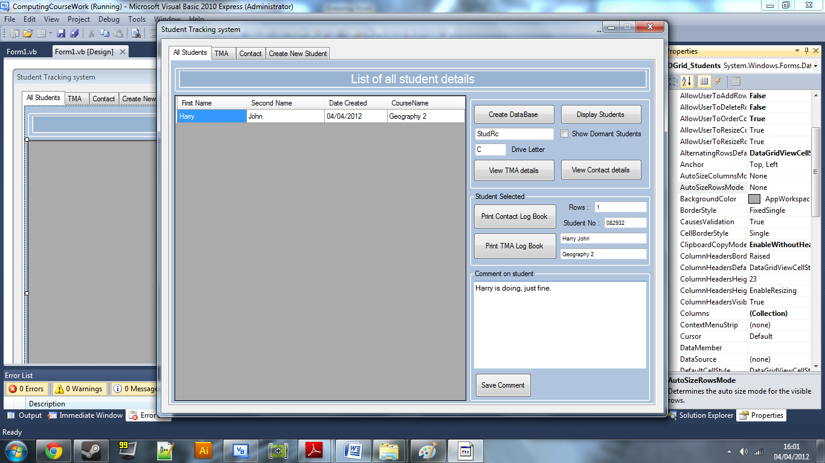

5

4

3

2

1e

1d

1c

1b

1a

1

All Students Tab with students information Fig. 7

1. The students are displayed in this grid, if you select one the information below is displayed, this also enables you to view more in depth details about the selected student, such as the T.M.A. details and contact times with this student.
   1. How many records are displayed, note this is un-dormant students only.
   2. Details about the student such as their student ID number
   3. The comment about the selected student is displayed, upon editing that information and pressing the save comment button, the edits are saved to that student.
   4. Print Contact Log Book, this option is also available on the Contact Tab and enables a report to be printed from Microsoft word, about the selected student and any contact details that the tutor has made.
   5. Similar to the Contact print, this prints a report of T.M.A. from Microsoft word.
2. To view T.M.A. details on the selected student
3. To view Contact details about the selected student
4. To create more students navigate to this tab

### Dormant

To show only dormant Students check this box before selecting the view students details button

# 6. Creating a new Contact time for a particular student

## Contact Tab

This tab displays all the contact times the tutor has had with the selected student.

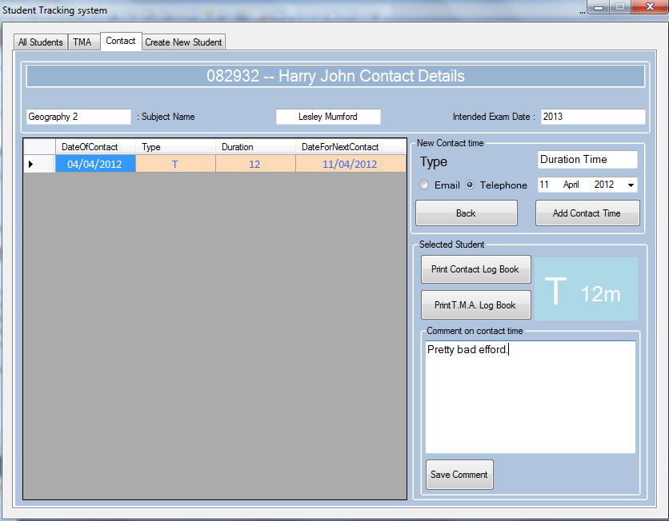

3

2

1c

1b

1a

1

Contact Tab Fig. 8

1. List of Contact details – Select one and more in depth details are displayed
   1. The Type and Duration are displayed in big for easy recognition
   2. Like the student comment, a contact comment can be edited and saved by this button
   3. Printing a contact or TMA report is similar to the All students Tab
2. New contact information, this is the type of contact, the length the contact took, and the date for the next contact time
3. Press back to navigate back to the All students tab

# 7. Creating a new T.M.A. for a particular student

## TMA

This tab displays the list of T.M.A. of the selected student, enables the tutor to enter in new received T.M.A. and edit comments on them.

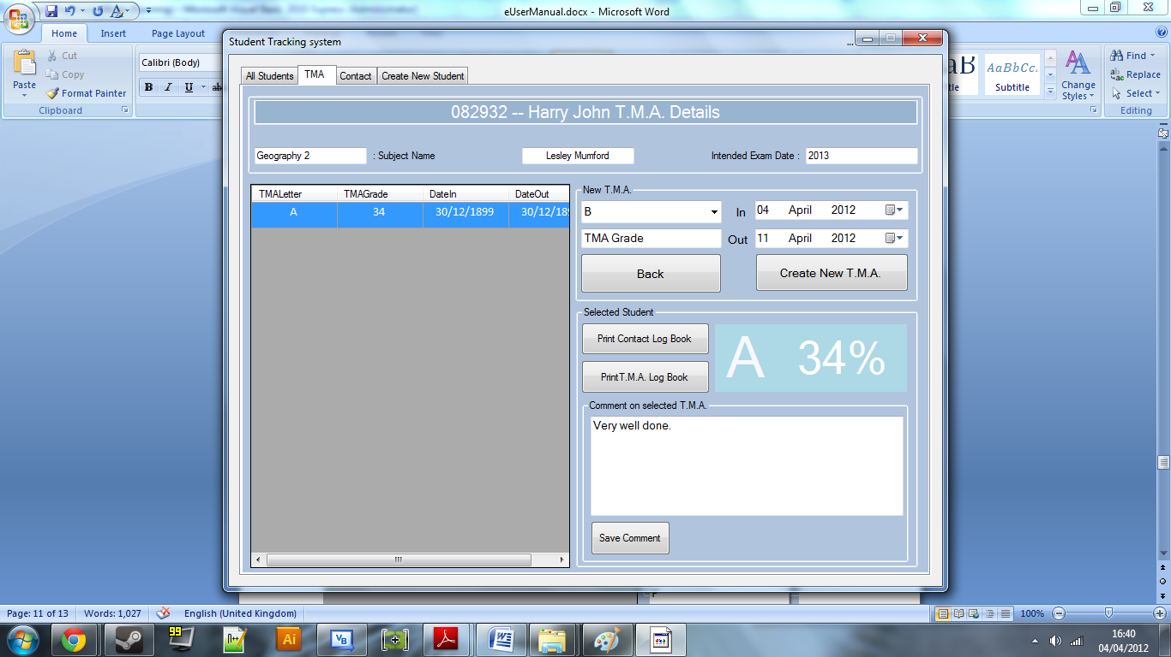

1c

1b

1a

3

2

1

TMA Tab Fig. 9

1. List of T.M.A. details – Select one and more in depth details are displayed
   1. The TMA Letter and Grade are displayed in big for easy recognition
   2. Like the student and Contact comment, a TMA Comment can be edited and saved by this button
   3. Printing a contact or TMA report is similar to the All students and Contact Tabs
2. New TMA information, this is the TMA letter, which is calculated based upon what TMA the student has already done, e.g. not A in the above case , the In date of the TMA and the Out Date, these have defaulted to today’s date and one week in advance respectively
3. Press back to navigate back to the All students tab

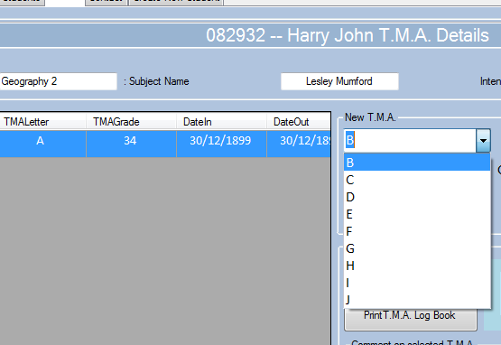

New TMA Letter Fig. 10

# 8. Print a T.M.A. report

**Microsoft Word**

Pressing the Print TMA report button on any tab (except the Create New Student Tab) will bring up a word document with a table showing the students T.M.A. information. To print this document, go to file – print.

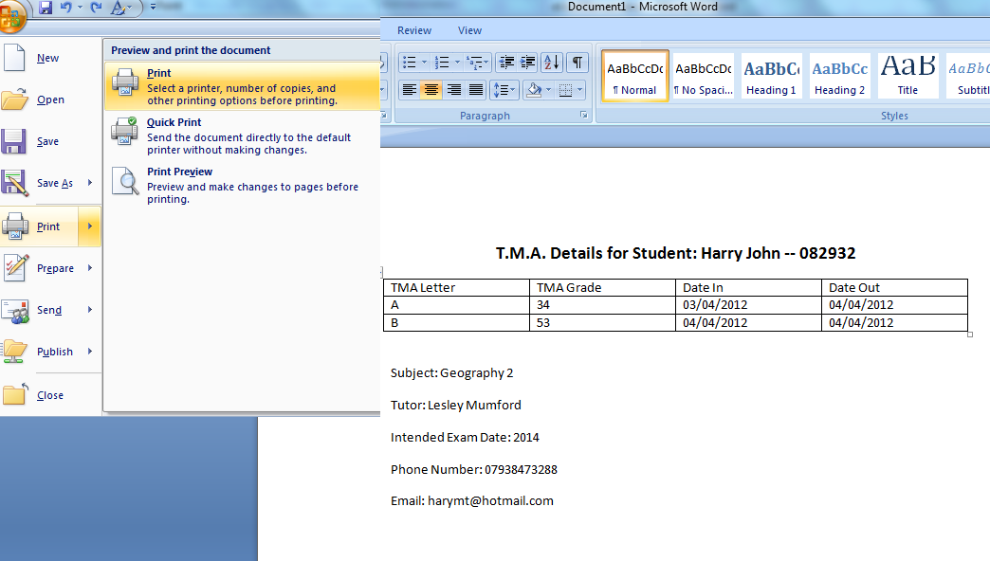

Print TMA Report Fig. 11

# 9. Print a Contact report

**Microsoft Word**

Pressing the Print Contact report button on any tab (except the Create New Student Tab) will bring up a word document with a table showing the students Contact information. To print this document, go to file – print.

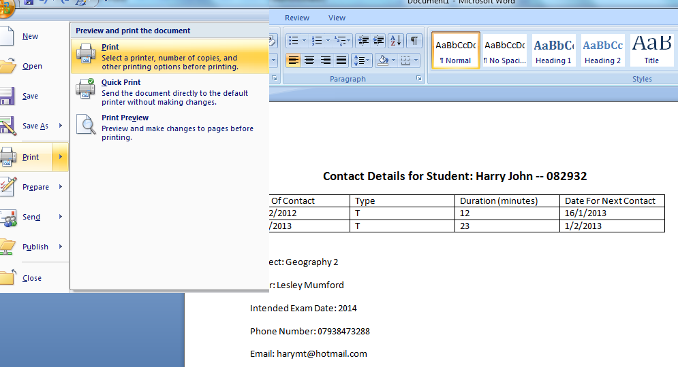

Print Contact Report Fig. 12

Evaluation Contents

Comparison against original objectives 123

User Feedback 125

Further Development 126

Final Conclusion 127

## Comparison against original objectives

For the final conclusion, the system needs to be compared against the original objectives from the analysis, to see if they have been completed.

They are below:

The System must be able to:

1. Display a list of student details into a grid. These include the date each student record was created, the first, second name of each student and the corresponding course name for each student,
2. Enable the user to select a student from the grid and more in depth details about the selected student are displayed, such as a comment about the student and the student ID of the selected student,
3. Display in a similar grid the **Tutor Marked Assignments** details corresponding to the selected student when a button is pressed. These are the **T.M.A.** grade, the **T.M.A.** letter number that relates to the grade and the date in and out dates for each **T.M.A.,**
4. Calculate the average grade of student results for each **T.M.A.**and display a percentage and grade for each students **T.M.A.**
5. Create a new **T.M.A.** record for the selected student based on the input values by the tutor,
6. Display in another grid the **Contact** details relating to the selected student. These are the times the tutor has interacted with the student, the type of the contact, the length of the contact, the date and the next expected date for another contact,
7. Create a new Contact record for the selected student, specific to the inputted values by the tutor,
8. Enable the user to create a new student record based on values entered by the tutor,
9. Make a student record **Dormant** when they haven’t produced work or responded with the tutor in a 3 month period,
   * Reactivate **Dormant** student records when they contact the tutor again via email or post within a year
10. Print a **Log Book T.M.A.** sheet with all the **T.M.A.** details relating to a particular student, make the report similar to the current system  **T.M.A. Log Book**
11. Print a **Log Book** Contact sheet with all of the details of a particular student, again have a similar report to the current system
12. Have support for the storage of old students who have completed their course, but these must not normally be displayed when viewing students.

|  |  |
| --- | --- |
| 1 | The information can be easily viewed in a table, including the student name, date the record was created and the course that student is on. |
| 2 | The comment on the student and the student ID are successfully displayed in boxes when the student is selected. |
| 3 | When the **T.M.A.** button is pressed, details are displayed in another table corresponding to the selected student, such as the **T.M.A**. Letter and the grade corresponding to the **T.M.A.** |
| 4 | After another discussion with the user, I came to a conclusion that this was unnecessary, so it was not implemented. |
| 5 | When details for the **T.M.A.** are entered and a button is pressed, a new **T.M.A.** record is created into the database. |
| 6 | Similar to the **T.M.A.** the contact details are displayed when the user presses a similar button. |
| 7 | Again similar to **T.M.A.**, contact records are created specific to the values inputted by tutors. |
| 8 | The tutor can create new students when their new records are entered into the system. |
| 9 | A button is available to enable and disable students to become dormant or not, upon the users input. – Students become dormant when their last **T.M.A.** was submitted 3 months from today. |
| 10 | Users can print **T.M.A.** log books from the TMA tab, but not from the main tab. This was decided to speed up the display part when the user selects a student, because otherwise the **T.M.A.** records would have to be fetched from the database each time a user selects a student, so this was removed.  The **T.M.A.** printout looks somewhat similar to the original but lacks black bars although these are irrelevant. |
| 11 | The printout for the **Contact** sheet has a similar style to the **T.M.A.** and was also removed from the all students tab. |
| 12 | Old students are students who have completed their course. After a discussion with the user, I came to a conclusion that the records don’t need to be viewed by the tutor, only to have some storage of these students. The database file still holds the student records but they aren’t displayed when the tutor views the students. |

## User Feedback – Analyse as you go

The following letter is from the user expressing their feedback on the project.

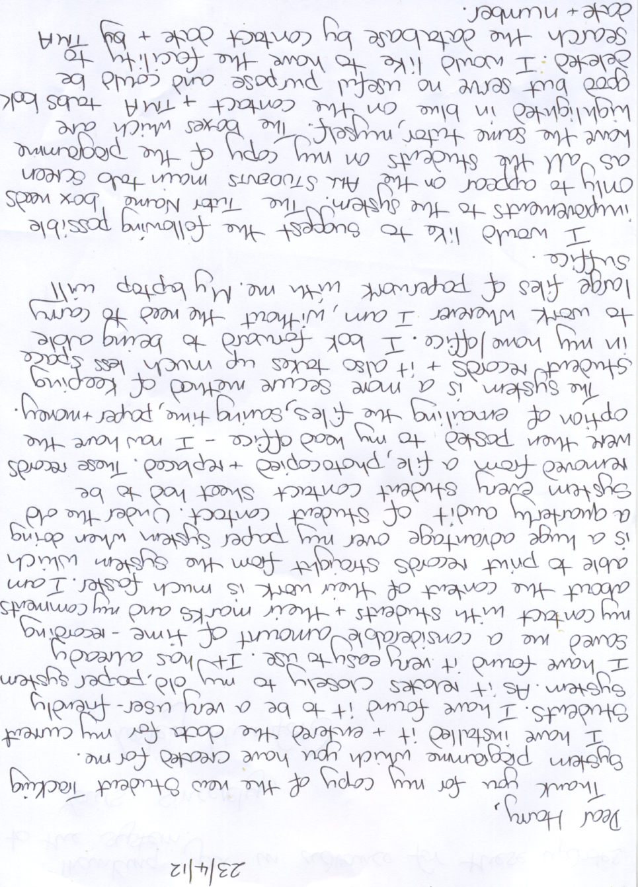

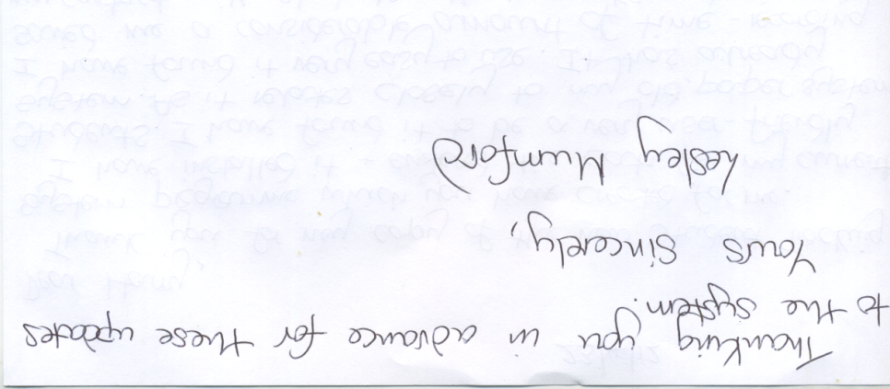

Based on the feedback letter from the user and the further development suggested by the user, the project has met the majority of the SMART objectives. The user’s further needs are minor and can be easily created into the system for the user.

## Further Development

If this project was to be developed further, some elements need to be considered, such as:

* The printing of **Log Books** could be tweaked. Setting the style of the print out identical to the original **Log Book**. This would enable a style to be created and text to be inserted into certain parts of the page, as opposed to the current new system, where the design is created when the text is inserted.
* Enable the use of printing **Log Books** from the all students tab, this could be achieved by fetching the student records when the button is pressed and not when each student is selected.
* Graphs of student data can be implemented with statistical information presented to the tutor. This data could be presented to the student as a report of their current grade and their **T.M.A.** results. Trend lines and scatter charts could be useful for yearly information, where the tutor can see the average grade of their students throughout the year.
* System could be turned into an online service, where the student and tutor can access the system from anywhere. Using mysql and an online server to store the student records, although security would need to be considered when choosing this route.
* Email could be automated with a mailmerge technique where the user has a button to send a reminder to students who are behind. This sends multiple emails to all students. Students could also submit work to the tutor via email and the tutor can receive work in the system.

Overall the user should be able to use this new system with less effort than the old system. If the user can see the benefit, then they will be happy to use and support this system. This is why further developments are important.

Appendix Contents

A.1 Questionnaire 131

A.2 Annotated Code 134

A.3 T.M.A. Log Books 157

TMA 157

Contact 158

A.4 System Print reports 159

TMA report 159

Contact report 160

A.5 Letter of feedback from user 161

# A.1 Questionnaire

List of Answers the user gave in response to the following questions:

|  |  |  |  |  |  |
| --- | --- | --- | --- | --- | --- |
| **The current system** | Describe the current system. | | | | |
| Paper system, looking through, filing paper. | | | | |
| Describe the problems with the current system. | | | | |
| Only paper, slow, labour intensive and have to look through every student before you know daily tasks | | | | |
| List the areas of the current system that are to be retained. | | | | |
| Marking, phoning, emailing. | | | | |
| **Possible solutions** | List the possible solutions to the problem. | | | | |
| List to see all the students who haven’t been marked yet and have alerts to list all of the students that need to be contacted, etc. | | | | |
| List the problems with implementing each of the possible solutions. | | | | |
| Have to manually type in all of the data, which could be a disadvantage if an error is made. | | | | |
| **Inputs** | List the inputs. | | | | |
| Details of new students from OOL, Student Description Sheet (SDS)  Un-marked from students Tutor Marked Assignments (TMA’s),  Emails from the student | | | | |
| List any special formats of input required. | | | | |
| Emails, phone calls | | | | |
| **Outputs** | List the outputs with any special formats required. | Is each output printed? Y/N | | How often is the output required? | |
| Marked TMA’s  Phone calls to have Work Review and Check Up | N | | Whenever the student sends the tutor work, weekly. | |
| **Processes** | List the processes that need to be performed on the data. | | | | |
| Record the data | | | | |
| List the searches that need to be performed. | | | | |
| For student Name, Date of Sent work, Type of course, Date until work due, TMA number | | | | |
| List any calculations that are required. | | | | |
| Addition of marks and percentage of total marks | | | | |
| Lists errors/exceptions that might occur and how they will be processed. | | | | |
| Loss of data – If not found students SDS  Time loss through lack of searching  - secure databases , easily searchable | | | | |
| **Data** | List the data that needs to be stored. | | How many records are expected? | | Immediate or batch update? |
| * Who contacted the tutor, Student or guardian. * How long were the phone calls? * Student overall marks. * Name, * Date of arrival, * Contact Details, * Student ID number | | 20-40 students so 40+ | | Immediate |
| **Security** | List any limits to areas of the system for different users. | | | | |
| N/A | | | | |
| List users who need usernames and passwords. | | | | |
| N/A | | | | |
| List types of personal data that will be entered into the system. | | | | |
| Students Name, Date of birth, Identification number and mark | | | | |
| **Hardware and software** | List the hardware the user currently owns. | | | | |
| Netbook with monitor resolution: 1280 x 800 and printer | | | | |
| List the hardware required for the new system. | | | | |
| N/A | | | | |
| List the software the user currently owns. | | | | |
| Microsoft word, Microsoft Outlook | | | | |
| List the software required for the new system. | | | | |
| Visual basic.net IDE | | | | |

|  |  |
| --- | --- |
| **Finances** | How much money is available for the new system? |
| £0 – a budget is unnecessary due to a family member as the user |
| **Further considerations** | List any further ideas the user wishes you to consider. |
| Quick call up of students data, marks, name, dates, Check-up Times, Work Review Times, contact details  Storage system,  Alerts for the above. |

# A.2 Annotated Code

Note comments are already inserted into the code. I will also be using the boxes (below) to state any ambiguous statements.

Imports System.Data.OleDb

Defining only the necessary global variables

Imports Word = Microsoft.Office.Interop.Word

'( - - - - - - - - - - - )'

'( Harry Mumford -Turner )'

'( Student Tracking Sys )'

'( Last Edited : 29/03 )'

'( - - - - - - - - - - - )'

PublicClassForm1

Dim SSStudentID, SSCourseID, SSTMAID AsInteger

Dim DTStudents, DTCourses, DTStudentCourses, DTContacts, DTTMAS, DTStudentTMAS AsDataTable

Dim DTofTMA AsDataTable = NewDataTable

Dim DTofContact AsDataTable = NewDataTable

Dim DTAllStud AsDataTable = NewDataTable

Dim DA AsOleDbDataAdapter

Dim DS AsDataSet

Dim oleCom AsOleDbCommand

Dim oleCon AsOleDbConnection

DimTables(6) AsString

PrivateSub MainForm_Load(ByVal sender As System.Object, ByVal e As System.EventArgs) HandlesMyBase.Load

EndSub

'Database load

PrivateSub Btn_CreateDB_Click(sender As System.Object, e As System.EventArgs) Handles Btn_CreateDB.Click

'Check to see where the Checkdatabase function has been called from

Dim CreateDB AsBoolean = True

CheckDatabaseExists(CreateDB)

Data base error checking

EndSub

FunctionCheckDatabaseExists(ByRef CreateDB AsBoolean)

'Gives the DBPath name based on user entered values

Dim DatabasePathName AsString = TBox_DriveLetter.Text &":\"& TBox_DatabaseName.Text &".accdb"

'Applies the connection string with the pathname

Dim ConnectionString AsString = "Provider=Microsoft.ACE.OLEDB.12.0;Data Source="& DatabasePathName &";"

'If the directory exists and the user has clicked the create DB button then a message box is displayed informing the user and 'new' is added to the filename

IfDir(DatabasePathName) <>""And CreateDB = TrueThen

MsgBox("Database allready exists.")

TBox_DatabaseName.Text = TBox_DatabaseName.Text &"new"

ElseIfDir(DatabasePathName) <>""And CreateDB = FalseThen

'If the database does exist and the user clicked on the Display Students button then simply get the connection string

Else

'Or if the database really does not exist then create it using the above strings

CreateDatabase(ConnectionString)

EndIf

'Returns the connection string to the caller of this function

CheckDatabaseExists = ConnectionString

EndFunction

PrivateSubCreateDatabase(ByVal ConnectionString AsString)

'Create New ADOX Database Object, commands which enable the creation of the database

Dim adoxDB AsNew ADOX.Catalog

Dim adodbCon AsNew ADODB.Connection

Dim adodbCom AsNew ADODB.Command

'Validation for the creation of tables

'A counter which increments when a table is created

Dim NoTables AsInteger = 0

'Creates the database in the entered pathname

adoxDB.Create(ConnectionString)

'The PathName is set to the connection object so we connected to the database

adodbCon.ConnectionString = ConnectionString

'Opens the connection between the database and the Data set

adodbCon.Open()

adoxDB.ActiveConnection = adodbCon

'Creates each table for the database

Creating each table in the database, syntax would change if this was used with a different storage system.

Dim SQLString AsString

' ------------------------

'Create tblStudent

' ------------------------

SQLString = "CREATE TABLE tblStudent " _

&"(" _

&"StudID LONG, " _

&"CONSTRAINT pk_StudID PRIMARY KEY (StudID), " _

&"FName TEXT(60), " _

&"SName TEXT(60), " _

&"IDNumber TEXT(6), " _

&"StudComment TEXT(200), " _

&"PhoneNo TEXT(15), " _

&"EmailAddress TEXT(40), " _

&"DateCreated DATE" _

&")"

'The SQL is inserted into the command object which is then executed

adodbCom.CommandText = SQLString

adodbCom.ActiveConnection = adodbCon

adodbCom.Execute()

'The counter incrementing

NoTables += 1

' ------------------------

' Create tblCourse

' ------------------------

SQLString = "CREATE TABLE tblCourse " _

&"(" _

&"CourseID LONG, " _

&"CONSTRAINT pk_CourseID PRIMARY KEY (CourseID), " _

&"CourseName TEXT(20)" _

&")"

adodbCom.CommandText = SQLString

adodbCom.ActiveConnection = adodbCon

adodbCom.Execute()

NoTables += 1

' ------------------------

' Create tblStudentCourse

' ------------------------

'Note defining a compound primary key below

SQLString = "CREATE TABLE tblStudentCourse " _

&"(" _

&"StudID LONG, " _

&"CourseID LONG, " _

&"CONSTRAINT fk_Coursetbl FOREIGN KEY (CourseID) REFERENCES tblCourse(CourseID), " _

&"CONSTRAINT fk_Studenttbl FOREIGN KEY (StudID) REFERENCES tblStudent(StudID), " _

&"PRIMARY KEY (StudID, CourseID), " _

&"StartDate DATE, " _

&"EndDate DATE, " _

&"Dormant TEXT(6)" _

&")"

adodbCom.CommandText = SQLString

adodbCom.ActiveConnection = adodbCon

adodbCom.Execute()

NoTables += 1

' ------------------------

' Create tblTMA

' ------------------------

SQLString = "CREATE TABLE tblTMA " _

&"(" _

&"TMAID LONG, " _

&"CONSTRAINT pk_TMAID PRIMARY KEY (TMAID), " _

&"CourseID LONG, " _

&"CONSTRAINT fk_TMACoursetbl FOREIGN KEY (CourseID) REFERENCES tblCourse(CourseID), " _

&"TMALetter TEXT(1)" _

&")"

adodbCom.CommandText = SQLString

adodbCom.ActiveConnection = adodbCon

adodbCom.Execute()

NoTables += 1

' ------------------------

' Create tblStudent-TMA

' ------------------------

SQLString = "CREATE TABLE tblStudentTMA " _

&"(" _

&"StudID LONG, " _

&"CourseID LONG, " _

&"TMAID LONG, " _

&"CONSTRAINT fk_TMAtbl FOREIGN KEY (TMAID) REFERENCES tblTMA(TMAID), " _

&"CONSTRAINT fk_StudentCourseStudTMAtbl FOREIGN KEY (StudID, CourseID) REFERENCES tblStudentCourse(StudID, CourseID), " _

&"Grade INTEGER, " _

&"DateIn DATE, " _

&"DateOut DATE, " _

&"TMAComment TEXT(200)" _

&")"

adodbCom.CommandText = SQLString

adodbCom.ActiveConnection = adodbCon

adodbCom.Execute()

NoTables += 1

' ------------------------

' Create tblContact Table

' ------------------------

SQLString = "CREATE TABLE tblContact " _

&"(" _

&"StudID LONG, " _

&"ContactID LONG, " _

&"DateOfContact DATE, " _

&"Type TEXT(1), " _

&"Duration INTEGER, " _

&"ContactComment TEXT(200), " _

&"DateForNextContact DATE, " _

&"CONSTRAINT fk_StudentContacttbl FOREIGN KEY (StudID) REFERENCES tblStudent(StudID)" _

&")"

adodbCom.CommandText = SQLString

adodbCom.ActiveConnection = adodbCon

adodbCom.Execute()

NoTables += 1

'Dialog box to notify the user of completion

MessageBox.Show("Database with "& NoTables &" table(s) has been successfully created!")

EndSub

'Display Students

PrivateSub Btn_DisplayStudents_Click(ByVal sender As System.Object, ByVal e As System.EventArgs) Handles Btn_DisplayStudents.Click

'Enables the searching for dormant students

Dim ShowDormantOnly AsBoolean = False

Runs a check to see if the user wants to search for dormant students

Dim CreateDB AsBoolean = False

If CBox_ShowDormant.Checked = TrueThen

ShowDormantOnly = True

ElseIf CBox_ShowDormant.Checked = FalseThen

ShowDormantOnly = False

EndIf

'Subroutine to populate the dataset with datatables extracted from the database

PopulateDSandDT(CheckDatabaseExists(CreateDB)) ' "CheckDatabaseExists" is a function which does just that and creates the DB if it doesn't

'the function returns the DB connection string, which is used when populating the dataset

DisplayStudents(ShowDormantOnly)

EndSub

PrivateSubPopulateDSandDT(ByVal ConStr)

'Form connection string and open the database connection

oleCon = NewOleDbConnection(ConStr)

oleCon.Open()

'Define DA and DS

DA = NewOleDbDataAdapter

DS = NewDataSet

oleCom = NewOleDbCommand

oleCom.Connection = oleCon

Tables(0) = "tblStudent"

Tables(1) = "tblCourse"

Tables(2) = "tblStudentCourse"

Tables(3) = "tblTMA"

Tables(4) = "tblStudentTMA"

Tables(5) = "tblContact"

'Fill a dataset with multiple Data tables

DA.SelectCommand = oleCom

For i = 0 ToTables.GetUpperBound(0) - 1

DA.SelectCommand.CommandText = "SELECT * FROM "&Tables(i)

DA.Fill(DS, Tables(i))

Next

Fill each data set table from each database table

'Close the connection

oleCon.Close()

'Map the 'default' names to actual names

DA.TableMappings.Add("Table", "tblStudent")

DA.TableMappings.Add("Table1", "tblCourse")

DA.TableMappings.Add("Table2", "tblStudentCourse")

DA.TableMappings.Add("Table3", "tblTMA")

DA.TableMappings.Add("Table4", "tblStudentTMA")

DA.TableMappings.Add("Table5", "tblContact")

'Create explicit table names to clarify code

DTStudents = DS.Tables(0)

DTCourses = DS.Tables(1)

DTStudentCourses = DS.Tables(2)

DTTMAS = DS.Tables(3)

Creating relationships between each table

DTStudentTMAS = DS.Tables(4)

DTContacts = DS.Tables(5)

'Create database relationships for the dataset

'Student - StudentCourse

DS.Relations.Add(NewDataRelation("StudStudCorRelation", DTStudents.Columns("StudID"), DTStudentCourses.Columns("StudID"), True))

'Course - StudentCourse

DS.Relations.Add(NewDataRelation("CourStudCorRelation", DTCourses.Columns("CourseID"), DTStudentCourses.Columns("CourseID"), True))

'Course - TMA

DS.Relations.Add(NewDataRelation("CourTMARelation", DTCourses.Columns("CourseID"), DTTMAS.Columns("CourseID"), True))

'TMA - StudentTMA

DS.Relations.Add(NewDataRelation("TMAStudTMA", DTTMAS.Columns("TMAID"), DTStudentTMAS.Columns("TMAID"), True))

'Student - Contact

DS.Relations.Add(NewDataRelation("StudContactRelation", DTStudents.Columns("StudID"), DTContacts.Columns("StudID"), True))

'Compound Primary Key For

' StudentCourse - StudentTMA

'Create an array of datacolumns where the 2 primary keys are held

DimSCcpk(1), SCSTcpk(1) AsDataColumn

SCcpk(0) = DTStudentCourses.Columns("StudID")

SCcpk(1) = DTStudentCourses.Columns("CourseID")

SCSTcpk(0) = DTStudentTMAS.Columns("StudID")

SCSTcpk(1) = DTStudentTMAS.Columns("CourseID")

'Enforces the relations between these 2 keys

DS.Relations.Add(NewDataRelation("CPKStudentTMA", SCcpk, SCSTcpk, True))

DS.EnforceConstraints = True

'Gets the number of rows in the students table and displays it for the user

TBox_allstudNoRows.Text = DTStudents.Rows.Count

'Enables the user commands for the ability to print

GBox_SS.Enabled = True

EndSub

SubDisplayStudents(ShowDormantOnly AsBoolean)

Algorithm to locate the courseID of each student

DTAllStud = CreateTempDTStudents()

Dim StudCourseRow AsDataRow

Dim CourseRow AsDataRow

Dim StudRow AsDataRow

'Goes through each row in DTStudents to see if the StudID matches in DTStudentCourses

If ShowDormantOnly = TrueThen

ForEach StudRow InDTStudents.Rows()

ForEach StudCourseRow InDTStudentCourses.Select("StudID = "& StudRow.Item("StudID") &" AND Dormant = 'True'")

'Goes through each row in DTCourses to see if the courseID of DTStudentCourses match

ForEach CourseRow InDTCourses.Select("CourseID = "& StudCourseRow.Item("CourseID"))

'If they do then add a new row to the 'AllStud' datatable based on the other records in the matching course row

Dim Addingrow AsDataRow = DTAllStud.NewRow()

Dim tempDateCreated AsDate = StudRow.Item("DateCreated")

With Addingrow

.Item(0) = StudRow.Item("StudID")

.Item(1) = StudRow.Item("FName")

.Item(2) = StudRow.Item("SName")

.Item(3) = tempDateCreated.ToString("d")

.Item(4) = StudRow.Item("StudComment")

.Item(5) = CourseRow.Item("CourseID")

.Item(6) = CourseRow.Item("CourseName")

.Item(7) = StudRow.Item("IDNumber")

EndWith

DTAllStud.Rows.Add(Addingrow)

Next

Next

Next

Else

ForEach StudRow InDTStudents.Rows()

ForEach StudCourseRow InDTStudentCourses.Select("StudID = "& StudRow.Item("StudID") &" AND Dormant = 'False'")

'Goes through each row in DTCourses to see if the courseID of DTStudentCourses match

ForEach CourseRow InDTCourses.Select("CourseID = "& StudCourseRow.Item("CourseID"))

'If they do then add a new row to the 'AllStud' datatable based on the other records in the matching course row

Dim Addingrow AsDataRow = DTAllStud.NewRow()

Dim tempDateCreated AsDate = StudRow.Item("DateCreated")

With Addingrow

.Item(0) = StudRow.Item("StudID")

.Item(1) = StudRow.Item("FName")

.Item(2) = StudRow.Item("SName")

.Item(3) = tempDateCreated.ToString("d")

.Item(4) = StudRow.Item("StudComment")

.Item(5) = CourseRow.Item("CourseID")

.Item(6) = CourseRow.Item("CourseName")

.Item(7) = StudRow.Item("IDNumber")

EndWith

DTAllStud.Rows.Add(Addingrow)

Next

Next

Next

EndIf

'Creates a new view on the data which uses the temporary data table to be displayed in the Data grid view

Dim view AsDataView = NewDataView

view.Table = DTAllStud

DGrid_Students.DataSource = view

'Renames the headers - making them look more pleasurable to the user

With DGrid_Students

.Columns.Item("FName").HeaderText() = "First Name"

.Columns.Item("SName").HeaderText() = "Second Name"

.Columns.Item("DateCreated").HeaderText() = "Date Created"

.Columns.Item("StudComment").Visible = False

.Columns.Item("StudID").Visible = False

Create a temporary data table where the student information is

.Columns.Item("CourseID").Visible = False

.Columns.Item("StudentNumber").Visible = False

EndWith

EndSub

FunctionCreateTempDTStudents()

'Declare a new datatable, name it and give it new datacolumns

Dim tempDT AsDataTable = NewDataTable

tempDT.TableName = "AllStudents"

'StudentID Column

Dim StudentIDColumn AsDataColumn = NewDataColumn

StudentIDColumn.DataType = System.Type.GetType("System.Single")

StudentIDColumn.ColumnName = "StudID"

' FirstName Column

Dim FirstNameColumn AsDataColumn = NewDataColumn

FirstNameColumn.DataType = System.Type.GetType("System.String")

FirstNameColumn.ColumnName = "FName"

'SurName Column

Dim SurNameColumn AsDataColumn = NewDataColumn

SurNameColumn.DataType = System.Type.GetType("System.String")

SurNameColumn.ColumnName = "SName"

'DateCreatedC olumn

Dim DateCreatedColumn AsDataColumn = NewDataColumn

DateCreatedColumn.DataType = System.Type.GetType("System.String")

DateCreatedColumn.ColumnName = "DateCreated"

'StudComment Column

Dim StudCommentColumn AsDataColumn = NewDataColumn

StudCommentColumn.DataType = System.Type.GetType("System.String")

StudCommentColumn.ColumnName = "StudComment"

'CourseID Column

Dim CourseIDColumn AsDataColumn = NewDataColumn

CourseIDColumn.DataType = System.Type.GetType("System.Single")

CourseIDColumn.ColumnName = "CourseID"

'CourseName Column

Dim CourseNameColumn AsDataColumn = NewDataColumn

CourseNameColumn.DataType = System.Type.GetType("System.String")

CourseNameColumn.ColumnName = "CourseName"

'Student Number Column

Dim StudentNumberColumn AsDataColumn = NewDataColumn

StudentNumberColumn.DataType = System.Type.GetType("System.String")

StudentNumberColumn.ColumnName = "StudentNumber"

'Add the columns to the newly created Datatable

With tempDT.Columns

.Add(StudentIDColumn)

.Add(FirstNameColumn)

.Add(SurNameColumn)

.Add(DateCreatedColumn)

.Add(StudCommentColumn)

.Add(CourseIDColumn)

.Add(CourseNameColumn)

.Add(StudentNumberColumn)

EndWith

Return tempDT

EndFunction

'Select a student

PrivateSub DataGridView_Students_CellClick(ByVal sender As System.Object, ByVal e As System.Windows.Forms.DataGridViewCellEventArgs) Handles DGrid_Students.CellClick

Btn_MakeDormant.Enabled = True

Btn_MakeUNDormant.Enabled = True

'If the user selects a column to sort the data by that column then an error wont occur

If e.RowIndex < 0 Then

Else

Btn_ViewContact.Enabled = True

Btn_ViewTMA.Enabled = True

'When the user clicks on a cell it selects the row which contains the information below this information is placed into variables which are displayed in textboxes

'Join First and Second Names together for the main box

TBox_allstudStudName.Text = DGrid_Students.Rows(e.RowIndex).Cells("FName").Value &" "& DGrid_Students.Rows(e.RowIndex).Cells("SName").Value

'Student Comment

TBox_StudComment.Text = DGrid_Students.Rows(e.RowIndex).Cells("StudComment").Value

'CourseName is placed in a textbox as well as in the data grid for the user to find it more easily

TBox_allstudCourse.Text = DGrid_Students.Rows(e.RowIndex).Cells("CourseName").Value

'Gets the student ID number

TBox_allstudSIDNO.Text = DGrid_Students.Rows(e.RowIndex).Cells("StudentNumber").Value

'Count the number of rows in the datagrid

TBox_allstudNoRows.Text = DGrid_Students.Rows.Count.ToString

'Fetch the Selected Student StudentID and Course ID

SSStudentID = DGrid_Students.Rows(e.RowIndex).Cells("StudID").Value

SSCourseID = DGrid_Students.Rows(e.RowIndex).Cells("CourseID").Value

EndIf

EndSub

'TMA details

PrivateSub Btn_ViewTMA_Click(ByVal sender As System.Object, ByVal e As System.EventArgs) Handles Btn_ViewTMA.Click

'CourseName

TBox_tmaCourse.Text = TBox_allstudCourse.Text

'Find Exam Date

Dim tempStartDate AsDateTime

ForEach row InDTStudentCourses.Select("StudID = "& SSStudentID &" AND CourseID = "& SSCourseID)

tempStartDate = row.Item("StartDate")

If TBox_tmaCourse.Text = "Geography 2"Then

TBox_tmaExamDate.Text = tempStartDate.AddYears(2).Year.ToString("d")

Else

TBox_tmaExamDate.Text = tempStartDate.AddYears(1).Year.ToString("d")

EndIf

Next

Fetches the Exam date based on the current year and when the student joined

'DTPicker

DTP_DateIn.Value = Date.Today

DTP_DateOut.Value = Date.Today.AddDays(7)

'Border

TBox_BorderTMA.Text = TBox_allstudSIDNO.Text &" -- "& TBox_allstudStudName.Text &" T.M.A. Details"

'Moves the display over to the TMA tab

TCtrl_Student.SelectTab(1)

'Populates the TMA datagrid with the TMA relating to the selected student

PopulateTMADGrid()

EndSub

SubPopulateTMADGrid()

'Resets the datatable so errors won’t occur

DTofTMA.Reset()

'Creates a new table with the below columns

DTofTMA.TableName = "SelectedStudent"

Dim TMALetterColumn AsDataColumn = NewDataColumn

TMALetterColumn.DataType = System.Type.GetType("System.String")

TMALetterColumn.ColumnName = "TMALetter"

Dim TMAGradeColumn AsDataColumn = NewDataColumn

TMAGradeColumn.DataType = System.Type.GetType("System.Decimal")

TMAGradeColumn.ColumnName = "TMAGrade"

Dim DateInColumn AsDataColumn = NewDataColumn

DateInColumn.DataType = System.Type.GetType("System.String")

DateInColumn.ColumnName = "DateIn"

Dim DateOutColumn AsDataColumn = NewDataColumn

DateOutColumn.DataType = System.Type.GetType("System.String")

DateOutColumn.ColumnName = "DateOut"

Dim TMAIDColumn AsDataColumn = NewDataColumn

TMAIDColumn.DataType = System.Type.GetType("System.Single")

TMAIDColumn.ColumnName = "TMAID"

Dim StudIDColumn AsDataColumn = NewDataColumn

StudIDColumn.DataType = System.Type.GetType("System.Single")

StudIDColumn.ColumnName = "StudID"

Dim CourseIDColumn AsDataColumn = NewDataColumn

CourseIDColumn.DataType = System.Type.GetType("System.Single")

CourseIDColumn.ColumnName = "CourseID"

Dim TMACommentColumn AsDataColumn = NewDataColumn

TMACommentColumn.DataType = System.Type.GetType("System.String")

TMACommentColumn.ColumnName = "TMAComment"

With DTofTMA

.Columns.Add(TMALetterColumn)

.Columns.Add(TMAGradeColumn)

.Columns.Add(DateInColumn)

.Columns.Add(DateOutColumn)

.Columns.Add(StudIDColumn)

.Columns.Add(CourseIDColumn)

.Columns.Add(TMACommentColumn)

.Columns.Add(TMAIDColumn)

EndWith

'Creates a new view and fill the above columns with data from the pure data tables

Dim view AsDataView = NewDataView

Dim StudTMArow AsDataRow

Dim TMArow AsDataRow

ForEach StudTMArow InDTStudentTMAS.Select("StudID = "& SSStudentID &" AND CourseID = "& SSCourseID)

ForEach TMArow InDTTMAS.Select("TMAID = "& StudTMArow.Item("TMAID") &" AND CourseID = "& SSCourseID)

Dim addingrow AsDataRow

addingrow = DTofTMA.NewRow()

Dim tempDateIn AsDate = StudTMArow.Item("DateIn")

Dim tempDateOut AsDate = StudTMArow.Item("DateOut")

With addingrow

.Item(0) = TMArow.Item("TMALetter")

.Item(1) = StudTMArow.Item("Grade")

.Item(2) = tempDateIn.ToString("d")

.Item(3) = tempDateOut.ToString("d")

.Item(4) = StudTMArow.Item("StudID")

.Item(5) = StudTMArow.Item("CourseID")

.Item(6) = StudTMArow.Item("TMAComment")

.Item(7) = TMArow.Item("TMAID")

EndWith

DTofTMA.Rows.Add(addingrow)

Next

Next

'Point the newly created datatable to the view which points to the datagrid

view.Table = DTofTMA

DGrid_TMA.DataSource = view

'Hide the index columns and others that wont be visible to the user

With DGrid_TMA

.Columns.Item("StudID").Visible = False

.Columns.Item("CourseID").Visible = False

.Columns.Item("TMAID").Visible = False

.Columns.Item("TMAComment").Visible = False

EndWith

'Get the maximum TMA Letter

Dim RowOfTMALetter AsInteger = DGrid_TMA.Rows.Count - 1

Dim TMALetter AsString

Try

TMALetter = DGrid_TMA.Rows(RowOfTMALetter).Cells("TMALetter").Value

Catch ex AsException

TMALetter = "Null"

EndTry

'Clears the Old TMA Letters that were previously in the Combo Box

CBox_TMALetterAdd.Items.Clear()

'For the adding of new student

'Fills the combo box with the correct TMALetter Names

Dim CourseNameRow AsDataRow

Dim AddTMALetters AsBoolean

ForEach CourseNameRow InDTCourses.Select("CourseID = "& SSCourseID)

SelectCaseCourseNameRow.Item("CourseName")

Case"Mathematics Year 7"To"Mathematics Year 8"

ForEach c In"ABCDEF".ToCharArray()

Gets the TMA letter, for the Combo Box where the user creates TMA, based upon the course the selected student is on.

If c = TMALetter Then

AddTMALetters = True

ElseIf TMALetter = "Null"Then

CBox_TMALetterAdd.Items.Add(c)

Else

If AddTMALetters = TrueThen

CBox_TMALetterAdd.Items.Add(c)

EndIf

EndIf

Next c

Case"Geography 1"To"Geography 2"

ForEach c In"ABCDEFGHIJ".ToCharArray()

If c = TMALetter Then

AddTMALetters = True

ElseIf TMALetter = "Null"Then

CBox_TMALetterAdd.Items.Add(c)

Else

If AddTMALetters = TrueThen

CBox_TMALetterAdd.Items.Add(c)

EndIf

EndIf

Next c

EndSelect

Next

EndSub

'TMA select

PrivateSub DataGridView_TMAStudent_CellClick(sender As System.Object, e As System.Windows.Forms.DataGridViewCellEventArgs) Handles DGrid_TMA.CellClick

'If the user selects a column to sort the data by that column then an error wont occur

If e.RowIndex < 0 Then

Else

'Fill the textboxes with the information about the selected student

lb_TMALetter.Text = DGrid_TMA.Rows(e.RowIndex).Cells("TMALetter").Value

Tbox_Grade.Text = DGrid_TMA.Rows(e.RowIndex).Cells("TMAGrade").Value &"%"

TBox_TMAComment.Text = DGrid_TMA.Rows(e.RowIndex).Cells("TMAComment").Value

SSTMAID = DGrid_TMA.Rows(e.RowIndex).Cells("TMAID").Value

EndIf

EndSub

'TMA Add

PrivateSub Button_AddnewTMA_Click(sender As System.Object, e As System.EventArgs) Handles Btn_AddTMA.Click

'Get the max TMAID

Dim SQL AsString = "SELECT MAX(TMAID) FROM tblStudentTMA"

Dim MaxTMAID AsInteger

Dim oleComScalar AsNewOleDbCommand(SQL, oleCon)

oleComScalar.Connection.Open()

Try

MaxTMAID = oleComScalar.ExecuteScalar()

Catch ex AsException

'If there isn’t any values let TMAID = 1

MaxTMAID = 0

EndTry

Create a new TMA with values entered in by the user

MaxTMAID += 1

oleCom.Connection = oleCon

'Add to Dataset

Dim TMAtblrow AsDataRow

TMAtblrow = DS.Tables("tblTMA").NewRow()

TMAtblrow.Item("CourseID") = SSCourseID

TMAtblrow.Item("TMAID") = MaxTMAID

TMAtblrow.Item("TMALetter") = CBox_TMALetterAdd.Text

DTTMAS.Rows.Add(TMAtblrow)

Dim StudTMAtblrow AsDataRow

StudTMAtblrow = DS.Tables("tblStudentTMA").NewRow()

StudTMAtblrow.Item("StudID") = SSStudentID

StudTMAtblrow.Item("CourseID") = SSCourseID

StudTMAtblrow.Item("TMAID") = MaxTMAID

StudTMAtblrow.Item("Grade") = CInt(TBox_GradeAdd.Text)

StudTMAtblrow.Item("DateIn") = DTP_DateIn.Value.ToString("d")

StudTMAtblrow.Item("DateOut") = DTP_DateOut.Value.ToString("d")

StudTMAtblrow.Item("TMAComment") = TBox_TMAComment.Text

DTStudentTMAS.Rows.Add(StudTMAtblrow)

'Add to Database

DA.InsertCommand = NewOleDbCommand("INSERT INTO tblTMA (CourseID, TMAID, TMALetter) " _

&"VALUES ("& SSCourseID &", "& MaxTMAID &", '"& CBox_TMALetterAdd.Text &"')", oleCon)

DA.Update(DTTMAS)

DA.InsertCommand = NewOleDbCommand("INSERT INTO tblStudentTMA (StudID, CourseID, TMAID, Grade, DateIn, DateOut, TMAComment) " _

&"VALUES ("& SSStudentID &", "& SSCourseID &", "& MaxTMAID &", '"&CInt(TBox_GradeAdd.Text) &"', #"& DTP_DateIn.Value.ToString("d") &"#, #"& DTP_DateOut.Value.ToString("d") &"#, '"& TBox_TMAComment.Text &"')", oleCon)

DA.Update(DTStudentTMAS)

DS.AcceptChanges()

oleCon.Close()

'Repopulates the datagrid with the new information

PopulateTMADGrid()

EndSub

'TMA Print

PrivateSub Btn_tmaPrintTMA_Click(sender As System.Object, e As System.EventArgs) Handles Btn_tmaPrintTMA.Click

Dim oWord As Word.Application

Dim oDoc As Word.Document

Dim oTable As Word.Table

Edited non-Candidate coding here, although a lot of it is customized to my needs

Dim oPara1, oPara2, oPara3, oPara4 As Word.Paragraph

Dim missing AsObject = System.Reflection.Missing.Value

'Start Word and open the document template.

oWord = CreateObject("Word.Application")

oWord.Visible = True

oDoc = oWord.Documents.Add

'Insert a paragraph at the beginning of the document.

oPara1 = oDoc.Content.Paragraphs.Add

oPara1.Range.Text = "T.M.A. Details for Student: "& TBox_allstudStudName.Text &" -- "& TBox_allstudSIDNO.Text

oPara1.Range.Font.Bold = True

oPara1.Format.SpaceAfter = 12 '12 pt spacing after paragraph.

oPara1.Range.InsertParagraphAfter()

oPara1.Range.Font.Bold = False

oPara1.Range.InsertFile(TBox_DriveLetter.Text &":\StudContactReport.docx", missing, False, False, False)

Dim MaxRows AsInteger

MaxRows = DGrid_TMA.Rows.Count

'Insert a MaxRows x 4 table, fill it with data

Dim r AsInteger, c AsInteger

oTable = oDoc.Tables.Add(oDoc.Bookmarks.Item("\endofdoc").Range, MaxRows + 1, 4)

oTable.Range.ParagraphFormat.SpaceAfter = 6

oTable.Borders.Enable = True

oTable.Cell(1, 1).Range.Text = "TMA Letter"

oTable.Cell(1, 2).Range.Text = "TMA Grade"

oTable.Cell(1, 3).Range.Text = "Date In"

oTable.Cell(1, 4).Range.Text = "Date Out"

For r = 2 To MaxRows + 1

For c = 1 To 4

oTable.Cell(r, c).Range.Text = DGrid_TMA.Rows(r - 2).Cells.Item(c - 1).Value.ToString

Next

Next

oTable.Rows.Item(1).Range.Font.Bold = True

'Add some text after the table.

oPara2 = oDoc.Content.Paragraphs.Add(oDoc.Bookmarks.Item("\endofdoc").Range)

oPara2.Range.Text = "Subject: "& TBox_tmaCourse.Text

oPara2.Format.SpaceAfter = 1

oPara2.Range.InsertParagraphAfter()

oPara2.Range.InsertFile(TBox_DriveLetter.Text &":\StudContactReport.docx", missing, False, False, False)

oPara3 = oDoc.Content.Paragraphs.Add(oDoc.Bookmarks.Item("\endofdoc").Range)

oPara3.Range.Text = "Tutor: Lesley Mumford"

oPara3.Format.SpaceAfter = 1

oPara3.Range.InsertParagraphAfter()

oPara3.Range.InsertFile(TBox_DriveLetter.Text &":\StudContactReport.docx", missing, False, False, False)

oPara4 = oDoc.Content.Paragraphs.Add(oDoc.Bookmarks.Item("\endofdoc").Range)

oPara4.Range.Text = "Intended Exam Date: "& TBox_tmaExamDate.Text

oPara4.Format.SpaceAfter = 1

oPara4.Range.InsertParagraphAfter()

oPara4.Range.InsertFile(TBox_DriveLetter.Text &":\StudContactReport.docx", missing, False, False, False)

EndSub

'Contact details

PrivateSub Btn_ViewContact_Click(sender As System.Object, e As System.EventArgs) Handles Btn_ViewContact.Click

'CourseName

TBox_contCourse.Text = TBox_allstudCourse.Text

'Find Exam Date

Dim tempStartDate AsDateTime

ForEach row InDTStudentCourses.Select("StudID = "& SSStudentID &" AND CourseID = "& SSCourseID)

tempStartDate = row.Item("StartDate")

If TBox_contCourse.Text = "Geography 2"Then

TBox_contExamDate.Text = tempStartDate.AddYears(2).Year.ToString("d")

Else

TBox_contExamDate.Text = tempStartDate.AddYears(1).Year.ToString("d")

EndIf

Next

'Fill Phone and email

ForEach row InDTStudents.Select("StudID = "& SSStudentID)

TBox_PhoneNo.Text = row.Item("PhoneNo")

TBox_EmailAddress.Text = row.Item("EmailAddress")

Next

'DTPicker

DTP_FutureContTime.Value = Date.Today.AddDays(7)

'Border

TBox_BorderContact.Text = TBox_allstudSIDNO.Text &" -- "& TBox_allstudStudName.Text &" Contact Details"

'Moves the display over to the Contact tab

TCtrl_Student.SelectTab(2)

Display the Contact details

PopulateContactDGrid()

EndSub

SubPopulateContactDGrid()

'Resets the datatable so errors wont occur

DTofContact.Reset()

DTofContact.TableName = "SelectedStudent"

'Creates a new table with the below columns

Dim DateOfContactColumn AsDataColumn = NewDataColumn

DateOfContactColumn.DataType = System.Type.GetType("System.DateTime")

DateOfContactColumn.ColumnName = "DateOfContact"

Dim TypeColumn AsDataColumn = NewDataColumn

TypeColumn.DataType = System.Type.GetType("System.String")

TypeColumn.ColumnName = "Type"

Dim DurationColumn AsDataColumn = NewDataColumn

DurationColumn.DataType = System.Type.GetType("System.Single")

DurationColumn.ColumnName = "Duration"

Dim DateForNextContactColumn AsDataColumn = NewDataColumn

DateForNextContactColumn.DataType = System.Type.GetType("System.DateTime")

DateForNextContactColumn.ColumnName = "DateForNextContact"

Dim StudIDColumn AsDataColumn = NewDataColumn

StudIDColumn.DataType = System.Type.GetType("System.Single")

StudIDColumn.ColumnName = "StudID"

Dim ContactIDColumn AsDataColumn = NewDataColumn

ContactIDColumn.DataType = System.Type.GetType("System.Single")

ContactIDColumn.ColumnName = "ContactID"

Dim ContactCommentColumn AsDataColumn = NewDataColumn

ContactCommentColumn.DataType = System.Type.GetType("System.String")

ContactCommentColumn.ColumnName = "ContactComment"

With DTofContact

.Columns.Add(DateOfContactColumn)

.Columns.Add(TypeColumn)

.Columns.Add(DurationColumn)

.Columns.Add(DateForNextContactColumn)

.Columns.Add(ContactCommentColumn)

.Columns.Add(StudIDColumn)

.Columns.Add(ContactIDColumn)

EndWith

'Creates a new view and fill the above columns with data from the pure data tables

Dim view AsDataView = NewDataView

Dim ContactRow AsDataRow

ForEach ContactRow In DTContacts.Rows

Dim addingrow AsDataRow

addingrow = DTofContact.NewRow()

Dim tempDateForNextContact AsDateTime = ContactRow.Item("DateForNextContact")

Dim tempDateOfContact AsDateTime = ContactRow.Item("DateOfContact")

With addingrow

.Item("DateOfContact") = tempDateOfContact.ToString("d")

.Item("Type") = ContactRow.Item("Type")

.Item("Duration") = ContactRow.Item("Duration")

.Item("DateForNextContact") = tempDateForNextContact.ToString("d")

.Item("ContactComment") = ContactRow.Item("ContactComment")

.Item("StudID") = ContactRow.Item("StudID")

.Item("ContactID") = ContactRow.Item("ContactID")

EndWith

DTofContact.Rows.Add(addingrow)

Next

'Point the newly created datatable to the view which points to the datagrid

view.Table = DTofContact

DGrid_Contact.DataSource = view

'Hide the index columns to the user

With DGrid_Contact

.Columns.Item("StudID").Visible = False

.Columns.Item("ContactID").Visible = False

.Columns.Item("ContactComment").Visible = False

EndWith

EndSub

'Contact select

PrivateSub DGrid_Contact_CellClick(sender As System.Object, e As System.Windows.Forms.DataGridViewCellEventArgs) Handles DGrid_Contact.CellClick

'If the user selects a column to sort the data by that column then an error wont occur

If e.RowIndex < 0 Then

Else

lb_contTypeBig.Text = DGrid_Contact.Rows(e.RowIndex).Cells("Type").Value

lb_contDurationBig.Text = DGrid_Contact.Rows(e.RowIndex).Cells("Duration").Value &"m"

TBox_contComment.Text = DGrid_Contact.Rows(e.RowIndex).Cells("ContactComment").Value

EndIf

EndSub

'Contact add

PrivateSub Btn_ContTimeAdd_Click(sender As System.Object, e As System.EventArgs) Handles Btn_ContTimeAdd.Click

'Get the maximum contactID from the contact table

Dim MaxContactID AsInteger

Dim SQL AsString = "SELECT MAX(ContactID) FROM tblContact"

Dim oleComScalar AsNewOleDbCommand(SQL, oleCon)

oleComScalar.Connection.Open()

Try

MaxContactID = oleComScalar.ExecuteScalar()

Catch ex AsException

MaxContactID = 0

EndTry

Creating a new Contact record

MaxContactID += 1

oleCom.Connection = oleCon

'Add to Dataset

Dim Contacttblrow AsDataRow

Contacttblrow = DTContacts.NewRow()

Dim Type AsString

'See what type is selected

If Rbtn_contEmailAdd.Checked Then

Type = "E"

Else

Type = "T"

EndIf

Contacttblrow.Item("StudID") = SSStudentID

Contacttblrow.Item("ContactID") = MaxContactID

Contacttblrow.Item("DateOfContact") = Date.Today.ToString("d")

Contacttblrow.Item("Type") = Type

Contacttblrow.Item("Duration") = CInt(TBox_Duration.Text)

Contacttblrow.Item("ContactComment") = "Enter Comment here"

Contacttblrow.Item("DateForNextContact") = DTP_FutureContTime.Value.ToString("d")

DTContacts.Rows.Add(Contacttblrow)

'Add to Database

DA.InsertCommand = NewOleDbCommand("INSERT INTO tblContact (StudID, ContactID, DateOfContact, Type, Duration, ContactComment, DateForNextContact) " _

&"VALUES ("& SSStudentID &","& MaxContactID &", #"&Date.Today.ToString("d") &"#, '"& Type &"', "&CInt(TBox_Duration.Text) &", 'Enter Comment here', #"& DTP_FutureContTime.Value.ToString("d") &"#)", oleCon)

DA.Update(DTContacts)

DS.AcceptChanges()

oleCon.Close()

PopulateContactDGrid()

EndSub

'Contact Print

PrivateSub Btn_contPrintContact_Click(sender As System.Object, e As System.EventArgs) Handles Btn_contPrintContact.Click

Dim oWord As Word.Application

Dim oDoc As Word.Document

Dim oTable As Word.Table

Dim oPara1, oPara2, oPara3, oPara4, oPara5, oPara6 As Word.Paragraph

Dim missing AsObject = System.Reflection.Missing.Value

'Start Word and open the document template.

Printing a new contact record, again customized non-candidate coding here

oWord = CreateObject("Word.Application")

oWord.Visible = True

oDoc = oWord.Documents.Add

'Insert a paragraph at the beginning of the document.

oPara1 = oDoc.Content.Paragraphs.Add

oPara1.Range.Text = "Contact Details for Student: "& TBox_allstudStudName.Text &" -- "& TBox_allstudSIDNO.Text

oPara1.Range.Font.Bold = True

oPara1.Format.SpaceAfter = 12 '12 pt spacing after paragraph.

oPara1.Range.InsertParagraphAfter()

oPara1.Range.Font.Bold = False

oPara1.Range.InsertFile(TBox_DriveLetter.Text &":\StudContactReport.docx", missing, False, False, False)

Dim MaxRows AsInteger

ForEach row InDTContacts.Select("StudID = "& SSStudentID)

MaxRows += 1

Next

'Insert a MaxRows x 4 table, fill it with data

Dim r AsInteger, c AsInteger

oTable = oDoc.Tables.Add(oDoc.Bookmarks.Item("\endofdoc").Range, MaxRows + 1, 4)

oTable.Range.ParagraphFormat.SpaceAfter = 6

oTable.Borders.Enable = True

oTable.Cell(1, 1).Range.Text = "Date Of Contact"

oTable.Cell(1, 2).Range.Text = "Type"

oTable.Cell(1, 3).Range.Text = "Duration"

oTable.Cell(1, 4).Range.Text = "Date for Next Contact"

For r = 2 To MaxRows + 1

For c = 1 To 4

oTable.Cell(r, c).Range.Text = DGrid_Contact.Rows(r - 2).Cells.Item(c - 1).Value.ToString

Next

Next

oTable.Rows.Item(1).Range.Font.Bold = True

'Add some text after the table.

oPara2 = oDoc.Content.Paragraphs.Add(oDoc.Bookmarks.Item("\endofdoc").Range)

oPara2.Range.InsertParagraphBefore()

oPara2.Range.Text = "Subject: "& TBox_contCourse.Text

oPara2.Format.SpaceAfter = 24

oPara2.Range.InsertParagraphAfter()

oPara2.Range.InsertFile(TBox_DriveLetter.Text &":\StudContactReport.docx", missing, False, False, False)

oPara3 = oDoc.Content.Paragraphs.Add(oDoc.Bookmarks.Item("\endofdoc").Range)

oPara3.Range.InsertParagraphBefore()

oPara3.Range.Text = "Tutor: Lesley Mumford"

oPara3.Format.SpaceAfter = 30

oPara3.Range.InsertParagraphAfter()

oPara3.Range.InsertFile(TBox_DriveLetter.Text &":\StudContactReport.docx", missing, False, False, False)

oPara4 = oDoc.Content.Paragraphs.Add(oDoc.Bookmarks.Item("\endofdoc").Range)

oPara4.Range.InsertParagraphBefore()

oPara4.Range.Text = "Intended Exam Date: "& TBox_contExamDate.Text

oPara4.Format.SpaceAfter = 30

oPara4.Range.InsertParagraphAfter()

oPara4.Range.InsertFile(TBox_DriveLetter.Text &":\StudContactReport.docx", missing, False, False, False)

oPara5 = oDoc.Content.Paragraphs.Add(oDoc.Bookmarks.Item("\endofdoc").Range)

oPara5.Range.InsertParagraphBefore()

oPara5.Range.Text = "Phone Number : "& TBox_EmailAddress.Text

oPara5.Format.SpaceAfter = 30

oPara5.Range.InsertParagraphAfter()

oPara5.Range.InsertFile(TBox_DriveLetter.Text &":\StudContactReport.docx", missing, False, False, False)

oPara6 = oDoc.Content.Paragraphs.Add(oDoc.Bookmarks.Item("\endofdoc").Range)

oPara6.Range.InsertParagraphBefore()

oPara6.Range.Text = "Email Address : "& TBox_PhoneNo.Text

oPara6.Format.SpaceAfter = 30

oPara6.Range.InsertParagraphAfter()

oPara6.Range.InsertFile(TBox_DriveLetter.Text &":\StudContactReport.docx", missing, False, False, False)

EndSub

'Create New student

PrivateSub Btn_CreateNewStudent_Click(ByVal sender As System.Object, ByVal e As System.EventArgs) Handles Btn_CreateNewStudent.Click

Dim addFName AsString = TBox_NewFN.Text

Dim addSName AsString = TBox_NewSN.Text

Dim addCourse AsString = CBox_NewCourse.Text

Dim addPhoneNum AsString = TBox_NewPhoneNo.Text

Dim addStudComment AsString = "Enter a Comment here"

Dim addEmailAddress AsString = TBox_NewEmail.Text

Dim addStudIDno AsString = TBox_NewIDNO.Text

'If the textboxes = what they originally = then error message

If addFName = "First Name"Or addSName = "Second Name"Or addCourse = "Course"Or addPhoneNum = "Phone Number"Or addEmailAddress = "Email Address"Or addStudIDno = "Student ID number"Then

MsgBox("Please Fill all fields")

Return

EndIf

Dim DatabasePathName AsString = TBox_DriveLetter.Text &":\"& TBox_DatabaseName.Text &".accdb"

Dim ConStr AsString = "Provider=Microsoft.ACE.OLEDB.12.0;Data Source="& DatabasePathName &";"

'Get the maximum stud ID

Dim SQL AsString = "SELECT MAX(StudID) FROM tblStudent"

oleCon = NewOleDbConnection(ConStr)

Dim oleComScalar AsNewOleDbCommand(SQL, oleCon)

oleComScalar.Connection.Open()

Dim NewStudID AsInteger

Try

NewStudID = oleComScalar.ExecuteScalar()

Catch ex AsException

NewStudID = 0

EndTry

NewStudID += 1

'Get the maximum CourseID

Creating a new student record, gets the max StudID and inserts the user entered values into the database

SQL = "SELECT MAX(CourseID) FROM tblCourse"

oleComScalar = NewOleDbCommand(SQL, oleCon)

Dim NewCourseID AsInteger

Try

NewCourseID = oleComScalar.ExecuteScalar()

Catch ex AsException

NewCourseID = 0

EndTry

NewCourseID += 1

'Form connection string and open the database connection

oleCom = NewOleDbCommand

oleCom.Connection = oleCon

DA = NewOleDbDataAdapter

'tblStudent

'[ROW-x]'

DA.InsertCommand = NewOleDbCommand("INSERT INTO tblStudent (StudID, FName, SName, IDNumber, StudComment, PhoneNo, EmailAddress, DateCreated) " _

&"VALUES ("& NewStudID &", '"& addFName &"', '"& addSName &"', '"& addStudIDno &"', "& _

"'"& addStudComment &"', '"& addPhoneNum &"', '"& addEmailAddress &"', #"&Date.Today.ToString("d") &"#)", oleCon)

Dim StudRow1 AsDataRow = DTStudents.NewRow()

StudRow1("StudID") = NewStudID

StudRow1("FName") = addFName

StudRow1("SName") = addSName

StudRow1("IDNumber") = addStudIDno

StudRow1("StudComment") = addStudComment

StudRow1("PhoneNo") = addPhoneNum

StudRow1("EmailAddress") = addEmailAddress

StudRow1("DateCreated") = Date.Today.ToString("d")

DTStudents.Rows.Add(StudRow1)

Try

DA.Update(DTStudents)

Catch ex AsException

MsgBox(ex.Message)

NewStudID = 0

NewCourseID = 0

Return

EndTry

DS.AcceptChanges()

'tblCourse

DA.InsertCommand = NewOleDbCommand("INSERT INTO tblCourse (CourseID, CourseName) " _

&"VALUES ("& NewCourseID &", '"& CBox_NewCourse.Text &"')", oleCon)

Dim CourseRow1 AsDataRow = DS.Tables(1).NewRow()

CourseRow1("CourseID") = NewCourseID

CourseRow1("CourseName") = CBox_NewCourse.Text

DTCourses.Rows.Add(CourseRow1)

DA.Update(DTCourses)

DS.AcceptChanges()

'tblStudentCourse

Dim EndDate AsString

If CBox_NewCourse.Text = "Geography 2"Then

EndDate = Date.Today.AddYears(2).ToString("d")

Else

EndDate = Date.Today.AddYears(1).ToString("d")

EndIf

DA.InsertCommand = NewOleDbCommand("INSERT INTO tblStudentCourse (StudID, CourseID, StartDate, EndDate, Dormant) " _

&"VALUES ("& NewStudID &", "& NewCourseID &", #"&Date.Today.ToString("d") &"#, #"& EndDate &"#, 'False')", oleCon)

Dim SCRow1 AsDataRow = DS.Tables(2).NewRow()

SCRow1("StudID") = NewStudID

SCRow1("CourseID") = NewCourseID

SCRow1("StartDate") = Date.Today.ToString("d")

SCRow1("EndDate") = EndDate

SCRow1("Dormant") = "False"

Other code relating to the back buttons and the changing of tab pages

DTStudentCourses.Rows.Add(SCRow1)

DA.Update(DTStudentCourses)

DS.AcceptChanges()

oleCon.Close()

MsgBox("Added "& addFName &" "& addSName)

EndSub

'##Others

PrivateSub Btn_tmaBack_Click(sender As System.Object, e As System.EventArgs) Handles Btn_tmaBack.Click

TCtrl_Student.SelectTab(0)

EndSub

PrivateSub Btn_contBack_Click(sender As System.Object, e As System.EventArgs) Handles Btn_contBack.Click

TCtrl_Student.SelectTab(0)

EndSub

PrivateSub TBox_GradeAdd_Click(sender As System.Object, e As System.EventArgs) Handles TBox_GradeAdd.Click

TBox_GradeAdd.Text = ""

EndSub

PrivateSub TPage_AllStud_Click(sender As System.Object, e As System.EventArgs) Handles TPage_AllStud.Click

EndSub

PrivateSub TCtrl_Student_SelectedIndexChanged(ByVal sender AsObject, ByVal e As System.EventArgs) Handles TCtrl_Student.SelectedIndexChanged

Dim i AsInteger

i = TCtrl_Student.SelectedIndex

If i = 0 Then

Dim ShowDormatnOnly AsBoolean = False

DisplayStudents(ShowDormatnOnly)

'Gets the number of rows in the students table and displays it for the user

TBox_allstudNoRows.Text = DTStudents.Rows.Count

EndIf

EndSub

PrivateSub TBox_NewFN_Click(sender As System.Object, e As System.EventArgs) Handles TBox_NewFN.Click

TBox_NewFN.SelectAll()

EndSub

PrivateSub TBox_NewIDNO_Click(sender As System.Object, e As System.EventArgs) Handles TBox_NewIDNO.Click

TBox_NewIDNO.SelectAll()

EndSub

PrivateSub TBox_NewPhoneNo_Click(sender As System.Object, e As System.EventArgs) Handles TBox_NewPhoneNo.Click

TBox_NewPhoneNo.SelectAll()

EndSub

PrivateSub TBox_NewEmail_Click(sender As System.Object, e As System.EventArgs) Handles TBox_NewEmail.Click

TBox_NewEmail.SelectAll()

EndSub

PrivateSub TBox_NewSN_Click(sender As System.Object, e As System.EventArgs) Handles TBox_NewSN.Click

TBox_NewSN.SelectAll()

EndSub

PrivateSub TBox_Duration_Click(sender As System.Object, e As System.EventArgs) Handles TBox_Duration.Click

TBox_Duration.SelectAll()

EndSub

'Add Stud Comment

PrivateSub Btn_SaveStudComment_Click(sender As System.Object, e As System.EventArgs) Handles Btn_SaveStudComment.Click

Dim addStudComment AsString = TBox_StudComment.Text

Dim DatabasePathName AsString = TBox_DriveLetter.Text &":\"& TBox_DatabaseName.Text &".accdb"

Dim ConStr AsString = "Provider=Microsoft.ACE.OLEDB.12.0;Data Source="& DatabasePathName &";"

'Form connection string and open the database connection

oleCon = NewOleDbConnection(ConStr)

oleCon.Open()

oleCom = NewOleDbCommand

oleCom.Connection = oleCon

'Update the comment

Dim oleStr AsString = "UPDATE tblStudent SET StudComment = '"& TBox_StudComment.Text &"' WHERE StudID = "& SSStudentID

oleCom = New OleDb.OleDbCommand(oleStr, oleCon)

oleCom.ExecuteNonQuery()

The adding of new comments to the database, when the user changes them

oleCon.Close()

MsgBox("CommentChanged")

Dim ShowDormantOnly AsBoolean = False

DisplayStudents(ShowDormantOnly)

EndSub

'Add Contact comment

PrivateSub Btn_SaveContCom_Click(sender As System.Object, e As System.EventArgs) Handles Btn_SaveContCom.Click

Dim addContComment AsString = TBox_contComment.Text

Dim DatabasePathName AsString = TBox_DriveLetter.Text &":\"& TBox_DatabaseName.Text &".accdb"

Dim ConStr AsString = "Provider=Microsoft.ACE.OLEDB.12.0;Data Source="& DatabasePathName &";"

'Form connection string and open the database connection

oleCon = NewOleDbConnection(ConStr)

oleCon.Open()

oleCom = NewOleDbCommand

oleCom.Connection = oleCon

'Update the comment

Dim oleStr AsString = "UPDATE tblContact SET ContactComment = '"& TBox_contComment.Text &"' WHERE CourseID = "& SSCourseID &"AND StudID = "& SSStudentID

oleCom = New OleDb.OleDbCommand(oleStr, oleCon)

oleCom.ExecuteNonQuery()

oleCon.Close()

MsgBox("CommentChanged")

Dim ShowDormantOnly AsBoolean = False

DisplayStudents(ShowDormantOnly)

EndSub

'Add TMA Comment

PrivateSub Btn_SaveTMACom_Click(sender As System.Object, e As System.EventArgs) Handles Btn_SaveTMACom.Click

Dim addTMAComment AsString = TBox_TMAComment.Text

Dim DatabasePathName AsString = TBox_DriveLetter.Text &":\"& TBox_DatabaseName.Text &".accdb"

Dim ConStr AsString = "Provider=Microsoft.ACE.OLEDB.12.0;Data Source="& DatabasePathName &";"

oleCom = NewOleDbCommand

'Form connection string and open the database connection

oleCon = NewOleDbConnection(ConStr)

oleCon.Open()

oleCom.Connection = oleCon

Dim oleStr AsString = "UPDATE tblTMA SET TMAComment='"& TBox_TMAComment.Text &"' WHERE CourseID="& SSCourseID &" AND TMAID="& SSTMAID

oleCom = NewOleDbCommand(oleStr, oleCon)

oleCom.ExecuteNonQuery()

oleCon.Close()

Setting the student dormant upon the button press

MsgBox("CommentChanged")

Dim ShowDormantOnly AsBoolean = False

DisplayStudents(ShowDormantOnly)

EndSub

'Dormant Buttons

PrivateSub Btn_MakeDormant_Click(sender As System.Object, e As System.EventArgs) Handles Btn_MakeDormant.Click

Dim DatabasePathName AsString = TBox_DriveLetter.Text &":\"& TBox_DatabaseName.Text &".accdb"

Dim ConStr AsString = "Provider=Microsoft.ACE.OLEDB.12.0;Data Source="& DatabasePathName &";"

'Form connection string and open the database connection

oleCon = NewOleDbConnection(ConStr)

oleCon.Open()

oleCom = NewOleDbCommand

oleCom.Connection = oleCon

Dim oleStr AsString

'Update dormant for the selected student

oleStr = "UPDATE tblStudentCourse SET Dormant = 'True' WHERE StudID = "& SSStudentID &" And CourseID = "& SSCourseID

MsgBox("Student is now dormant")

oleCom = New OleDb.OleDbCommand(oleStr, oleCon)

oleCom.ExecuteNonQuery()

oleCon.Close()

Dim ShowDormantOnly AsBoolean = False

Btn_DisplayStudents.PerformClick()

EndSub

PrivateSub Btn_MakeUNDormant_Click(sender As System.Object, e As System.EventArgs) Handles Btn_MakeUNDormant.Click

Dim DatabasePathName AsString = TBox_DriveLetter.Text &":\"& TBox_DatabaseName.Text &".accdb"

Dim ConStr AsString = "Provider=Microsoft.ACE.OLEDB.12.0;Data Source="& DatabasePathName &";"

'Form connection string and open the database connection

oleCon = NewOleDbConnection(ConStr)

oleCon.Open()

oleCom = NewOleDbCommand

oleCom.Connection = oleCon

Dim oleStr AsString

'Update dormant for the selected student

oleStr = "UPDATE tblStudentCourse SET Dormant = 'False' WHERE StudID = "& SSStudentID &" And CourseID = "& SSCourseID

MsgBox("Student is now NOT dormant")

Make the student Un-Dormant

oleCom = New OleDb.OleDbCommand(oleStr, oleCon)

oleCom.ExecuteNonQuery()

oleCon.Close()

Btn_DisplayStudents.PerformClick()

EndSub

EndClass

# A.3 T.M.A. Log Books

## TMA



## Contact



# A.4 System Print reports

## TMA report

**T.M.A. Details for Student: Harry Mumford -- 09123**

|  |  |  |  |
| --- | --- | --- | --- |
| **TMA Letter** | **TMA Grade** | **Date In** | **Date Out** |
| A | 12 | 22/04/2012 | 29/04/2012 |
| B | 76 | 24/04/2012 | 30/04/2012 |
| C | 98 | 02/05/2012 | 09/05/2012 |

Subject: Geography 1

Tutor: Lesley Mumford

Intended Exam Date: 2013

## Contact report

**Contact Details for Student: Harry Mumford -- 09123**

|  |  |  |  |
| --- | --- | --- | --- |
| **Date Of Contact** | **Type** | **Duration** | **Date for Next Contact** |
| 22/04/2012 | T | 32 | 29/04/2012 |
| 22/04/2012 | E | 12 | 29/04/2012 |
| 22/04/2012 | E | 2 | 01/05/2012 |
| 22/04/2012 | T | 35 | 17/05/2012 |

Subject: Geography 1

Tutor: Lesley Mumford

Intended Exam Date: 2013

Phone Number : harrymt@hotmail.com

Email Address : 07596061388

# A.5 Letter of feedback from user

